

CAPSTONE PROJECT REPORT
Report 3 – Software Requirement Specification

– Hanoi, Aug 2026 –
Table of Contents
Change Log 8
I. Overall Requirements 9
1. Context Diagram 9
2. Main Business Flow 9
2.1 MBF-01 Customer Service & Room Usage 9
2.2 MBF-02 Financial Control & Period Management 12
2.3 MBF-03 Workforce & Payroll Management 14
2.4 MBF-04 Branch Resource & Facility Management 17
3. Conceptual Data Model 20
3.1 Entity Relationship Diagram 20
3.2 Entity Descriptions 21
3.3 Data Business Rules 26
4. User Requirements 27
4.1 Actors 27
4.2 Use Cases (UC) 28
4.3 Use Case Diagrams 43
4.4 Permission Matrix 52
5. System Functionalities 59
5.1 Screen Inventory 59
5.2 External API Inventory 66
5.3 Background Job Inventory 66
II. Use Case Specifications 66
1. System Configuration Management 66
1.1 UC-01 - Change Password 66
1.2 UC-02 - Reset Password 67
1.3 UC-03 - Update Account Information 68
1.4 UC-04 - Create User Account 69
1.5 UC-05 - View User Accounts 70
1.6 UC-06 - Set Account Role 71
1.7 UC-07 - Deactivate User Account 72
1.8 UC-08 - View Audit Log 72
1.9 UC-09 - Create Branch 73
1.10 UC-10 - View Branches 74
1.11 UC-11 - Update Branch 74
1.12 UC-12 - Set Branch Manager 75
1.13 UC-13 - Deactivate Branch 75
1.14 UC-14 - Create Room Type 76
1.15 UC-15 - View Room Types 77
1.16 UC-16 - Update Room Type 77
1.17 UC-17 - Deactivate Room Type 78
1.18 UC-18 - Delete Room Type 78
1.19 UC-19 - Create Room Price 79
1.20 UC-20 - View Room Prices 79
1.21 UC-21 - Update Room Price 80
1.22 UC-22 - Deactivate Room Price 81
1.23 UC-23 - Create Combo Package 81
1.24 UC-24 - View Combo Packages 82
1.25 UC-25 - Update Combo Package 82
1.26 UC-26 - Deactivate Combo Package 83
1.27 UC-27 - Delete Combo Package 84
1.28 UC-28 - Create Room 84
1.29 UC-29 - Update Room 85
1.30 UC-30 - Deactivate Room 85
1.31 UC-31 - Delete Room 86
2. Service Management 86
2.1 UC-32 - View Rooms 86
2.2 UC-33 - Set Room Operating Status 87
2.3 UC-34 - Create Booking 87
2.4 UC-35 - View Bookings 89
2.5 UC-36 - Update Booking 89
2.6 UC-37 - Cancel Booking 90
2.7 UC-38 - Check In Guest 91
2.8 UC-39 - Change Room 91
2.9 UC-40 - Extend Room Stay 92
2.10 UC-41 - Check Out Guest 93
2.11 UC-42 - Collect Booking Deposit 94
2.12 UC-43 - Create Deposit Refund Request 95
2.13 UC-44 - Refund Booking Deposit 96
3. Resource Management 97
3.1 UC-45 - Create Menu Item 97
3.2 UC-46 - View Menu Items 97
3.3 UC-47 - Update Menu Item 98
3.4 UC-48 - Deactivate Menu Item 98
3.5 UC-49 - Delete Menu Item 99
3.6 UC-50 - Add Items to Booking 99
3.7 UC-51 - Submit Item Request 100
3.8 UC-52 - View Booking Items 101
3.9 UC-53 - Confirm Item Request 101
3.10 UC-54 - Create Inventory Item 102
3.11 UC-55 - View Inventory 103
3.12 UC-56 - Update Inventory Item 103
3.13 UC-57 - Delete Inventory Item 104
3.14 UC-58 - Record Stock Receipt 104
3.15 UC-59 - Adjust Stock Quantity 105
3.16 UC-60 - Create Equipment Category 105
3.17 UC-61 - View Equipment Categories 106
3.18 UC-62 - Update Equipment Category 107
3.19 UC-63 - Deactivate Equipment Category 107
3.20 UC-64 - Delete Equipment Category 108
3.21 UC-65 - Create Equipment Asset 108
3.22 UC-66 - View Equipment Assets 109
3.23 UC-67 - Update Equipment Asset 110
3.24 UC-68 - Deactivate Equipment Asset 110
3.25 UC-69 - Delete Equipment Asset 111
3.26 UC-70 - Create Equipment Incident Report 111
3.27 UC-71 - Record Repair Outcome 112
3.28 UC-72 - View Equipment Incidents 113
3.29 UC-73 - Assess Equipment Incident 113
3.30 UC-74 - Create Equipment Transfer Request 114
3.31 UC-75 - Confirm Equipment Handover 115
3.32 UC-76 - Confirm Equipment Receipt 116
4. Workforce Management 117
4.1 UC-77 - Create Staff Record 117
4.2 UC-78 - View Staff Records 117
4.3 UC-79 - Update Staff Record 118
4.4 UC-80 - Deactivate Staff Record 119
4.5 UC-81 - Set Employee Branch 119
4.6 UC-82 - Transfer Employee 120
4.7 UC-83 - Register for Shift 120
4.8 UC-84 - View Shift Schedule 121
4.9 UC-85 - Set Weekly Shift Availability 121
4.10 UC-86 - Update Shift Schedule 122
4.11 UC-87 - Record Daily Attendance 122
4.12 UC-88 - View Attendance Records 123
4.13 UC-89 - Close Monthly Attendance Sheet 124
4.14 UC-90 - View Personal Work Records 124
4.15 UC-91 - Calculate Monthly Payroll 125
4.16 UC-92 - View Monthly Payroll 126
4.17 UC-93 - Export Monthly Payroll 126
4.18 UC-94 - Update Monthly Payroll 126
4.19 UC-95 - Confirm Monthly Payroll 127
4.20 UC-96 - Pay Salary Advance 128
4.21 UC-97 - Pay Monthly Salary 128
5. Business Performance Management 130
5.1 UC-98 - Record Daily Cash Closing 130
5.2 UC-99 - View Daily Cash Closings 130
5.3 UC-100 - View Cash Variance Alerts 131
5.4 UC-101 - Confirm Daily Cash Reconciliation 131
5.5 UC-102 - Record Incoming Fund 132
5.6 UC-103 - Allocate Branch Fund 133
5.7 UC-104 - View Accountant Fund 133
5.8 UC-105 - Close Financial Period 134
5.9 UC-106 - Adjust Financial Transaction 134
5.10 UC-107 - Create Payment Request 135
5.11 UC-108 - Pay Approved Request 136
5.12 UC-109 - View Payment Requests 137
5.13 UC-110 - Review Payment Request 137
5.14 UC-111 - Create Reimbursement Request 138
5.15 UC-112 - Pay Reimbursement 139
5.16 UC-113 - View Reimbursement Requests 140
5.17 UC-114 - Review Reimbursement Request 140
5.18 UC-115 - Create Expense Category 141
5.19 UC-116 - View Expense Categories 142
5.20 UC-117 - Update Expense Category 142
5.21 UC-118 - Deactivate Expense Category 142
5.22 UC-119 - Delete Expense Category 143
5.23 UC-120 - View Expense History 143
5.24 UC-121 - View Chain Dashboard 144
5.25 UC-122 - View Branch Dashboard 144
5.26 UC-123 - View Monthly Performance Report 145
5.27 UC-124 - View Expense Breakdown Report 146
5.28 UC-125 - Export Tax Accounting Data 146
III. Functional Requirements 147
1. Authentication and Authorization 147
1.1 Login 147
1.2 Forgot / Reset Password 148
2. Booking and Room Operations 150
2.1 Receptionist Overview 150
2.2 Room Management 151
2.3 Walk-in Guest Reception 153
2.4 Booking Management 154
2.5 Create Booking 156
2.6 Booking Check-in 158
2.7 Room Stay Details 159
2.8 F&B Order 161
2.9 Change Room 162
2.10 Checkout 164
2.11 Payment 166
2.12 Cancel Booking 172
2.13 Deposit Management 175
2.14 Paid Bill Lookup and Adjustment 178
2.15 Incident Reporting 181
5. Background Job Inventory 183
5.1 Monitor Booking Arrival and Stay Time (JOB-01) 183
5.2 Monitor Daily Revenue Closing and Reconciliation (JOB-02) 184
6. External API Inventory 185
6.1 SePay Payment Integration (API-01) 185
6.2 Password Reset Confirmation API (API-02) 185
IV. Non-Functional Requirements 185
1. External Interfaces 185
2. Quality Attributes 186
2.1 Usability 186
2.2 Performance 187
2.3 Security 187
2.4 Availability 187
2.5 Scalability 188
V. Requirement Appendix 188
1. Business Rules 188
2. System Messages 205
3. Other Requirements 207
Definition and Acronyms 207

Change Log
Date | A*  M, D | In charge | Change Description
28/09/2026 | A | TrangCTH | Add Context Diagram and Main Business Flow
29/09/2026 | A | TrangCTH | Add Use Case Diagrams and Use Case Description
30/09/2026 | A | TrangCTH | Add Entity Relationship Diagram and Entity Description
02/09/2026 | M | TrangCTH | Modify UC List and UC Diagram
02/10/2026 | A | ThanhNT | Add Logical Entity–Relationship Diagram
03/10/2026 | M | TrangCTH | Modify Main Business Flow and UC Description
04/10/2026 | M | TrangCTH | Modify Main Business Flow and Context Diagram
05/10/2026 | A | TrangCTH | Add Non-Functional Requirement and UC Description
05/10/2026 | A | ThanhNT | Add External API Inventory
06/10/2026 | A | TrangCTH | Add UC Description
06/10/2026 | M | HuyDV | Modify Entity Descriptions
06/10/2026 | A | HuyDV | Add Background Job Inventor and External API Inventory
07/10/2026 | A | HuyDV | Add Functional Requirements
07/10/2026 | A | TrangCTH | Add UC Description, System Messages and Other Requirements
07/10/2026 | A | ThanhNT | Add Functional Requirements
08/10/2026 | M | TrangCTH | Modify UC Diagram and Business Rule
*A - Added M - Modified D - Deleted

I. Overall Requirements

1. Context Diagram
For GenZ Cinema & Music Box management and branch staff who need to efficiently manage daily operations across multiple branches, GCMB is a centralized web-based management platform that integrates booking, sales, inventory, equipment maintenance, workforce management, payroll, cashflow, and reporting. Unlike fragmented manual processes and separate management tools, GCMB provides a unified source of operational and financial data with role-based access across the entire GenZ Cinema & Music Box chain.

This is the System Context Diagram of GCMB System showing how 7 external entities interact with GCMB through data flows
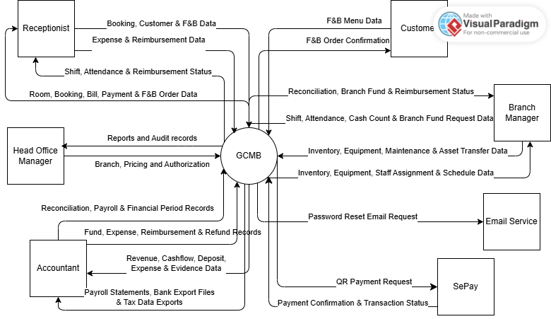
Figure 3.1 Context Diagram of GCMB System

2. Main Business Flow

2.1 MBF-01 Customer Service & Room Usage
This is a Swimlane Activity Diagram used to describe the high-level business process of theCustomer Service & Room Usage workflow. In this workflow, 3 actors (corresponding to 3 swimlanes) and 1 system swimlane interact with each other according to the scenario below to execute and complete the business function.
Trigger: A customer requests a room booking
End condition: The customer completes checkout and payment, or the booking ends with the deposit handled under the applicable policy
Step | Role | Activity | Outcome
Common steps
1 | Customer | Request a room booking and provide usage requirements | The Receptionist receives the customer's request
2 | Receptionist | Receive the request and arrange a booking that meets the customer's needs | The booking is created
3 | Receptionist | Handle the booking deposit under the applicable policy | Deposit information is recorded
Case 1: The booking is cancelled or the customer does not arrive before using the room
4 | Receptionist | Handle a cancelled booking or a no-show | The booking is recorded as not proceeding
Case 1.1: The deposit is eligible for a refund
5 | Accountant | Process the deposit refund for the customer | The deposit is refunded and the booking ends
Case 1.2: The deposit is not eligible for a refund
5 | Receptionist | Complete booking handling under the non-refundable deposit policy | The booking ends and the deposit is not refunded
Case 2: The customer proceeds with room use
4 | Receptionist | Check in the customer | The customer starts using the room
5 | Receptionist | Monitor and handle requests related to room use during the customer's stay | Room use continues according to the customer's actual needs
6 | Receptionist | Receive and handle food and beverage requests during room use | Additional food and beverage charges are recorded
7 | Receptionist | Prepare the information required for customer checkout | Room usage and service information is complete for billing
8 | GCMB | Determine the final amount the customer needs to pay | The amount payable is determined
9 | Customer | Pay the remaining amount due | Payment obligations are fulfilled
10 | Receptionist | Complete the customer's room stay | Customer service is completed

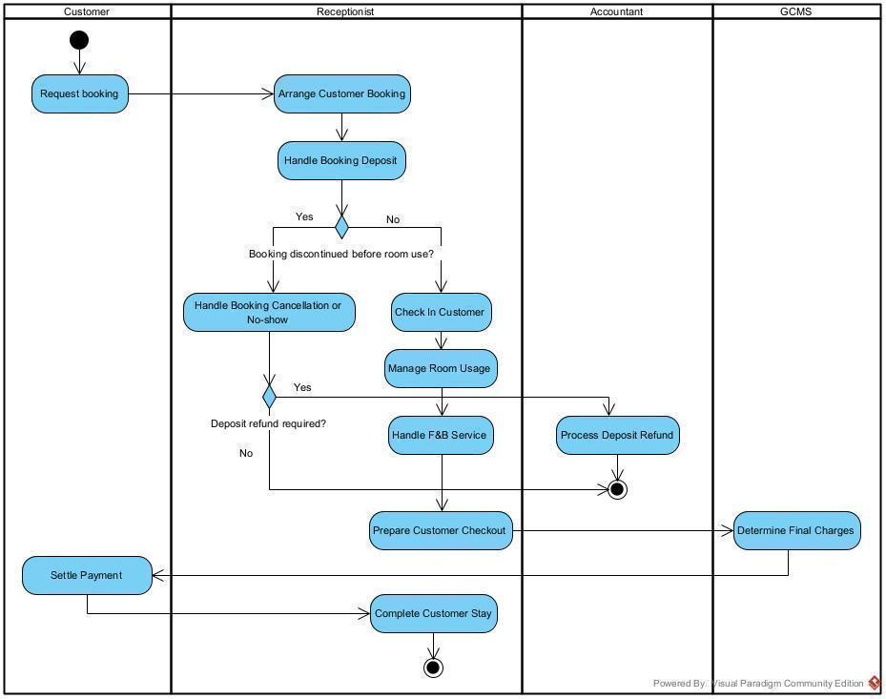
Figure 3.2 Swimlane Activity Diagram of Customer Service Management

2.2 MBF-02 Financial Control & Period Management
This is a Swimlane Activity Diagram used to describe the high-level business process of the Financial Control & Period Management workflow. In this workflow, 3 actors (corresponding to 3 swimlanes) and 1 system swimlane interact with each other according to the scenario below to execute and complete the business function.
Trigger: The Accountant receives operating funds
End condition: The financial period is closed and the Head Office Manager reviews business performance
Step | Role | Activity | Outcome
Common steps
1 | Accountant | Receive funds for business operations | Operating funds are recorded
2 | Accountant | Check the funds currently available for business operations | Available funds are identified
3 | Accountant | Allocate operating funds to each branch | The branch has funds for its operations
4 | Branch Manager | Manage operating expenses at the branch within its allocated fund | Branch operating expenses are controlled and recorded
5 | GCMB | Summarize daily financial activity from receipts, expenses and other financial movements | Financial figures are available for daily closing
6 | Branch Manager | Prepare and perform daily financial closing based on actual operations | Daily closing data is recorded
7 | GCMB | Compare daily closing figures with recorded financial figures and identify variances | It is determined whether a variance exists
Case 1: A variance is found during daily closing
8 | Branch Manager | Investigate the cause and explain the variance | An explanation for the variance is available
Common steps after handling variances
9 | Accountant | Review daily closing results and related information | Daily closing results are reviewed
10 | Accountant | Reconcile daily financial figures to confirm that recorded figures match actual results | Daily financial results are reconciled
11 | Accountant | Consolidate financial results for the days in the period | Consolidated financial figures for the period are available
12 | Accountant | Close the financial period after reconciliation and consolidation are complete | Period data is confirmed and locked
13 | Head Office Manager | Review business results based on finalized financial figures | A basis is available for assessing business performance

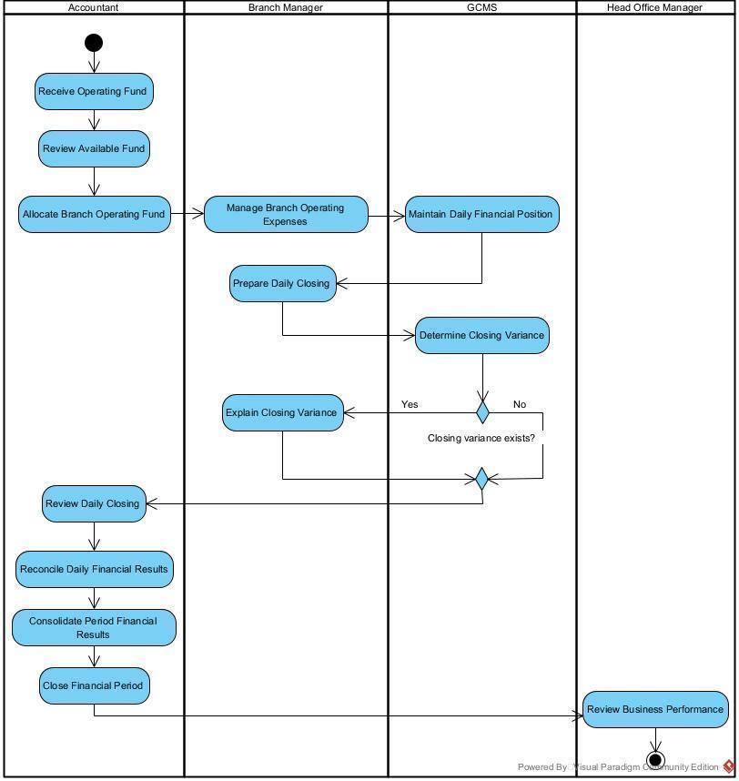
Figure 3.4 Swimlane Activity Diagram of Financial Management

2.3 MBF-03 Workforce & Payroll Management
This is a Swimlane Activity Diagram used to describe the high-level business process of the Workforce & Payroll Management workflow. In this workflow, 3 actors (corresponding to 3 swimlanes) and 1 system swimlane interact with each other according to the scenario below to execute and complete the business function.
Trigger: The Branch Manager begins planning the weekly work schedule
End condition: Salary payments for the period are completed
Step | Role | Activity | Outcome
Common steps
1 | Branch Manager | Manage information about employees at the branch | Staff information needed to organize work is maintained
2 | Branch Manager | Plan available shifts for the week | A list of shifts is available for employee registration
3 | Receptionist | Register for available shifts | Employee work schedules are established
Case 1: The work schedule needs adjustment
4 | Branch Manager | Adjust the work schedule when changes or staff reassignment are needed | The work schedule is updated to reflect actual needs
Case 1.1: The work schedule does not need adjustment
4 | Branch Manager | Continue with the established work schedule | The work schedule serves as the basis for recording attendance
Common steps after the work schedule is established
5 | Branch Manager | Record actual employee attendance each day | Actual attendance data is recorded
6 | Receptionist | Review personal attendance information | Employees can confirm their own attendance records
Case 2: An attendance issue is identified
7 | Branch Manager | Investigate and resolve the identified attendance issue | Attendance issues are addressed before the period is closed
Case 2.1: No attendance issue is identified
7 | Branch Manager | Proceed with closing the attendance sheet using the recorded data | Attendance data is ready for closing
Common steps at the end of the period
8 | Branch Manager | Close the attendance sheet for the period | Attendance data is confirmed as the basis for payroll calculation
9 | GCMB | Calculate monthly payroll based on the closed attendance sheet | Employee payroll results are generated
10 | Accountant | Review and confirm payroll results | Payroll is confirmed
11 | Accountant | Prepare information for salary payment | Salary payment information is ready
12 | Accountant | Complete salary payments to employees | Salary payments for the period are completed

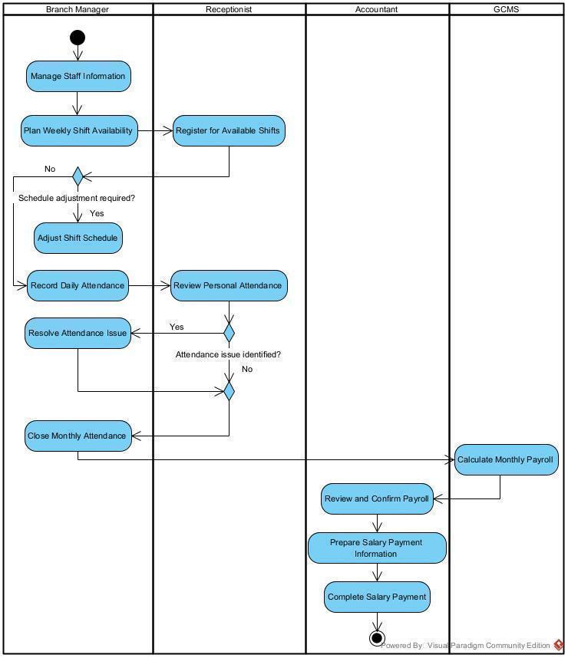
Figure 3.3 Swimlane Activity Diagram of Workforce Management

2.4 MBF-04 Branch Resource & Facility Management
This is a Swimlane Activity Diagram used to describe the high-level business process of the Branch Resource & Facility Management workflow. In this workflow, 2 actors (corresponding to 2 swimlanes) and 1 system swimlane interact with each other according to the scenario below to execute and complete the business function.
Trigger: The Branch Manager starts reviewing branch resources
End condition: The resource need or issue is handled and resource availability is updated
Step | Role | Activity | Outcome
Common steps
1 | Branch Manager | Monitor inventory, equipment and other resources used for branch operations | The condition of branch resources is known
2 | Branch Manager | Identify resource needs or issues requiring action | The type of issue requiring action is identified
Case 1: An inventory issue arises
3 | Branch Manager | Check inventory status and determine the required action | The need to replenish stock or correct quantity discrepancies is identified
Case 1.1: Inventory needs replenishment
4 | Branch Manager | Replenish the goods needed by the branch | Stock quantities are replenished
Case 1.2: A stock quantity discrepancy is identified
4 | Branch Manager | Reconcile and adjust stock quantities to match actual stock | Stock quantities reflect actual stock
Case 2: An equipment incident occurs
3 | Branch Manager | Assess equipment condition and determine the appropriate action | Equipment requiring repair or replacement is identified
Case 2.1: Equipment needs replacement
4 | Branch Manager | Arrange replacement of equipment that is no longer suitable for use | Replacement equipment is provided for branch operations
Case 2.2: Equipment can be repaired
4 | Branch Manager | Arrange equipment repairs | Equipment is sent for repair
5 | Branch Manager | Check the repair results after completion | Equipment condition after repair is confirmed
6 | Accountant | Receive and process invoices and pay repair costs | Repair costs are paid
Common final steps
7 | GCMB | Update resource availability and information after the required actions | Resource information reflects the current state and the process ends

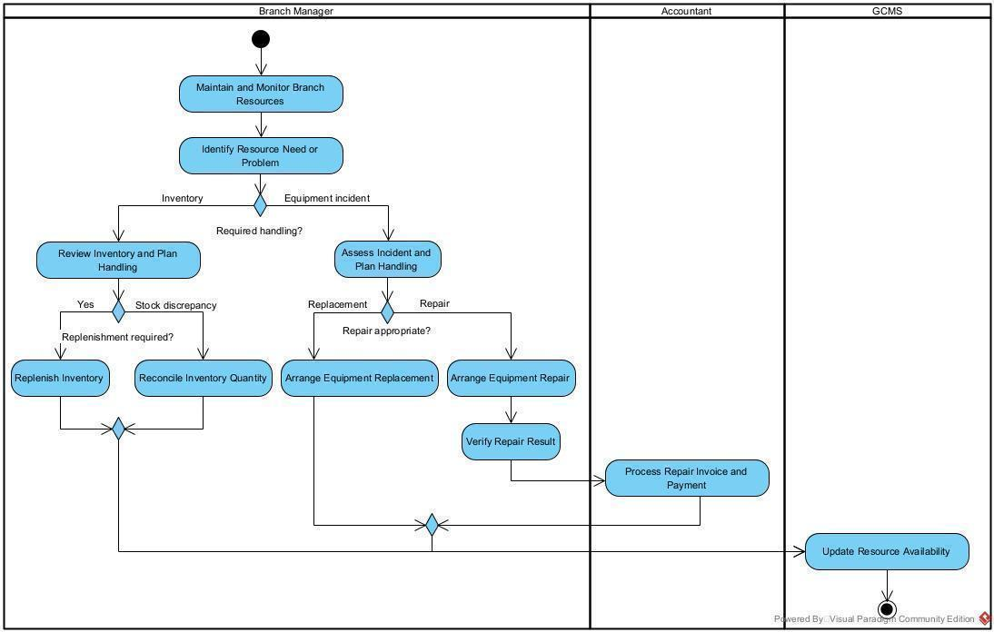
Figure 3.4 Swimlane Activity Diagram of Branch Facility Management

3. Conceptual Data Model

3.1 Entity Relationship Diagram
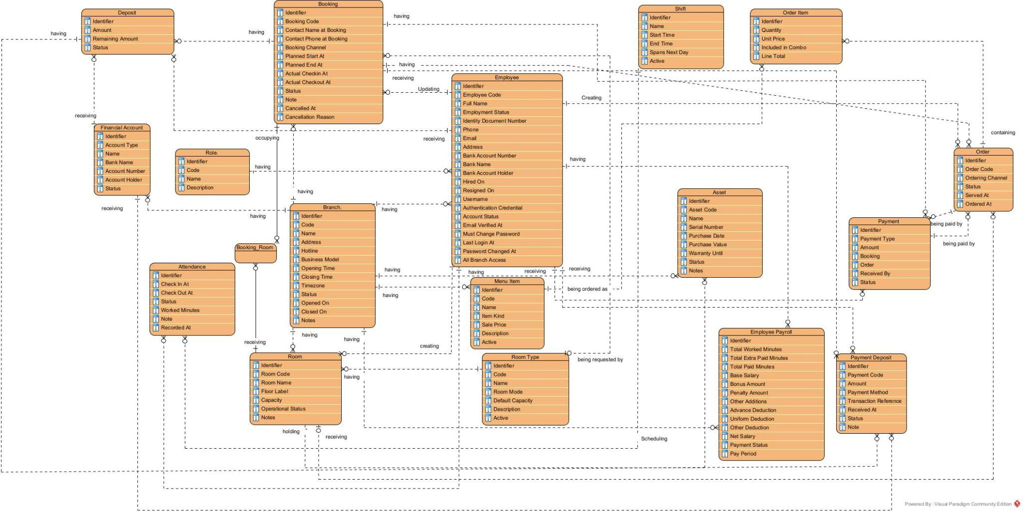
Figure 3.5. Logical Entity–Relationship Diagram of the GenZ Music Box and Cinema Management System (GCMB)

3.2 Entity Descriptions
Entity: Role
Field | Value
Purpose | Defines an internal access category, such as Head Office Manager, Branch Manager, Receptionist or Accountant.
Key business attributes | Identifier, Code, Name, Description.
Business identity | Identifier identifies the role; Code is its business reference.
Relationships | One Role is assigned to multiple User Accounts through the Having role relationship.
Status / lifecycle | N/A

Entity: Branch
Field | Value
Purpose | Represents a GenZ operating location, including its address, service model, operating hours and current operating status.
Key business attributes | Identifier, Code, Name, Address, Hotline, Business Model, Opening Time, Closing Time, Timezone, Status, Opened On, Closed On, Notes.
Business identity | Identifier identifies the branch; Code is its business reference.
Relationships | Has Rooms and Employees. Provides the organizational context for branch operations, employee attendance, shift scheduling and payroll-related activities, according to the relationships defined in the ERD.
Status / lifecycle | The Status attribute records the branch's operational state. Specific status values and transition rules must be defined in the business rules.

Entity: Room Type
Field | Value
Purpose | Classifies rooms into categories to support room organization, capacity management, and room-related business rules.
Key business attributes | Identifier, Code, Name, Room Mode, Default Capacity, Description, Active.
Business identity | Identifier uniquely identifies each room type; Code is the business-facing reference.
Relationships | Associated with Room to classify rooms according to their configured type.
Status / lifecycle | Active indicates whether the room type can be assigned to rooms or used in new operational activities. Historical room records should retain their existing classification where necessary.

Entity: Room
Field | Value
Purpose | Represents a physical room at a GenZ branch, including its identification, floor, capacity and current operational condition.
Key business attributes | Identifier, Room Code, Room Name, Floor Level, Capacity, Operational Status, Notes.
Business identity | Identifier uniquely identifies each room; Room Code is the room's business reference.
Relationships | Belongs to a Branch and is classified by a Room Type. Can be associated with Booking through Booking Room. May also be associated with Assets or room-related operational activities where supported by the ERD.
Status / lifecycle | Operational Status records the room's current condition. Possible operational transitions, such as available, in use, cleaning and under maintenance, must be defined in the business rules.

Entity: Booking
Field | Value
Purpose | Records a customer's reservation, including booking contact information, booking channel, planned room-use period, actual check-in/check-out times and cancellation details.
Key business attributes | Identifier, Booking Code, Contact Name at Booking, Contact Phone at Booking, Booking Channel, Planned Start At, Planned End At, Actual Checkin At, Actual Checkout At, Status, Note, Cancelled At, Cancellation Reason.
Business identity | Identifier uniquely identifies each booking; Booking Code is its operational reference.
Relationships | Associated with Room through Booking Room. Can be associated with Deposit and Payment records. Employee-related relationships support booking updates or operational handling where applicable.
Status / lifecycle | Status records the booking's current state. The business rules should define the permitted transitions for reservation, check-in, check-out and cancellation, including any no-show handling if supported.

Entity: Menu Item
Field | Value
Purpose | Defines a product or service offered by GenZ for sale, including its classification, selling price and availability.
Key business attributes | Identifier, Code, Name, Item Kind, Sale Price, Description, Active.
Business identity | Identifier uniquely identifies each menu item; Code is its catalogue reference.
Relationships | Associated with Order Item to identify products or services included in an order. The ERD may also support menu-item and order associations through the Order Item structure, depending on the finalized model.
Status / lifecycle | Active indicates whether the menu item is available for selection and sale. Inactive items should remain available for historical order records where necessary.

Entity: Order
Field | Value
Purpose | Records an order created for customer service usage, including its order channel, creation time and fulfillment status.
Key business attributes | Identifier, Order Code, Ordering Channel, Status, Served At, Ordered At.
Business identity | Identifier uniquely identifies each order; Order Code is its operational reference.
Relationships | Associated with Order Item records and Payment records. Can be associated with Booking and Room to connect the order to the relevant customer booking or room-use session.
Status / lifecycle | Status records the order's current state. The business rules should define the transitions for order processing, fulfillment and cancellation. The system should also define when an existing order is updated rather than creating a new order for the same room-use session.

Entity: Order Item
Field | Value
Purpose | Stores an individual line within an order, including the quantity ordered, unit price and calculated line total.
Key business attributes | Identifier, Quantity, Unit Price, Included in Combo, Line Total.
Business identity | Identifier uniquely identifies each order item.
Relationships | Belongs to an Order. Records the individual item details associated with that order. The Included in Combo attribute indicates whether the item is treated as part of a combo.
Status / lifecycle | N/A

Entity: Deposit
Field | Value
Purpose | Records a customer's deposit associated with a booking, including the original amount, remaining balance and deposit status.
Key business attributes | Identifier, Amount, Remaining Amount, Status.
Business identity | Identifier uniquely identifies each deposit record.
Relationships | Associated with Booking and Financial Account. Supports tracking of deposit balances and their relationship to booking-related financial transactions.
Status / lifecycle | Status tracks the deposit's current state. Rules should define when a deposit is retained, applied to an order or payment, refunded, or forfeited, according to the system's supported business processes.

Entity: Payment
Field | Value
Purpose | Records a payment transaction associated with a booking or order, including the payment type, amount, receiving employee and transaction status.
Key business attributes | Identifier, Payment Type, Amount, Booking, Order, Received By, Status.
Business identity | Identifier uniquely identifies each payment record.
Relationships | Associated with Booking and/or Order as the payment target and with Employee through the Received By relationship. Payment information supports transaction tracking and financial reconciliation.
Status / lifecycle | Status records the payment's current state. The business rules should define supported states and transitions, including successful, failed, pending or refunded transactions where applicable. Deposit application and partial-payment handling must be clearly defined to avoid duplicate financial records.

Entity: Employee
Field | Value
Purpose | Stores a staff member’s identity, contact details, bank-payment information and employment dates.
Key business attributes | Identifier, Employee Code, Full Name, Employment Status, Identity Document Number, Phone, Email, Address, Bank Account Number, Bank Name, Bank Account Holder, Hired On, Resigned On, Username, Authentication Credential, Account Status, Email Verified At, Must Change Password, Last Login At, Password Changed At, All Branch Access.
Business identity | Identifier identifies the employee; Employee Code is the staff business reference.
Relationships | Associated with Role and Branch. Related to Attendance and Employee Payroll records. Employee records may also be connected to booking, payment or other operational activities where an employee is responsible for performing or recording them.
Status / lifecycle | Employment Status tracks the employee's employment state, while Account Status tracks access to the system. Hiring, resignation and account-access changes should follow their respective business rules.

Entity: Shift
Field | Value
Purpose | Defines a work shift, including its name, scheduled start and end times, and whether it continues into the next calendar day.
Key business attributes | Identifier, Name, Start Time, End Time, Spans Next Day, Active.
Business identity | Identifier uniquely identifies each shift.
Relationships | Associated with employee scheduling and branch operations through the relationships defined in the ERD. The final model should make clear how employees are assigned to shifts and branches.
Status / lifecycle | Active indicates whether the shift is available for scheduling. Spans Next Day indicates whether the shift ends on the following calendar day.

Entity: Attendance
Field | Value
Purpose | Records employee attendance information, including check-in/check-out times, worked minutes, attendance status and related notes.
Key business attributes | Identifier, Check In At, Check Out At, Status, Worked Minutes, Note, Recorded At.
Business identity | Identifier uniquely identifies each attendance record.
Relationships | Associated with Employee attendance activities and the employee responsible for recording the attendance information, according to the relationships shown in the ERD.
Status / lifecycle | Status records the attendance result. The business rules should define supported values and handling for late arrival, early departure, absence and incomplete attendance records.

Entity: Employee Payroll
Field | Value
Purpose | Records an employee's payroll calculation, including working-time totals, salary components, additions, deductions, net salary and payment status
Key business attributes | Identifier, Total Worked Minutes, Total Extra Paid Minutes, Total Paid Minutes, Base Salary, Bonus Amount, Penalty Amount, Other Additions, Advance Deduction, Uniform Deduction, Other Deduction, Net Salary, Payment Status, Pay Period. .
Business identity | Identifier identifies the employee payroll record.
Relationships | Associated with Employee and Branch. May use attendance and working-time information as inputs to payroll calculations according to the payroll rules.
Status / lifecycle | Payment Status tracks the payroll payment state. The system should define the permitted stages from calculation and review to payment completion. Pay Period identifies the period covered by the payroll record.

Entity: Asset
Field | Value
Purpose | Records business assets, including equipment and facilities, with their identifying details, purchase information, warranty and current status.
Key business attributes | Identifier, Asset Code, Name, Serial Number, Purchase Date, Purchase Value, Warranty Until, Status, Notes.
Business identity | Identifier identifies the asset; Asset Code is its tracking reference.
Relationships | Associated with the relevant operational resources through the relationships defined in the ERD. Where shown, assets can be associated with a Room or other location to support asset tracking.
Status / lifecycle | Status records the asset's current condition. Business rules should define supported states, such as in use, under maintenance, damaged or retired, if these are required.

Entity: Financial Account
Field | Value
Purpose | Identifies a cash fund or bank account used in branch operations, including account type, bank details and account status.
Key business attributes | Identifier, Account Type, Name, Bank Name, Account Number, Account Holder, Status.
Business identity | Identifier identifies the financial account or cash fund; Account Number describes a bank account when applicable.
Relationships | Belongs to Branch and is used by Deposit records through the Using account relationship.
Status / lifecycle | active → inactive

3.3 Data Business Rules
Data business rules define the conditions that must be satisfied when data is created, updated, and used in GCMB. These rules ensure uniqueness, validity, consistency between entities, and preservation of business history.
Rule | Description | Enforced On
DBR-01 - Unique username | Each user account must have a unique username across the system, regardless of role or branch. | Account creation and username update.
DBR-02 - Unique business codes | Branch codes, employee codes, booking codes, order codes, and asset codes must each be unique within their respective entity across the system. | Record creation and business-code update.
DBR-03 - Unique room code within a branch | Each room must have a unique room code within its branch. Different branches may use the same room code. | Room creation and room update.
DBR-04 - Valid data references | All referenced records must exist. A referenced record must not be deleted if deletion would compromise the integrity of existing business data. | Record creation, relationship update, and deletion.
DBR-05 - Consistent order branch | An F&B order must belong to the same branch as its related booking. If a serving room is specified, that room must also belong to the order's branch. | F&B order creation and update.
DBR-06 - Valid booking times | The planned end time must be later than the planned start time. When actual checkout is recorded, an actual check-in time must exist and checkout must occur after check-in. | Booking creation, time changes, and checkout.
DBR-07 - No overlapping room reservations | Effective bookings assigned to the same room must not have overlapping room-use intervals. This constraint must be rechecked when the schedule changes, the room changes, or the stay is extended. | Booking creation, room assignment, room change, and extension.
DBR-08 - Preserved booking contact details | Contact name and phone number must be stored for each booking. The same phone number may appear in multiple bookings. Updates to other records must not automatically overwrite these historical contact details. | Booking creation and contact-detail update.
DBR-09 - Valid service prices | Hourly prices, overtime prices, and menu-item sale prices must not be negative. Catalogue price changes must not automatically alter confirmed booking prices or captured order-line unit prices. | Price configuration, booking confirmation, and order recording.
DBR-10 - Valid order-line values | Quantity must be greater than zero and unit price must not be negative. Line amounts must follow quantity, unit price, and combo rules consistently. Items already included in a combo must not be charged again. | Order-line creation, update, and billing.
DBR-11 - Order linked to an active room session | An F&B order charged to a booking must be linked to an ongoing room-use session when the order is placed. The order-to-booking relationship must be retained after checkout. | F&B order recording and acceptance.
DBR-12 - Valid deposit balance | The original deposit amount must be greater than zero. The remaining amount must not be negative or exceed the original amount. Total amounts applied, refunded, and forfeited must not exceed the deposit received. | Deposit receipt, application, refund, and forfeiture.
DBR-13 - Valid payment association | Each payment must identify the booking or order being paid. If both are referenced, the order must belong to that booking. Each payment must be counted only once when calculating total receipts. | Payment recording and payment aggregation.
DBR-14 - No duplicate bank-transfer receipts | A bank transfer may be recorded as received only when SePay confirmation matches the payment reference and requested amount. Repeated notifications for the same transaction must not create additional receipts. | SePay transaction notification processing.
DBR-15 - Valid employment dates | The resignation date, when provided, must not precede the hire date. Changing an employee to resigned must preserve historical attendance, payroll, and related transactions. | Employee update and resignation recording.
DBR-16 - Valid attendance times | When both timestamps are available, check-out must be later than check-in, and worked minutes must not be negative. Overnight shifts must use complete dates and times to calculate the duration correctly. | Attendance recording and correction.
DBR-17 - Protection of closed attendance | Attendance data for a closed month must not be modified through normal editing. Payroll generation must use closed attendance data. | Attendance closing, correction, and payroll generation.
DBR-18 - No duplicate salary deductions or payments | Each paid salary advance must be deducted no more than once. Each employee must have no more than one successful final salary payment for the same payroll period. | Payroll calculation and salary-payment confirmation.
DBR-19 - Consistent asset location | If an asset is assigned to a room, the room must belong to the branch managing the asset. For cross-branch transfers, branch and location information must be updated only after the required handover and receipt confirmations are complete. | Asset-location assignment and transfer completion.
DBR-20 - Preserved historical data | Accounts no longer in use must be deactivated while retaining links to their previous records. Financial transactions in closed periods must be preserved; corrections must use adjustment records identifying the reason, responsible user, and time. | Account deactivation, period closing, and financial adjustment.

4. User Requirements

4.1 Actors
# | Actor | Description
1 | Head Office Manager | A management role that uses GCMB to manage branches, room categories, prices, combo packages, user access, important approvals, and chain-wide reports.
2 | Branch Manager | A branch management role that uses GCMB to manage rooms, receptionist, attendance, inventory, equipment issues, branch expenses, branch funds, and daily cash closing.
3 | Receptionist | An operational role that uses GCMB to manage bookings, check-in and check-out, room changes, stay extensions, deposits, payments, F&B orders, equipment issue reports, personal shift and attendance information.
4 | Accountant | A finance role that uses GCMB to manage funds, expenses, reimbursements, deposit refunds, daily cash reconciliation, payroll, salary payments, financial period closing, and financial reports.
5 | Customer | A customer role that uses GCMB to view the F&B menu and place F&B orders by scanning the QR code in the room
6 | Email Service | An external service that works with GCMB to send password recovery and password reset emails to system users
7 | SePay | An external payment service that works with GCMB to support bank-transfer payments and send payment confirmation information back to the system

4.2 Use Cases (UC)
ID | Use Case | Primary Actors | Major Feature | Use Case Description
UC-01 | Change Password | Head Office Manager, Branch Manager, Receptionist, Accountant | System Configuration Management | A logged-in account holder changes their current password. GCMB saves the new password for future login
UC-02 | Reset Password | Head Office Manager, Branch Manager, Receptionist, Accountant | System Configuration Management | An account holder resets a forgotten password after identity verification. GCMB saves the replacement password
UC-03 | Update Account Information | Head Office Manager, Branch Manager, Receptionist, Accountant | System Configuration Management | A logged-in account holder updates their own account information. GCMB saves the confirmed changes
UC-04 | Create User Account | Head Office Manager, Branch Manager | System Configuration Management | The Head Office Manager or Branch Manager creates an account within their permitted scope. GCMB records the account information
UC-05 | View User Accounts | Head Office Manager, Branch Manager | System Configuration Management | The Head Office Manager or Branch Manager views, searches, or filters accounts within their permitted scope. GCMB leaves the account records unchanged
UC-06 | Set Account Role | Head Office Manager | System Configuration Management | The Head Office Manager assigns a role to an existing account. GCMB updates the account's access according to the assigned role
UC-07 | Deactivate User Account | Head Office Manager, Branch Manager | System Configuration Management | The Head Office Manager or Branch Manager deactivates an account within their permitted scope. GCMB prevents further access while retaining associated records
UC-08 | View Audit Log | Head Office Manager | System Configuration Management | The Head Office Manager views, searches, or filters recorded system activities. GCMB leaves the audit records unchanged
UC-09 | Create Branch | Head Office Manager | System Configuration Management | The Head Office Manager creates a branch record. GCMB saves the branch information
UC-10 | View Branches | Head Office Manager | System Configuration Management | The Head Office Manager views, searches, or filters branch records. GCMB provides the branch details without changing them
UC-11 | Update Branch | Head Office Manager | System Configuration Management | The Head Office Manager updates an existing branch's information. GCMB saves the confirmed changes
UC-12 | Set Branch Manager | Head Office Manager | System Configuration Management | The Head Office Manager assigns a Branch Manager to a branch. GCMB records the assignment
UC-13 | Deactivate Branch | Head Office Manager | System Configuration Management | The Head Office Manager stops a branch's operations. GCMB records the change while retaining the branch's historical information
UC-14 | Create Room Type | Head Office Manager | System Configuration Management | The Head Office Manager creates a room type. GCMB saves the information used to classify rooms
UC-15 | View Room Types | Head Office Manager | System Configuration Management | The Head Office Manager views, searches, or filters room types. GCMB leaves the room type records unchanged
UC-16 | Update Room Type | Head Office Manager | System Configuration Management | The Head Office Manager updates an existing room type. GCMB saves the confirmed changes
UC-17 | Deactivate Room Type | Head Office Manager | System Configuration Management | The Head Office Manager deactivates a room type that is no longer used for new room assignments. GCMB retains its historical references
UC-18 | Delete Room Type | Head Office Manager | System Configuration Management | The Head Office Manager deletes an unused room type. GCMB allows deletion only when no dependent records exist
UC-19 | Create Room Price | Head Office Manager | System Configuration Management | The Head Office Manager creates a room price for the applicable room type and time period. GCMB saves the pricing information
UC-20 | View Room Prices | Head Office Manager | System Configuration Management | The Head Office Manager views, searches, or filters room prices. GCMB leaves the pricing records unchanged
UC-21 | Update Room Price | Head Office Manager | System Configuration Management | The Head Office Manager updates an existing room price. GCMB saves the changes without altering prices already confirmed for bookings
UC-22 | Deactivate Room Price | Head Office Manager | System Configuration Management | The Head Office Manager stops a room price from being applied to new bookings. GCMB retains historical pricing information and confirmed booking prices
UC-23 | Create Combo Package | Head Office Manager | System Configuration Management | The Head Office Manager creates a combo package with its included services and price. GCMB saves the package for booking use
UC-24 | View Combo Packages | Head Office Manager | System Configuration Management | The Head Office Manager views, searches, or filters combo packages. GCMB leaves the package records unchanged
UC-25 | Update Combo Package | Head Office Manager | System Configuration Management | The Head Office Manager updates a combo package. GCMB saves the changes without altering the package details already confirmed for bookings
UC-26 | Deactivate Combo Package | Head Office Manager | System Configuration Management | The Head Office Manager stops a combo package from being selected for new bookings. GCMB retains its historical use
UC-27 | Delete Combo Package | Head Office Manager | System Configuration Management | The Head Office Manager deletes an unused combo package. GCMB allows deletion only when no dependent records exist
UC-28 | Create Room | Branch Manager | System Configuration Management | The Branch Manager creates a room record for their branch. GCMB saves the room information
UC-29 | Update Room | Branch Manager | System Configuration Management | The Branch Manager updates a room's details at their branch. GCMB saves the confirmed changes
UC-30 | Deactivate Room | Branch Manager | System Configuration Management | The Branch Manager deactivates a room that is no longer offered for service. GCMB retains its booking and operating history
UC-31 | Delete Room | Branch Manager | System Configuration Management | The Branch Manager deletes an unused room record. GCMB allows deletion only when no dependent records exist
UC-32 | View Rooms | Receptionist, Branch Manager | Service Management | The Receptionist or Branch Manager views, searches, or filters rooms at their branch. GCMB provides room details and operating status without changing them
UC-33 | Set Room Operating Status | Branch Manager | Service Management | The Branch Manager sets a room's operating status. GCMB updates whether the room can be used for service
UC-34 | Create Booking | Receptionist | Service Management | The Receptionist creates a booking for a walk-in or advance customer. GCMB records the agreed price and reserves a suitable room for the requested period
UC-35 | View Bookings | Receptionist | Service Management | The Receptionist views, searches, or filters bookings at their branch. GCMB provides booking details without changing them
UC-36 | Update Booking | Receptionist | Service Management | The Receptionist updates allowed booking details. GCMB checks room availability and preserves the booking's confirmed price
UC-37 | Cancel Booking | Receptionist | Service Management | The Receptionist records a customer cancellation or no-show. GCMB cancels the booking, releases the reserved room, and records the applicable deposit outcome
UC-38 | Check In Guest | Receptionist | Service Management | The Receptionist checks in a customer against an existing booking. GCMB records the arrival time and starts the room stay
UC-39 | Change Room | Receptionist | Service Management | The Receptionist changes the room for an active booking. GCMB records the room change and applies the applicable price difference
UC-40 | Extend Room Stay | Receptionist | Service Management | The Receptionist extends a customer's room stay. GCMB checks availability for the additional period and records the extension
UC-41 | Check Out Guest | Receptionist | Service Management | The Receptionist records the room inspection and confirms the customer's bill and payment. GCMB records checkout and ends the room stay
UC-42 | Collect Booking Deposit | Receptionist | Service Management | The Receptionist records a confirmed deposit payment. GCMB links the deposit to the booking
UC-43 | Create Deposit Refund Request | Receptionist | Service Management | The Receptionist creates a refund request for an eligible booking deposit. GCMB records the request for Accountant review
UC-44 | Refund Booking Deposit | Accountant | Service Management | The Accountant refunds an eligible booking deposit. GCMB records the refund without exceeding the remaining refundable balance
UC-45 | Create Menu Item | Branch Manager | Resource Management | The Branch Manager creates a menu item with its selling information. GCMB saves the item for use in the menu
UC-46 | View Menu Items | Branch Manager, Receptionist, Customer | Resource Management | The Branch Manager, Receptionist, or Customer views, searches, or filters menu items. GCMB provides item details and current availability
UC-47 | Update Menu Item | Branch Manager | Resource Management | The Branch Manager updates an existing menu item. GCMB saves the changes while retaining historical sales information
UC-48 | Deactivate Menu Item | Branch Manager | Resource Management | The Branch Manager stops a menu item from being offered for new sales. GCMB retains its previous sales records
UC-49 | Delete Menu Item | Branch Manager | Resource Management | The Branch Manager deletes an unused menu item. GCMB allows deletion only when no dependent records exist
UC-50 | Add Items to Booking | Receptionist | Resource Management | The Receptionist adds selected items to an existing booking. GCMB records their charges and automatically deducts applicable stock once
UC-51 | Submit Item Request | Customer | Resource Management | The Customer submits an item request for their booking. GCMB records the request without confirming a sale or deducting stock
UC-52 | View Booking Items | Receptionist | Resource Management | The Receptionist views, searches, or filters items recorded against a booking. GCMB provides the quantities and charges without changing them
UC-53 | Confirm Item Request | Receptionist | Resource Management | The Receptionist confirms an incoming item request. GCMB checks availability, adds the accepted items to the booking, and deducts applicable stock once
UC-54 | Create Inventory Item | Branch Manager | Resource Management | The Branch Manager creates an inventory item for their branch. GCMB saves the information used to track its stock
UC-55 | View Inventory | Branch Manager | Resource Management | The Branch Manager views, searches, or filters inventory at their branch. GCMB provides recorded stock quantities without changing them
UC-56 | Update Inventory Item | Branch Manager | Resource Management | The Branch Manager updates an inventory item's details. GCMB saves the changes without replacing its stock movement history
UC-57 | Delete Inventory Item | Branch Manager | Resource Management | The Branch Manager deletes an unused inventory item. GCMB allows deletion only when no dependent records exist
UC-58 | Record Stock Receipt | Branch Manager | Resource Management | The Branch Manager records the quantities actually received and their costs. GCMB records the receipt and increases stock after confirmation
UC-59 | Adjust Stock Quantity | Branch Manager | Resource Management | The Branch Manager records a stock adjustment with its reason. GCMB updates the quantity and retains the adjustment history
UC-60 | Create Equipment Category | Head Office Manager, Branch Manager | Resource Management | The Head Office Manager or Branch Manager creates an equipment category within their permitted scope. GCMB saves the category for asset classification
UC-61 | View Equipment Categories | Head Office Manager, Branch Manager | Resource Management | The Head Office Manager or Branch Manager views, searches, or filters equipment categories within their permitted scope. GCMB leaves the category records unchanged
UC-62 | Update Equipment Category | Head Office Manager, Branch Manager | Resource Management | The Head Office Manager or Branch Manager updates an equipment category within their permitted scope. GCMB saves the confirmed changes
UC-63 | Deactivate Equipment Category | Head Office Manager, Branch Manager | Resource Management | The Head Office Manager or Branch Manager deactivates an equipment category within their permitted scope. GCMB retains its existing asset references
UC-64 | Delete Equipment Category | Head Office Manager, Branch Manager | Resource Management | The Head Office Manager or Branch Manager deletes an unused equipment category within their permitted scope. GCMB allows deletion only when no dependent records exist
UC-65 | Create Equipment Asset | Head Office Manager, Branch Manager | Resource Management | The Head Office Manager or Branch Manager registers an equipment asset within their permitted scope. GCMB records the asset's details, branch, and location
UC-66 | View Equipment Assets | Head Office Manager, Branch Manager | Resource Management | The Head Office Manager or Branch Manager views, searches, or filters equipment assets within their permitted scope. GCMB provides asset details and recorded history
UC-67 | Update Equipment Asset | Head Office Manager, Branch Manager | Resource Management | The Head Office Manager or Branch Manager updates an asset's details within their permitted scope. GCMB retains its history and prevents branch changes that bypass transfer confirmation
UC-68 | Deactivate Equipment Asset | Head Office Manager, Branch Manager | Resource Management | The Head Office Manager or Branch Manager deactivates an asset that is no longer used. GCMB retains its incident, repair, and transfer history
UC-69 | Delete Equipment Asset | Head Office Manager, Branch Manager | Resource Management | The Head Office Manager or Branch Manager deletes an unused asset record within their permitted scope. GCMB allows deletion only when no dependent records exist
UC-70 | Create Equipment Incident Report | Receptionist, Branch Manager | Resource Management | The Receptionist or Branch Manager reports an equipment incident at their branch. GCMB records the affected asset and supporting information
UC-71 | Record Repair Outcome | Branch Manager | Resource Management | The Branch Manager records the repair result and actual cost. GCMB updates the related incident and equipment information
UC-72 | View Equipment Incidents | Branch Manager | Resource Management | The Branch Manager views, searches, or filters equipment incidents at their branch. GCMB provides the recorded incident details and progress
UC-73 | Assess Equipment Incident | Branch Manager | Resource Management | The Branch Manager assesses a reported equipment incident. GCMB records the assessment and required repair or replacement action
UC-74 | Create Equipment Transfer Request | Head Office Manager | Resource Management | The Head Office Manager creates an equipment transfer request between branches. GCMB records the request without changing the asset's assigned branch
UC-75 | Confirm Equipment Handover | Branch Manager of the source branch | Resource Management | The Source Branch Manager confirms equipment handover. GCMB records the confirmation and makes the transfer ready for destination receipt confirmation
UC-76 | Confirm Equipment Receipt | Branch Manager of the destination branch | Resource Management | The Destination Branch Manager confirms receipt and the destination location. GCMB updates the asset's branch and location and retains the completed transfer history
UC-77 | Create Staff Record | Head Office Manager, Branch Manager | Workforce Management | The Head Office Manager or Branch Manager creates a staff record within their permitted scope. GCMB saves the staff information
UC-78 | View Staff Records | Head Office Manager, Branch Manager | Workforce Management | The Head Office Manager or Branch Manager views, searches, or filters staff records within their permitted scope. GCMB provides current information and relevant history
UC-79 | Update Staff Record | Head Office Manager, Branch Manager | Workforce Management | The Head Office Manager or Branch Manager updates staff information within their permitted scope. GCMB saves the changes and retains relevant history
UC-80 | Deactivate Staff Record | Head Office Manager, Branch Manager | Workforce Management | The Head Office Manager or Branch Manager deactivates a staff record. GCMB retains its workforce and payroll history
UC-81 | Set Employee Branch | Head Office Manager | Workforce Management | The Head Office Manager assigns an employee to a branch. GCMB saves the employee's branch assignment
UC-82 | Transfer Employee | Head Office Manager | Workforce Management | The Head Office Manager transfers an employee to another branch. GCMB updates the assignment and retains its history
UC-83 | Register for Shift | Receptionist | Workforce Management | The Receptionist registers for an available shift at their home branch. GCMB automatically confirms the registration and updates remaining capacity
UC-84 | View Shift Schedule | Branch Manager | Workforce Management | The Branch Manager views, searches, or filters the branch's shift schedule. GCMB provides recorded assignments without changing them
UC-85 | Set Weekly Shift Availability | Branch Manager | Workforce Management | The Branch Manager sets available shifts and staffing capacity for the upcoming week. GCMB saves the weekly availability for registration
UC-86 | Update Shift Schedule | Branch Manager | Workforce Management | The Branch Manager changes an employee's assigned shift. GCMB updates the branch schedule
UC-87 | Record Daily Attendance | Branch Manager | Workforce Management | The Branch Manager records or corrects daily attendance. GCMB saves the information only while the attendance sheet remains open
UC-88 | View Attendance Records | Branch Manager | Workforce Management | The Branch Manager views, searches, or filters attendance records at their branch. GCMB leaves the recorded attendance unchanged
UC-89 | Close Monthly Attendance Sheet | Branch Manager | Workforce Management | The Branch Manager closes finalized monthly attendance after reported discrepancies are resolved. GCMB protects the closed records from normal changes
UC-90 | View Personal Work Records | Receptionist | Workforce Management | The Receptionist views their assigned shifts and recorded attendance for a selected period. GCMB leaves those records unchanged
UC-91 | Calculate Monthly Payroll | Accountant | Workforce Management | The Accountant requests payroll calculation for a selected period. GCMB calculates payroll from closed attendance and applicable payroll rules
UC-92 | View Monthly Payroll | Accountant | Workforce Management | The Accountant views, searches, or filters monthly payroll information. GCMB leaves the payroll records unchanged
UC-93 | Export Monthly Payroll | Accountant | Workforce Management | The Accountant exports confirmed monthly payroll information. GCMB provides the exported data without changing payroll or payment status
UC-94 | Update Monthly Payroll | Accountant | Workforce Management | The Accountant records permitted payroll adjustments. GCMB updates the calculated amounts and retains the adjustment information
UC-95 | Confirm Monthly Payroll | Accountant | Workforce Management | The Accountant confirms a reviewed monthly payroll. GCMB records the confirmed payroll for salary payment
UC-96 | Pay Salary Advance | Accountant | Workforce Management | The Accountant records a salary advance actually paid to an employee. GCMB retains the payment for later payroll deduction
UC-97 | Pay Monthly Salary | Accountant | Workforce Management | The Accountant records final salary payment results for selected employees. GCMB marks only successful payments as paid and prevents duplicate final payments for the same employee and period
UC-98 | Record Daily Cash Closing | Branch Manager | Business Performance Management | The Branch Manager records actual closing cash for the branch. GCMB calculates expected closing cash and the cash variance and retains the related explanation
UC-99 | View Daily Cash Closings | Accountant | Business Performance Management | The Accountant views, searches, or filters daily cash closings by branch and date. GCMB provides closing details without changing them
UC-100 | View Cash Variance Alerts | Branch Manager, Accountant | Business Performance Management | The Branch Manager or Accountant views, searches, or filters cash variance alerts within their permitted scope. GCMB provides the related closing details
UC-101 | Confirm Daily Cash Reconciliation | Accountant | Business Performance Management | The Accountant confirms reconciliation after reviewing the daily closing and resolving required discrepancies. GCMB records the reconciliation result
UC-102 | Record Incoming Fund | Accountant | Business Performance Management | The Accountant records funds received from Head Office. GCMB records an internal funding movement and updates the Accountant Available Fund
UC-103 | Allocate Branch Fund | Accountant | Business Performance Management | The Accountant allocates operating funds to a branch. GCMB records the internal transfer and updates both affected fund balances
UC-104 | View Accountant Fund | Accountant | Business Performance Management | The Accountant views the current fund balance and relevant recorded movements. GCMB calculates the Accountant Available Fund without changing financial records
UC-105 | Close Financial Period | Accountant | Business Performance Management | The Accountant closes a financial period after required reconciliations are completed. GCMB protects the period's transactions from normal changes
UC-106 | Adjust Financial Transaction | Accountant | Business Performance Management | The Accountant records a financial correction with its reason. GCMB creates a separate adjustment linked to the original transaction without overwriting it
UC-107 | Create Payment Request | Branch Manager | Business Performance Management | The Branch Manager creates a payment request for a business expense. GCMB records its amount, payment source, and required approval route without reducing a fund balance
UC-108 | Pay Approved Request | Accountant | Business Performance Management | The Accountant records actual payment of an approved request. GCMB records the payment result and updates the specified payment source
UC-109 | View Payment Requests | Head Office Manager, Branch Manager, Accountant | Business Performance Management | The Head Office Manager, Branch Manager, or Accountant views, searches, or filters payment requests within their permitted scope. GCMB leaves the request records unchanged
UC-110 | Review Payment Request | Head Office Manager | Business Performance Management | The Head Office Manager approves or rejects a payment request requiring their approval. GCMB records the decision and review history
UC-111 | Create Reimbursement Request | Receptionist, Branch Manager | Business Performance Management | The Receptionist or Branch Manager requests reimbursement for a business expense paid personally. GCMB records the request and supporting evidence for review
UC-112 | Pay Reimbursement | Accountant | Business Performance Management | The Accountant pays an approved reimbursement. GCMB records the payment within the approved amount and prevents reimbursement of the same expense twice
UC-113 | View Reimbursement Requests | Receptionist, Branch Manager, Accountant | Business Performance Management | The Receptionist, Branch Manager, or Accountant views, searches, or filters reimbursement requests within their permitted scope. GCMB leaves the request records unchanged
UC-114 | Review Reimbursement Request | Accountant | Business Performance Management | The Accountant accepts or rejects a reimbursement request. GCMB records the decision and approved reimbursable amount when applicable
UC-115 | Create Expense Category | Accountant | Business Performance Management | The Accountant creates an expense category. GCMB saves it for classifying business expenses
UC-116 | View Expense Categories | Accountant | Business Performance Management | The Accountant views, searches, or filters expense categories. GCMB leaves the category records unchanged
UC-117 | Update Expense Category | Accountant | Business Performance Management | The Accountant updates an expense category. GCMB saves the confirmed changes
UC-118 | Deactivate Expense Category | Accountant | Business Performance Management | The Accountant stops an expense category from being used for new expenses. GCMB retains its historical references
UC-119 | Delete Expense Category | Accountant | Business Performance Management | The Accountant deletes an unused expense category. GCMB allows deletion only when no dependent records exist
UC-120 | View Expense History | Branch Manager, Accountant | Business Performance Management | The Branch Manager or Accountant views, searches, or filters recorded expenses within their permitted scope. GCMB provides expense details and supporting evidence without changing them
UC-121 | View Chain Dashboard | Head Office Manager | Business Performance Management | The Head Office Manager views chain performance for a selected period. GCMB provides consolidated results with available search and filtering
UC-122 | View Branch Dashboard | Branch Manager | Business Performance Management | The Branch Manager views their branch's performance for a selected period. GCMB provides branch results with available search and filtering
UC-123 | View Monthly Performance Report | Head Office Manager, Accountant | Business Performance Management | The Head Office Manager or Accountant views a monthly performance report. GCMB provides operating income, expenses, profit, and applicable performance measures
UC-124 | View Expense Breakdown Report | Head Office Manager, Accountant | Business Performance Management | The Head Office Manager or Accountant views an expense breakdown for a selected period. GCMB groups recorded expenses by the selected reporting criteria
UC-125 | Export Tax Accounting Data | Accountant | Business Performance Management | The Accountant exports recorded financial data for tax accounting. GCMB provides the selected data without changing the underlying transactions

4.3 Use Case Diagrams
These are the Use Case Diagrams organized by features, showing how actors interact with the system to perform functional operations and achieve their business goals

4.3.1 System Configuration Management

4.3.1.1 Personal Account Management
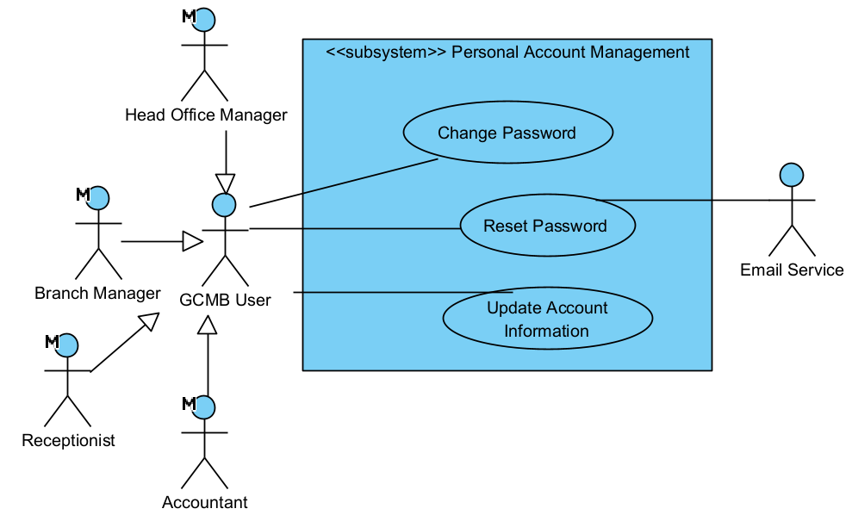
Figure 3.6. Use Case Diagram of Personal Account Management

4.3.1.2 User Account Management
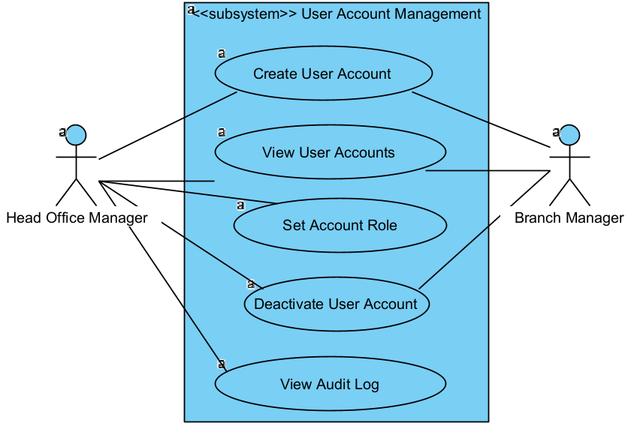
Figure 3.7. Use Case Diagram of User Account Management

4.3.1.3 Branch Management
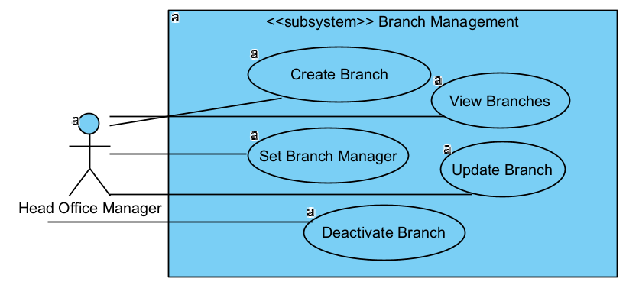
Figure 3.8. Use Case Diagram of Branch Management

4.3.2 Service Management

4.3.2.1 Room Type Management
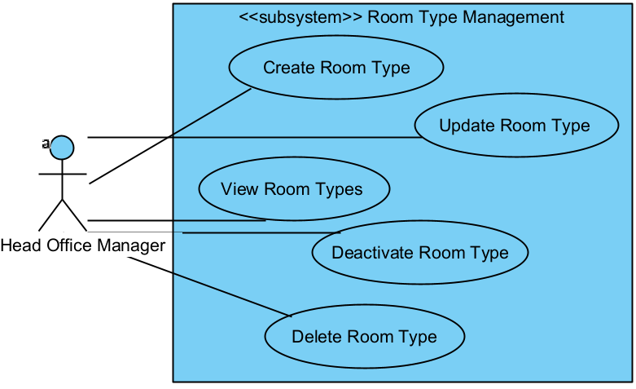
Figure 3.9. Use Case Diagram of Room Type Management

4.3.2.2 Room Price Management
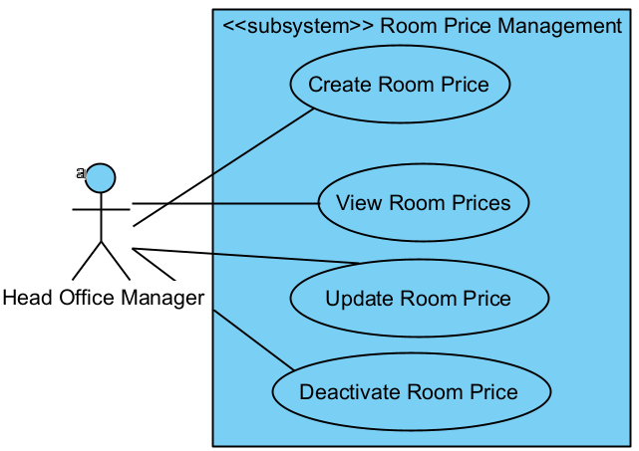
Figure 3.10. Use Case Diagram of Room Price Management

4.3.2.3 Combo Package Management
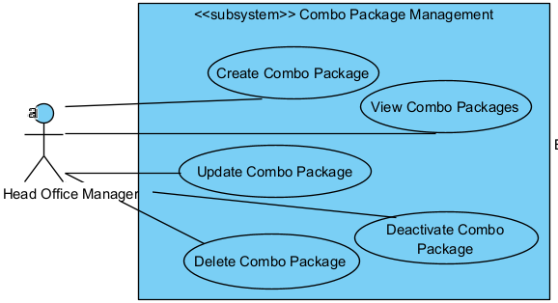
Figure 3.11. Use Case Diagram of Combo Package Management

4.3.2.4 Room Management
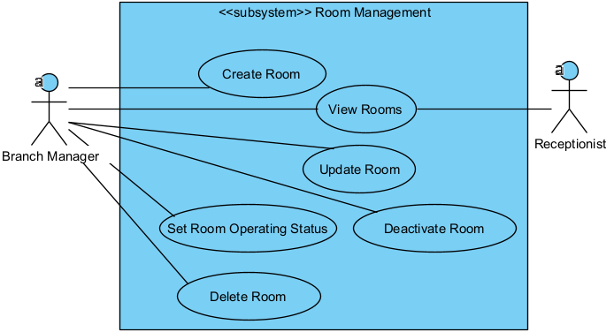
Figure 3.12. Use Case Diagram of Room Management

4.3.2.5 Booking Management
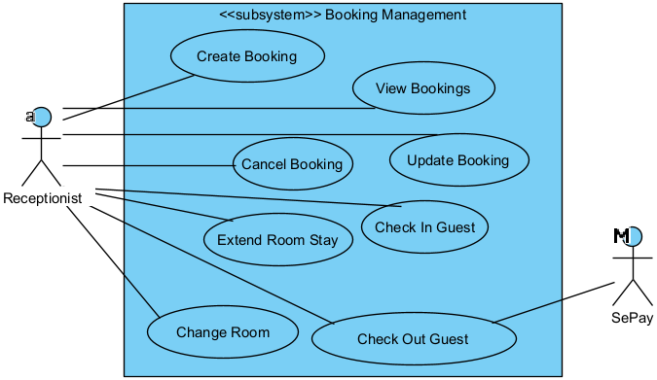
Figure 3.13. Use Case Diagram of Booking Management

4.3.2.6 Deposit Management
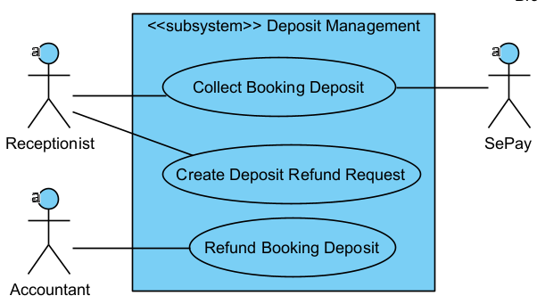
Figure 3.14. Use Case Diagram of Deposit Management

4.3.2.7 Food Service Management
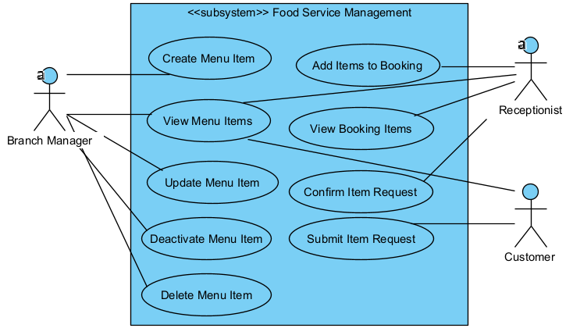
Figure 3.15. Use Case Diagram of Food Service Management

4.3.3 Resource Management

4.3.3.1 Inventory Management
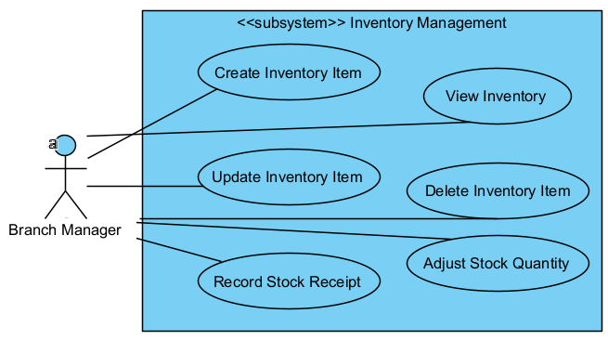
Figure 3.16. Use Case Diagram of Inventory Management

4.3.3.2 Equipment Category Management
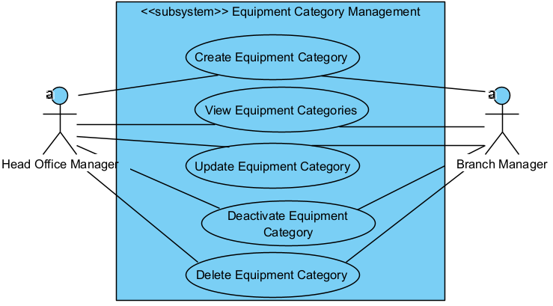
Figure 3.17. Use Case Diagram of Equipment Category Management

4.3.3.3 Equipment Management
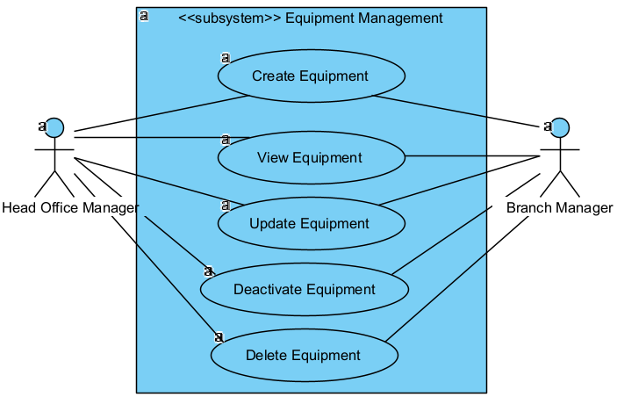
Figure 3.18. Use Case Diagram of Equipment & Maintenance Subsystem

4.3.3.4 Equipment Maintenance
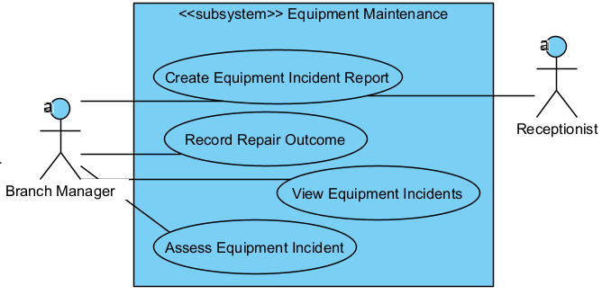
Figure 3.19. Use Case Diagram of Equipment & Maintenance Subsystem

4.3.3.5 Equipment Transfer Management
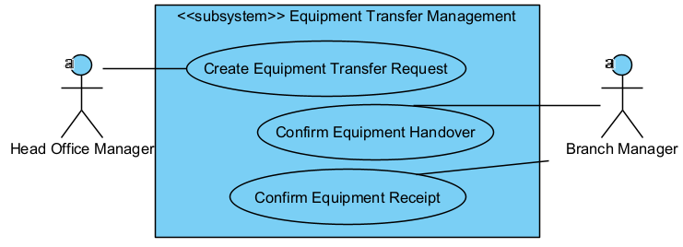
Figure 3.20. Use Case Diagram of Equipment & Maintenance Subsystem

4.3.4 Workforce Management

4.3.4.1 Staff Management
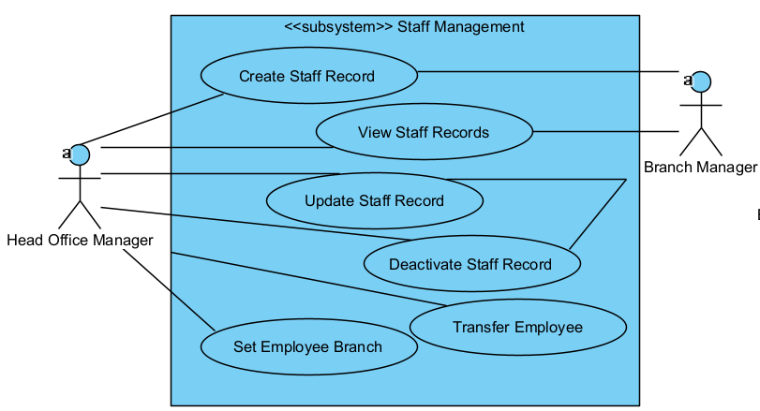
Figure 3.21. Use Case Diagram of Staff Management

4.3.4.2 Shift Management
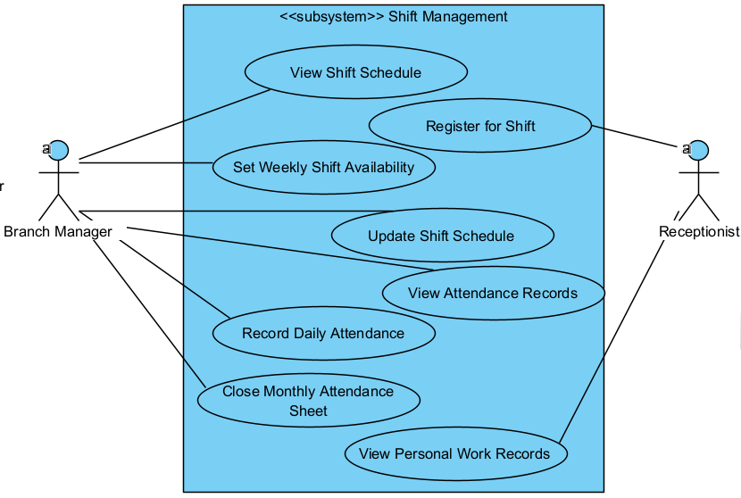
Figure 3.22. Use Case Diagram of Shift Management

4.3.4.3 Payroll Management

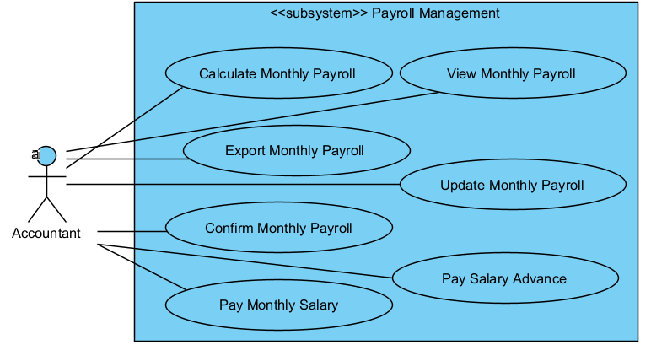
Figure 3.23. Use Case Diagram of Payroll Management

4.3.5 Business Performance Management

4.3.5.1 Cash Management
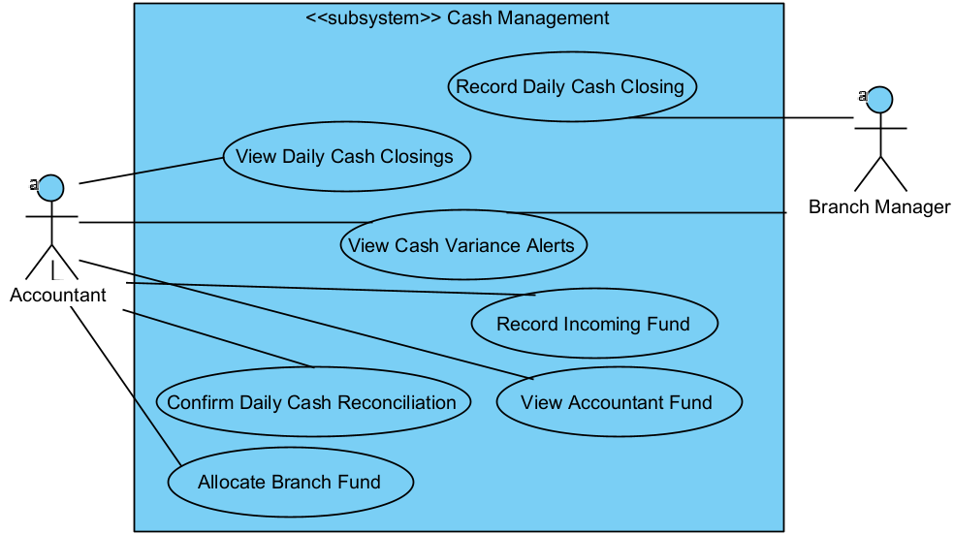
Figure 3.24. Use Case Diagram of Cash Management

4.3.5.2 Financial Control
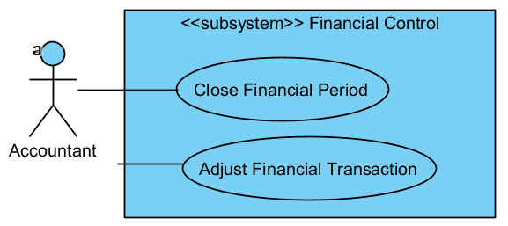
Figure 3.25. Use Case Diagram of Financial Control

4.3.5.3 Payment Request Management
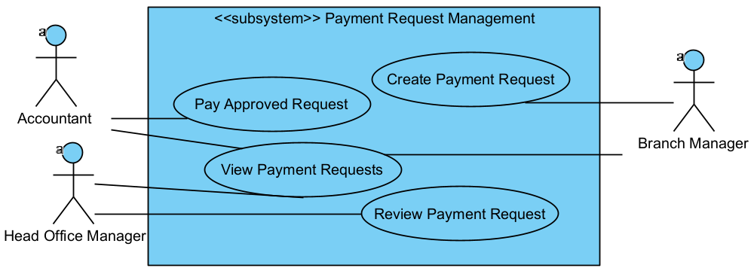
Figure 3.26. Use Case Diagram of Payment Request Management

4.3.5.4 Reimbursement Management
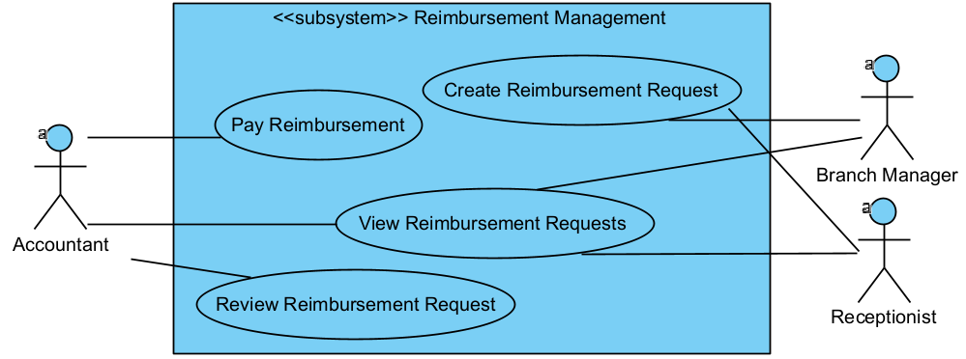
Figure 3.27. Use Case Diagram of Reimbursement Management

4.3.5.5 Expense Management
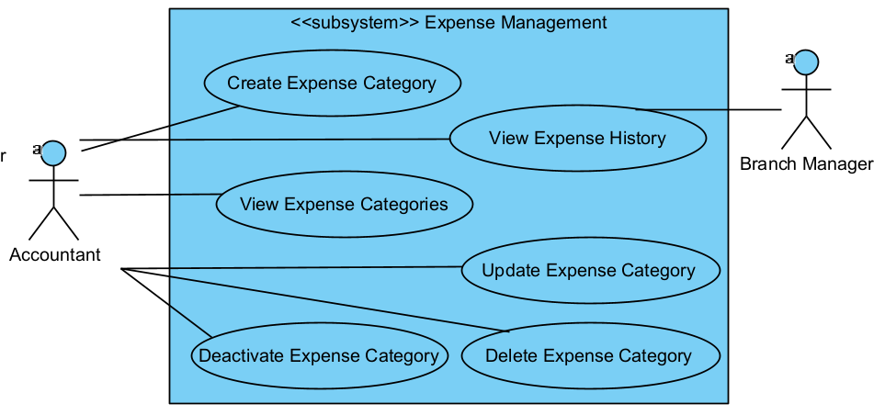
Figure 3.28. Use Case Diagram of Expense Management

4.3.5.6 Performance Reporting
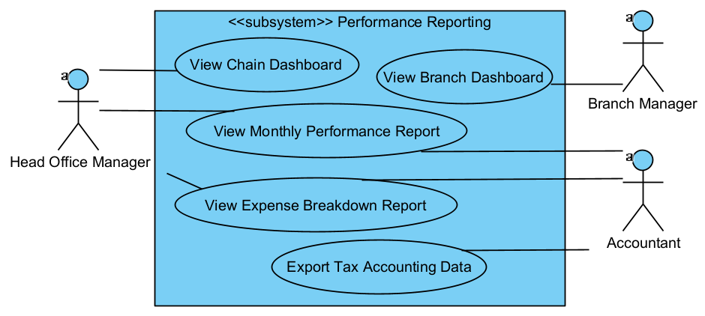
Figure 3.27. Use Case Diagram of Performance Reporting

4.4 Permission Matrix
Entity / Feature | Action | Head Office Manager | Branch Manager | Receptionist | Accountant
Personal Account Management | Change Password | Own | Own | Own | Own
Personal Account Management | Reset Password | Own | Own | Own | Own
Personal Account Management | Update Account Information | Own | Own | Own | Own
User Account Management | Create User Account | Full | Branch | No | No
User Account Management | View User Accounts | Full | Branch | No | No
User Account Management | Set Account Role | Full | No | No | No
User Account Management | Deactivate User Account | Full | Branch | No | No
User Account Management | View Audit Log | Full | No | No | No
Branch Management | Create Branch | Full | No | No | No
Branch Management | View Branches | Full | No | No | No
Branch Management | Update Branch | Full | No | No | No
Branch Management | Set Branch Manager | Full | No | No | No
Branch Management | Deactivate Branch | Full | No | No | No
Room Type Management | Create Room Type | Full | No | No | No
Room Type Management | View Room Types | Full | No | No | No
Room Type Management | Update Room Type | Full | No | No | No
Room Type Management | Deactivate Room Type | Full | No | No | No
Room Type Management | Delete Room Type | Full | No | No | No
Room Price Management | Create Room Price | Full | No | No | No
Room Price Management | View Room Prices | Full | No | No | No
Room Price Management | Update Room Price | Full | No | No | No
Room Price Management | Deactivate Room Price | Full | No | No | No
Combo Package Management | Create Combo Package | Full | No | No | No
Combo Package Management | View Combo Packages | Full | No | No | No
Combo Package Management | Update Combo Package | Full | No | No | No
Combo Package Management | Deactivate Combo Package | Full | No | No | No
Combo Package Management | Delete Combo Package | Full | No | No | No
Room Management | Create Room | No | Branch | No | No
Room Management | Update Room | No | Branch | No | No
Room Management | Deactivate Room | No | Branch | No | No
Room Management | Delete Room | No | Branch | No | No
Room Management | View Rooms | Full | Branch | Branch | No
Room Management | Set Room Operating Status | No | Branch | No | No
Booking Management | Create Booking | No | No | Branch | No
Booking Management | View Bookings | No | No | Branch | No
Booking Management | Update Booking | No | No | Branch | No
Booking Management | Cancel Booking | No | No | Branch | No
Booking Management | Check In Guest | No | No | Branch | No
Booking Management | Change Room | No | No | Branch | No
Booking Management | Extend Room Stay | No | No | Branch | No
Booking Management | Check Out Guest | No | No | Branch | No
Deposit Management | Collect Booking Deposit | No | No | Branch | No
Deposit Management | Create Deposit Refund Request | No | No | Branch | No
Deposit Management | Refund Booking Deposit | No | No | No | Full
Food Service Management | Create Menu Item | No | Branch | No | No
Food Service Management | View Menu Items | No | Branch | Branch | No
Food Service Management | Update Menu Item | No | Branch | No | No
Food Service Management | Deactivate Menu Item | No | Branch | No | No
Food Service Management | Delete Menu Item | No | Branch | No | No
Food Service Management | Add Items to Booking | No | No | Branch | No
Food Service Management | Submit Item Request | No | No | No | No
Food Service Management | View Booking Items | No | No | Branch | No
Food Service Management | Confirm Item Request | No | No | Branch | No
Inventory Management | Create Inventory Item | No | Branch | No | No
Inventory Management | View Inventory | No | Branch | No | No
Inventory Management | Update Inventory Item | No | Branch | No | No
Inventory Management | Delete Inventory Item | No | Branch | No | No
Inventory Management | Record Stock Receipt | No | Branch | No | No
Inventory Management | Adjust Stock Quantity | No | Branch | No | No
Equipment Category Management | Create Equipment Category | Full | Branch | No | No
Equipment Category Management | View Equipment Categories | Full | Branch | No | No
Equipment Category Management | Update Equipment Category | Full | Branch | No | No
Equipment Category Management | Deactivate Equipment Category | Full | Branch | No | No
Equipment Category Management | Delete Equipment Category | Full | Branch | No | No
Equipment Management | Create Equipment | Full | Branch | No | No
Equipment Management | View Equipment | Full | Branch | No | No
Equipment Management | Update Equipment | Full | Branch | No | No
Equipment Management | Deactivate Equipment | Full | Branch | No | No
Equipment Management | Delete Equipment | Full | Branch | No | No
Equipment Maintenance | Create Equipment Incident Report | No | Branch | Branch | No
Equipment Maintenance | Record Repair Outcome | No | Branch | No | No
Equipment Maintenance | View Equipment Incidents | No | Branch | No | No
Equipment Maintenance | Assess Equipment Incident | No | Branch | No | No
Equipment Transfer Management | Create Equipment Transfer Request | Full | No | No | No
Equipment Transfer Management | Confirm Equipment Handover | No | Branch | No | No
Equipment Transfer Management | Confirm Equipment Receipt | No | Branch | No | No
Staff Management | Create Staff Record | Full | Branch | No | No
Staff Management | View Staff Records | Full | Branch | No | No
Staff Management | Update Staff Record | Full | Branch | No | No
Staff Management | Deactivate Staff Record | Full | Branch | No | No
Staff Management | Set Employee Branch | Full | No | No | No
Staff Management | Transfer Employee | Full | No | No | No
Shift Management | Register for Shift | No | No | Own | No
Shift Management | View Shift Schedule | No | Branch | No | No
Shift Management | Set Weekly Shift Availability | No | Branch | No | No
Shift Management | Update Shift Schedule | No | Branch | No | No
Shift Management | Record Daily Attendance | No | Branch | No | No
Shift Management | View Attendance Records | No | Branch | No | No
Shift Management | Close Monthly Attendance Sheet | No | Branch | No | No
Shift Management | View Personal Work Records | No | No | Own | No
Payroll Management | Calculate Monthly Payroll | No | No | No | Full
Payroll Management | View Monthly Payroll | No | No | No | Full
Payroll Management | Export Monthly Payroll | No | No | No | Full
Payroll Management | Update Monthly Payroll | No | No | No | Full
Payroll Management | Confirm Monthly Payroll | No | No | No | Full
Payroll Management | Pay Salary Advance | No | No | No | Full
Payroll Management | Pay Monthly Salary | No | No | No | Full
Cash Management | Record Daily Cash Closing | No | Branch | No | No
Cash Management | View Daily Cash Closings | No | No | No | Full
Cash Management | View Cash Variance Alerts | No | Branch | No | Full
Cash Management | Confirm Daily Cash Reconciliation | No | No | No | Full
Cash Management | Record Incoming Fund | No | No | No | Full
Cash Management | Allocate Branch Fund | No | No | No | Full
Cash Management | View Accountant Fund | No | No | No | Full
Financial Control | Close Financial Period | No | No | No | Full
Financial Control | Adjust Financial Transaction | No | No | No | Full
Payment Request Management | Create Payment Request | No | Branch | No | No
Payment Request Management | Pay Approved Request | No | No | No | Full
Payment Request Management | View Payment Requests | Full | Branch | No | Full
Payment Request Management | Review Payment Request | Full | No | No | No
Reimbursement Management | Create Reimbursement Request | No | Own | Own | No
Reimbursement Management | Pay Reimbursement | No | No | No | Full
Reimbursement Management | View Reimbursement Requests | No | Own | Own | Full
Reimbursement Management | Review Reimbursement Request | No | No | No | Full
Expense Management | Create Expense Category | No | No | No | Full
Expense Management | View Expense Categories | No | No | No | Full
Expense Management | Update Expense Category | No | No | No | Full
Expense Management | Deactivate Expense Category | No | No | No | Full
Expense Management | Delete Expense Category | No | No | No | Full
Expense Management | View Expense History | No | Branch | No | Full
Performance Reporting | View Chain Dashboard | Full | No | No | No
Performance Reporting | View Branch Dashboard | No | Branch | No | No
Performance Reporting | View Monthly Performance Report | Full | No | No | Full
Performance Reporting | View Expense Breakdown Report | Full | No | No | Full
Performance Reporting | Export Tax Accounting Data | No | No | No | Full

5. System Functionalities

5.1 Screen Inventory

a. Screen Flow

5.1.1 Screen Booking
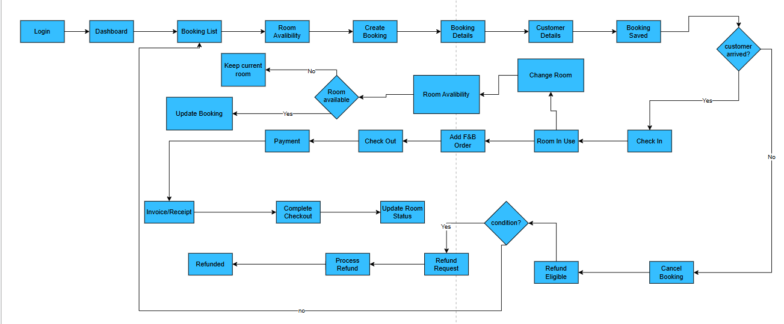

5.1.2 Workforce & Payroll Management Screen Flow.
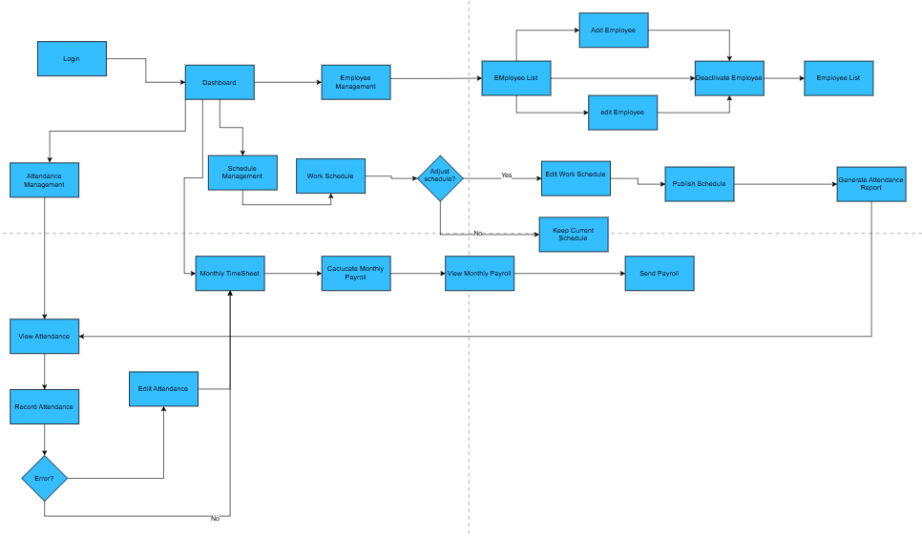

5.1.3 Financial Control & Period Management Screen Flow
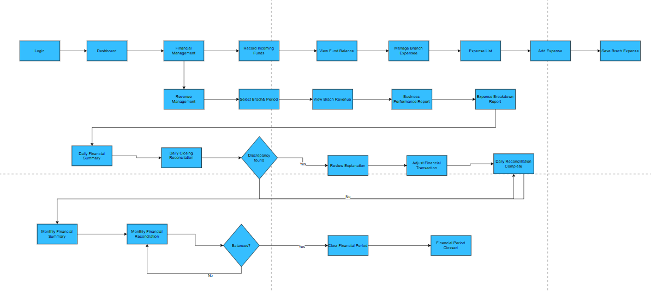

5.1.4 Branch Manager – Inventory, Equipment & Maintenance Management Screen Flow
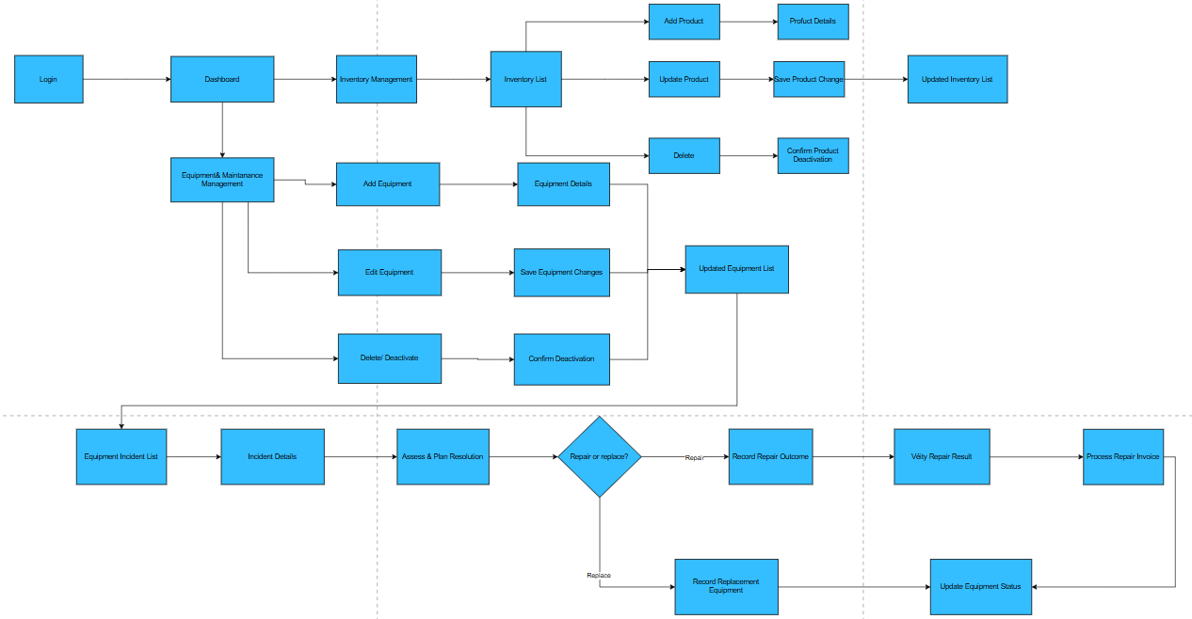
Figure 3.29. Screen Flow of Booking

b. Screen List
# | Screen Name | Feature | Description
1 | Login | Authentication | Allows staff to sign in and access functions permitted for their role and branch.
2 | Dashboard | Dashboard | Provides the receptionist’s main workspace and access to booking and room management.
3 | Booking List | Booking management | Displays bookings for the assigned branch and allows staff to search, select, or create a booking
4 | Room Availability | Room Management | Shows rooms available for the selected branch and booking time.
5 | Create Booking | Booking Management | Starts a booking and captures its branch, requested room type, planned time, and booking channel
6 | Booking Details | Booking Management | Displays the booking schedule, room assignment, status, and deposit information.
7 | Customer Details | Customer Management | Allows staff to enter the customer’s name and phone number using details received through social media or other channels
8 | Booking Saved | Booking Management | Confirms that the booking has been saved and displays its booking code and status.
9 | Check In | Room Management | Allows staff to verify an eligible booking and record the customer’s actual check-in.
10 | Room In Use | Room Management | Displays the active booking and the room currently assigned to the customer.
11 | Change Room | Room Management | Allows staff to start a room change for an active booking
12 | Room Availability | Room Management | Checks whether the selected replacement room is available for the remaining stay period.
13 | Update Booking | Room Management | Assigns the available replacement room to the active booking and records the room change.
14 | Keep Curent Room | Room Management | Keeps the existing room assignment when the requested replacement room is unavailable.
15 | Add F&B Order | F&B Management | Allows staff to add available food and beverage items to the active booking and customer bill
16 | Check out | Checkout Management | Shows room usage, F&B, service charges, deposit, and applicable discounts for checkout calculation.
17 | Payment | Payment Management | Allows staff to record cash payment or confirm a QR/bank transfer for the remaining amount due
18 | Invoice/Receipt | Billing | Displays the settled bill and allows staff to print or provide the receipt.
19 | Complete Checkout | Checkout Management | Confirms checkout, records the actual checkout time, closes the room-use session, and completes the booking.
20 | Update Room Status | Room Management | Updates the room status after checkout, such as marking it for cleaning before it becomes available again
21 | Cancel Booking | Cancellation Management | Records a customer-requested cancellation, captures its reason, and releases the reserved room time.
22 | Record No-show | Cancellation Management | Records that the customer did not arrive and releases the reserved room time. The deposit is marked non-refundable.
23 | Refund Request | Deposit Management | Allows staff to submit a refund request for an eligible deposit for Accountant processing.
24 | Process Refund | Deposit Management | Allows the Accountant to process the eligible refund and record its details and supporting evidence.
25 | Refunded | Deposit Management | Confirms completion of the refund and updates the deposit and refund request status.
26 | Deposit Forfrited | Deposit Management | Records that the deposit is not refundable and retains its forfeited status against the booking.
28 | Employee Management | Employee Management | Provides access to employee records and employee management functions
29 | Employee List | Employee Management | Displays employees and allows the Branch Manager to select an employee to view or manage.
30 | Add Employee | Employee Management | Allows the Branch Manager to enter and save a new employee’s information
31 | Edit Employee | Employee Management | Allows the Branch Manager to update an employee’s information
32 | Deactivate Employee | Employee Management | Allows the Branch Manager to deactivate an employee who has left while preserving their records.
33 | Schedule Management | Work Schedule Management | Provides access to work schedules and schedule management functions.
34 | Work Schedule | Work Schedule Management | Displays the work schedule and employee shift requests for review.
35 | Edit Work Schedule | Work Schedule Management | Allows the Branch Manager to assign or adjust employee shifts.
36 | Publish Schedule | Work Schedule Management | Saves and publishes the updated work schedule
37 | Attendance Management | Attendance Management | Provides access to attendance records and attendance management functions
38 | View Attendance | Attendance Management | Displays attendance records generated from the published work schedule.
39 | Record Attendance | Attendance Management | Allows the Branch Manager to record employee attendance
40 | Edit Attendance | Attendance Management | Allows the Branch Manager to review and correct attendance errors
41 | Monthly Timesheet | Attendance Management | Displays the monthly timesheet consolidated from attendance records
42 | View Monthly Payroll | Payroll Management | Allows the Branch Manager to view the calculated payroll for a selected month
43 | Send Payroll | Payroll Management | Allows the Branch Manager to submit the reviewed monthly payroll to the accountant
44 | Generate Attendance Report | Attendance Processing | Automatically generates an attendance report after the work schedule is published. This is a system process, not a manager-operated screen.
45 | Calculate Monthly Payroll | Payroll Processing | Automatically calculates monthly payroll using the monthly timesheet. This is a system process, not a manager-operated screen.
46 | Keep Current Schedule | Attendance Management | Represents the outcome when no schedule adjustment is needed; it is not a separate screen.
47 | Financial Management | Financial Control | Provides access to fund, expense, revenue, and financial period management
48 | Record Incoming Funds | Fund Management | Allows the Accountant to record operating funds received by the business.
49 | View Fund Balance | Fund Management | Displays the current available fund balance
50 | Manage Branch Expenses | Expense Management | Allows the Accountant to access and manage expense records for each branch.
51 | Expense List | Expense Management | Displays expenses for a selected branch and allows the Accountant to review expense records.
52 | Add Expense | Expense Management | Allows the user to enter a new expense, including its amount, category, and reason.
53 | Save Branch Expense | Expense Management | Saves the expense under the selected branch and updates its expense records.
54 | Revenue Management | Expense Management | Provides access to branch revenue information and financial reports.
55 | Select Branch & Period | Expense Management | Allows the Accountant to select a branch and reporting period, such as a day, month, or year
56 | View Branch Revenue | Expense Management | Displays revenue for the selected branch and reporting period.
57 | Business Performance Report | Financial Reporting | Summarizes revenue, expenses, profit, and cash flow for the selected branch and period
58 | Expense Breakdown Report | Financial Reporting | Groups and displays expenses by category, branch, or period
59 | Daily Financial Summary | Financial Reporting | Automatically consolidates the day’s income and expense transactions.
60 | Daily Closing Reconciliation | Daily Reconciliation | Allows the Accountant to compare the branch’s actual closing figures with the recorded financial data
61 | Review Explanation | Daily Reconciliation | Allows the Accountant to review the Branch Manager’s explanation for a financial discrepancy.
62 | Adjust Financial Transaction | Financial Control | Allows the Accountant to record a correction while preserving the original transaction history.
63 | Daily Reconciliation Complete | Daily Reconciliation | Confirms that the daily reconciliation result has been recorded
64 | Monthly Financial Summary | Period Management | Consolidates daily financial results for the selected month or period
65 | Monthly Financial Reconciliation | Period Management | Allows the Accountant to review and reconcile financial figures for the month.
66 | Close Financial Period | Period Management | Allows the Accountant to finalize and close a financial period after required checks are complete.
67 | Financial Period Closed | Period Management | Confirms that the period has been closed and normal changes are locked.
68 | Inventory Management | Inventory Management | Provides access to inventory records and product management functions.
69 | Inventory List | Inventory Management | Displays inventory items and allows the user to select an item to manage
70 | Add Product | Inventory Management | Starts the workflow for adding a new inventory product
71 | Product Details | Inventory Management | Allows the user to enter product information, such as name, code, unit, and quantity.
72 | Update Product | Inventory Management | Allows the user to edit an existing product’s information or stock quantity.
73 | Save Product Changes | Inventory Management | Saves the new or updated product information
74 | Updated Inventory List | Inventory Management | Displays the inventory list after product information has been updated
75 | Delete | Inventory Management | Starts the workflow for removing or deactivating a selected product.
76 | Confirm Product Deactivation | Inventory Management | Allows the user to confirm product deactivation before the inventory list is updated.
77 | Equipment & Maintenance Management | Equipment Management | Provides access to equipment records and maintenance functions.
78 | Add Equipment | Equipment Management | Starts the workflow for registering new equipment.
79 | Equipment Details | Equipment Management | Allows the user to enter or view equipment details, including its code, category, branch, and location.
80 | Edit Equipment | Equipment Management | Allows the user to update existing equipment information
81 | Save Equipment Changes | Equipment Management | Saves changes made to an equipment record
82 | Delete/Deactivate | Equipment Management | Starts the workflow for removing or deactivating selected equipment.
83 | Confirm Deactivation | Equipment Management | Allows the user to confirm equipment deactivation while preserving its history.
84 | Updated Equipment List | Equipment Management | Displays the equipment list with the latest information and status
85 | Equipment Incident List | Maintenance Management | Displays reported equipment or facility incidents for the Branch Manager to review.
86 | Incident Details | Maintenance Management | Shows the affected equipment, incident description, and supporting evidence.
87 | Assess & Plan Resolution | Maintenance Management | Allows the Branch Manager to assess the incident and plan a repair or replacement.
88 | Record Repair Outcome | Maintenance Management | Allows the Branch Manager to record the repair result, cost, and supporting evidence.
89 | Verify Repair Result | Maintenance Management | Allows the Branch Manager to confirm that the repair is complete and the equipment is usable
90 | Process Repair Invoice | Financial Processing | Allows the Accountant to process payment for the repair invoice.
91 | Record Replacement Equipment | Maintenance Management | Allows the Branch Manager to record replacement equipment and update its asset details
92 | Update Equipment Status | Maintenance Management | Updates the equipment’s current condition and availability after repair or replacement.

5.2 External API Inventory
# | API Name | Calling Path | Description
1 | SePay Payment Integration | GCMB → SePay | Supports bank-transfer payments for booking deposits and checkout bills. GCMB uses the expected payment amount and a unique payment reference to match confirmed transactions to the corresponding branch, booking, and bill. A payment is recorded as successful only after a matching confirmation is obtained.
2 | Password Recovery Email Service | GCMB → Email Service | Sends password-reset emails to users’ registered email addresses when they request password recovery. General workflow email notifications are outside the current scope.

5.3 Background Job Inventory
# | Job Name | Group | Description
1 | Monitor Booking Arrival and Stay Time (JOB-01) | Scheduled | Every minute
2 | Monitor Daily Revenue Closing and Reconciliation (JOB-02) | Scheduled | Every 15 minutes; checks apply after the configured closing or reconciliation deadline

II. Use Case Specifications

1. System Configuration Management

1.1 UC-01 - Change Password
Primary Actors | Head Office Manager, Branch Manager, Receptionist, Accountant | Secondary Actors | None
Description | As a Head Office Manager, Branch Manager, Receptionist, or Accountant, I want to change my own password so that I can use a new password for future access to GCMB
Preconditions | - The Head Office Manager, Branch Manager, Receptionist, or Accountant is logged in to GCMB
Normal Flow | Change Password  - The Head Office Manager, Branch Manager, Receptionist, or Accountant requests to change their own password  - GCMB requests the new password and its confirmation  - The Head Office Manager, Branch Manager, Receptionist, or Accountant provides the new password and its confirmation  - GCMB checks that the new password and its confirmation match  - GCMB replaces the account’s current password with the new password  - GCMB confirms that the password has been changed
Alternative Flows | Step 4.1 Password Confirmation Does Not Match  - GCMB informs the Head Office Manager, Branch Manager, Receptionist, or Accountant that the confirmation does not match  - The Head Office Manager, Branch Manager, Receptionist, or Accountant corrects the password or its confirmation  - The flow returns to Step 4 of the Normal Flow
Postconditions | - The account’s password is replaced by the confirmed new password  - The new password is recorded for future login
Business Rule | BR-114

1.2 UC-02 - Reset Password
Primary Actors | Head Office Manager, Branch Manager, Receptionist, Accountant | Secondary Actors | Email Service
Description | As a Head Office Manager, Branch Manager, Receptionist, or Accountant, I want to reset my forgotten password so that I can regain access to my GCMB account
Preconditions | - The account exists in GCMB  - The account has recorded email contact information for recovery
Normal Flow | Reset Password  - The Head Office Manager, Branch Manager, Receptionist, or Accountant requests to reset a forgotten password  - GCMB requests the information needed to identify the account  - The Head Office Manager, Branch Manager, Receptionist, or Accountant provides the account recovery information  - GCMB checks the supplied recovery information and requests identity verification through the Email Service  - The Head Office Manager, Branch Manager, Receptionist, or Accountant completes identity verification  - GCMB verifies the account holder’s identity  - The Head Office Manager, Branch Manager, Receptionist, or Accountant provides a replacement password and its confirmation  - GCMB checks that the replacement password and its confirmation match  - GCMB records the replacement password  - GCMB confirms that the password has been reset
Alternative Flows | Step 4.1 Recovery Information Is Invalid  - GCMB informs the Head Office Manager, Branch Manager, Receptionist, or Accountant that the recovery information cannot be accepted  - The Head Office Manager, Branch Manager, Receptionist, or Accountant corrects the recovery information  - The flow returns to Step 4 of the Normal Flow  Step 6.1 Identity Verification Is Not Completed  - GCMB does not replace the password  - The use case ends without resetting the password  Step 8.1 Password Confirmation Does Not Match  - GCMB informs the Head Office Manager, Branch Manager, Receptionist, or Accountant that the confirmation does not match  - The Head Office Manager, Branch Manager, Receptionist, or Accountant corrects the password or its confirmation  - The flow returns to Step 8 of the Normal Flow
Postconditions | - The account’s password is replaced after identity verification  - The replacement password is recorded for future login
Business Rule | BR-113, BR-114

1.3 UC-03 - Update Account Information
Primary Actors | Head Office Manager, Branch Manager, Receptionist, Accountant | Secondary Actors | None
Description | As a Head Office Manager, Branch Manager, Receptionist, or Accountant, I want to update my own account information so that my account information stays up to date
Preconditions | - The Head Office Manager, Branch Manager, Receptionist, or Accountant is logged in to GCMB
Normal Flow | Update Account Information  - The Head Office Manager, Branch Manager, Receptionist, or Accountant requests to update their own account information  - The Head Office Manager, Branch Manager, Receptionist, or Accountant identifies their own account  - GCMB provides the current information  - The Head Office Manager, Branch Manager, Receptionist, or Accountant specifies the permitted changes  - GCMB checks the supplied email contact information and provides the proposed changes for review  - The Head Office Manager, Branch Manager, Receptionist, or Accountant confirms the changes  - GCMB records the confirmed changes  - GCMB confirms that the account information has been updated
Alternative Flows | Step 5.1 Email Contact Information Is Invalid  - GCMB informs the Head Office Manager, Branch Manager, Receptionist, or Accountant that the email contact information is invalid  - The Head Office Manager, Branch Manager, Receptionist, or Accountant corrects the information  - The flow returns to Step 5 of the Normal Flow
Postconditions | - The account contains the confirmed personal information  - The account’s assigned role and branch scope are unchanged
Business Rule | BR-113

1.4 UC-04 - Create User Account
Primary Actors | Head Office Manager, Branch Manager | Secondary Actors | None
Description | As a Head Office Manager or Branch Manager, I want to create a user account so that account access can be established
Preconditions | - The Head Office Manager or Branch Manager is logged in to GCMB
Normal Flow | Create User Account  - The Head Office Manager or Branch Manager requests to create a user account  - GCMB requests the required information within the Head Office Manager’s full scope or the Branch Manager’s assigned branch scope  - The Head Office Manager or Branch Manager provides the account information  - GCMB checks that required information is provided, the username is not used by an existing account, and the supplied email has a valid format  - GCMB provides the proposed user account information for review  - The Head Office Manager or Branch Manager confirms the information  - GCMB records the new user account  - GCMB confirms that the user account has been created
Alternative Flows | Step 4.1 Required Information Is Missing  - GCMB informs the Head Office Manager or Branch Manager which required information is missing  - The Head Office Manager or Branch Manager provides the missing information  - The flow returns to Step 4 of the Normal Flow  Step 4.2 Username Is Already Used  - GCMB informs the Head Office Manager or Branch Manager that the username is already used  - The Head Office Manager or Branch Manager provides a different username  - The flow returns to Step 4 of the Normal Flow  Step 4.3 Email Address Is Invalid  - GCMB informs the Head Office Manager or Branch Manager that the email address is invalid  - The Head Office Manager or Branch Manager corrects the email address  - The flow returns to Step 4 of the Normal Flow
Postconditions | - The new user account is recorded in GCMB  - The user account contains the confirmed information
Business Rule | BR-111, BR-112, BR-113, BR-114[RR2]

1.5 UC-05 - View User Accounts
Primary Actors | Head Office Manager, Branch Manager | Secondary Actors | None
Description | As a Head Office Manager or Branch Manager, I want to view user accounts so that I can review the recorded information
Preconditions | - The Head Office Manager or Branch Manager is logged in to GCMB
Normal Flow | View User Accounts  - The Head Office Manager or Branch Manager requests to view user accounts  - GCMB provides records across branches for the Head Office Manager and within the assigned branch for the Branch Manager  - The Head Office Manager or Branch Manager specifies search or filtering criteria when needed  - GCMB provides the matching information  - The Head Office Manager or Branch Manager identifies a record to review when details are needed  - GCMB provides the requested details
Alternative Flows | Step 4.1 No Information Matches the Criteria  - GCMB informs the Head Office Manager or Branch Manager that no information matches the criteria  - The Head Office Manager or Branch Manager may revise the criteria  - The flow returns to Step 3 of the Normal Flow if the criteria are revised
Postconditions | - The requested user accounts information is provided  - No recorded information is changed
Business Rule | None

1.6 UC-06 - Set Account Role
Primary Actors | Head Office Manager | Secondary Actors | None
Description | As a Head Office Manager, I want to assign a role to a user account so that the user can access the functions and data appropriate to their responsibilities
Preconditions | - The Head Office Manager is logged in to GCMB  - The user account to be assigned a role exists in GCMB
Normal Flow | Set Account Role  - The Head Office Manager requests to assign role-based access to a user account  - The Head Office Manager specifies the user account  - GCMB provides the account's current role and the roles available for assignment  - The Head Office Manager specifies the role to assign  - The Head Office Manager confirms the role assignment  - GCMB assigns the selected role to the user account and updates the functions and data that the user can access  - GCMB confirms that the role-based access has been assigned successfully
Alternative Flows | None
Postconditions | - The selected role is assigned to the user account  - The user's accessible functions and data reflect the assigned role and applicable branch scope  - The user's previous role assignment is replaced by the confirmed role assignment
Business Rule | None

1.7 UC-07 - Deactivate User Account
Primary Actors | Head Office Manager, Branch Manager | Secondary Actors | None
Description | As a Head Office Manager or Branch Manager, I want to deactivate a user account so that it can stop being used while its historical information is retained
Preconditions | - The Head Office Manager or Branch Manager is logged in to GCMB  - The user account exists in GCMB
Normal Flow | Deactivate User Account  - The Head Office Manager or Branch Manager requests to deactivate a user account  - The Head Office Manager or Branch Manager identifies the user account  - GCMB provides the selected record within the Head Office Manager’s full scope or the Branch Manager’s assigned branch scope  - The Head Office Manager or Branch Manager confirms the deactivation  - GCMB deactivates the account, prevents further access, and retains all associated records  - GCMB confirms that the user account has been deactivated
Alternative Flows | Step 4.1 Deactivation Is Not Confirmed  - The Head Office Manager or Branch Manager indicates that the deactivation should not be applied  - GCMB leaves the user account unchanged  - The use case ends
Postconditions | - The account is deactivated and cannot be used to access GCMB  - The account and its associated history are retained
Business Rule | None

1.8 UC-08 - View Audit Log
Primary Actors | Head Office Manager | Secondary Actors | None
Description | As a Head Office Manager, I want to view audit log so that I can review the recorded information
Preconditions | - The Head Office Manager is logged in to GCMB
Normal Flow | View Audit Log  - The Head Office Manager requests to view audit log  - GCMB provides the audit log within the applicable scope  - The Head Office Manager specifies search or filtering criteria when needed  - GCMB provides the matching information  - The Head Office Manager identifies a record to review when details are needed  - GCMB provides the requested details
Alternative Flows | Step 4.1 No Information Matches the Criteria  - GCMB informs the Head Office Manager that no information matches the criteria  - The Head Office Manager may revise the criteria  - The flow returns to Step 3 of the Normal Flow if the criteria are revised
Postconditions | - The requested audit information is provided  - No audit log entry is changed or deleted
Business Rule | None

1.9 UC-09 - Create Branch
Primary Actors | Head Office Manager | Secondary Actors | None
Description | As a Head Office Manager, I want to create a branch so that the branch can be recorded in GCMB
Preconditions | - The Head Office Manager is logged in to GCMB
Normal Flow | Create Branch  - The Head Office Manager requests to create a branch  - GCMB requests the required branch information  - The Head Office Manager provides the branch information  - GCMB checks that the required information has been provided  - GCMB provides the proposed branch information for review  - The Head Office Manager confirms the information  - GCMB records the new branch  - GCMB confirms that the branch has been created
Alternative Flows | Step 4.1 Required Information Is Missing  - GCMB informs the Head Office Manager which required information is missing  - The Head Office Manager provides the missing information  - The flow returns to Step 4 of the Normal Flow
Postconditions | - The new branch is recorded in GCMB  - The branch contains the confirmed information
Business Rule | BR-111

1.10 UC-10 - View Branches
Primary Actors | Head Office Manager | Secondary Actors | None
Description | As a Head Office Manager, I want to view branches so that I can review the recorded information
Preconditions | - The Head Office Manager is logged in to GCMB
Normal Flow | View Branches  - The Head Office Manager requests to view branches  - GCMB provides the branches within the applicable scope  - The Head Office Manager specifies search or filtering criteria when needed  - GCMB provides the matching information  - The Head Office Manager identifies a record to review when details are needed  - GCMB provides the requested details
Alternative Flows | Step 4.1 No Information Matches the Criteria  - GCMB informs the Head Office Manager that no information matches the criteria  - The Head Office Manager may revise the criteria  - The flow returns to Step 3 of the Normal Flow if the criteria are revised
Postconditions | - The requested branches information is provided  - No recorded information is changed
Business Rule | None

1.11 UC-11 - Update Branch
Primary Actors | Head Office Manager | Secondary Actors | None
Description | As a Head Office Manager, I want to update the branch so that the recorded branch information remains accurate
Preconditions | - The Head Office Manager is logged in to GCMB  - The branch exists in GCMB
Normal Flow | Update Branch  - The Head Office Manager requests to update a branch  - The Head Office Manager identifies the branch to update  - GCMB provides the current information  - The Head Office Manager specifies the permitted changes  - GCMB provides the proposed changes for review  - The Head Office Manager confirms the changes  - GCMB records the confirmed changes  - GCMB confirms that the branch has been updated
Alternative Flows | None
Postconditions | - The confirmed changes are recorded in the branch  - Existing historical references to the branch are retained
Business Rule | None

1.12 UC-12 - Set Branch Manager
Primary Actors | Head Office Manager | Secondary Actors | None
Description | As a Head Office Manager, I want to set the Branch Manager for a branch so that the responsible manager is recorded for branch operations
Preconditions | - The Head Office Manager is logged in to GCMB  - The branch exists in GCMB  - A Branch Manager account exists in GCMB
Normal Flow | Set Branch Manager  - The Head Office Manager requests to set a Branch Manager  - The Head Office Manager identifies the branch  - GCMB provides the current manager assignment and available Branch Manager accounts  - The Head Office Manager specifies the Branch Manager  - GCMB provides the proposed assignment for review  - The Head Office Manager confirms the assignment  - GCMB records the Branch Manager assigned to the branch  - GCMB confirms that the manager assignment has been updated
Alternative Flows | None
Postconditions | - The branch has the confirmed Branch Manager assignment  - The previous assignment is replaced by the confirmed assignment
Business Rule | None

1.13 UC-13 - Deactivate Branch
Primary Actors | Head Office Manager | Secondary Actors | None
Description | As a Head Office Manager, I want to stop a branch’s operations so that the branch is no longer used for active operations while its history remains available
Preconditions | - The Head Office Manager is logged in to GCMB  - The branch exists in GCMB
Normal Flow | Deactivate Branch  - The Head Office Manager requests to deactivate a branch  - The Head Office Manager identifies the branch  - GCMB provides the current branch information  - The Head Office Manager confirms the deactivation  - GCMB records that the branch’s operations have stopped and retains its historical information  - GCMB confirms that the branch has been deactivated
Alternative Flows | Step 4.1 Deactivation Is Not Confirmed  - The Head Office Manager indicates that the deactivation should not be applied  - GCMB leaves the branch unchanged  - The use case ends
Postconditions | - The branch is no longer operating  - The branch’s financial, booking, workforce, and equipment history is retained
Business Rule | None

1.14 UC-14 - Create Room Type
Primary Actors | Head Office Manager | Secondary Actors | None
Description | As a Head Office Manager, I want to create a room type so that rooms can use a consistent type
Preconditions | - The Head Office Manager is logged in to GCMB
Normal Flow | Create Room Type  - The Head Office Manager requests to create a room type  - GCMB requests the required room type information  - The Head Office Manager provides the room type information  - GCMB checks that the required information has been provided  - GCMB provides the proposed room type information for review  - The Head Office Manager confirms the information  - GCMB records the new room type  - GCMB confirms that the room type has been created
Alternative Flows | Step 4.1 Required Information Is Missing  - GCMB informs the Head Office Manager which required information is missing  - The Head Office Manager provides the missing information  - The flow returns to Step 4 of the Normal Flow
Postconditions | - The new room type is recorded in GCMB  - The room type contains the confirmed information
Business Rule | BR-111[RR2]

1.15 UC-15 - View Room Types
Primary Actors | Head Office Manager | Secondary Actors | None
Description | As a Head Office Manager, I want to view room types so that I can review the recorded information
Preconditions | - The Head Office Manager is logged in to GCMB
Normal Flow | View Room Types  - The Head Office Manager requests to view room types  - GCMB provides the room types within the applicable scope  - The Head Office Manager specifies search or filtering criteria when needed  - GCMB provides the matching information  - The Head Office Manager identifies a record to review when details are needed  - GCMB provides the requested details
Alternative Flows | Step 4.1 No Information Matches the Criteria  - GCMB informs the Head Office Manager that no information matches the criteria  - The Head Office Manager may revise the criteria  - The flow returns to Step 3 of the Normal Flow if the criteria are revised
Postconditions | - The requested room types information is provided  - No recorded information is changed
Business Rule | None

1.16 UC-16 - Update Room Type
Primary Actors | Head Office Manager | Secondary Actors | None
Description | As a Head Office Manager, I want to update the room type so that the recorded room type information remains accurate
Preconditions | - The Head Office Manager is logged in to GCMB  - The room type exists in GCMB
Normal Flow | Update Room Type  - The Head Office Manager requests to update a room type  - The Head Office Manager identifies the room type to update  - GCMB provides the current information  - The Head Office Manager specifies the permitted changes  - GCMB provides the proposed changes for review  - The Head Office Manager confirms the changes  - GCMB records the confirmed changes  - GCMB confirms that the room type has been updated
Alternative Flows | None
Postconditions | - The confirmed changes are recorded in the room type  - Existing historical references to the room type are retained
Business Rule | None

1.17 UC-17 - Deactivate Room Type
Primary Actors | Head Office Manager | Secondary Actors | None
Description | As a Head Office Manager, I want to deactivate a room type so that it can stop being used while its historical information is retained
Preconditions | - The Head Office Manager is logged in to GCMB  - The room type exists in GCMB
Normal Flow | Deactivate Room Type  - The Head Office Manager requests to deactivate a room type  - The Head Office Manager identifies the room type  - GCMB provides the current room type information  - The Head Office Manager confirms the deactivation  - GCMB records the deactivation and retains the existing history  - GCMB confirms that the room type has been deactivated
Alternative Flows | Step 4.1 Deactivation Is Not Confirmed  - The Head Office Manager indicates that the deactivation should not be applied  - GCMB leaves the room type unchanged  - The use case ends
Postconditions | - The room type is no longer active  - The room type and its historical references remain available
Business Rule | None

1.18 UC-18 - Delete Room Type
Primary Actors | Head Office Manager | Secondary Actors | None
Description | As a Head Office Manager, I want to delete an unused room type so that an unnecessary record can be removed without affecting business history
Preconditions | - The Head Office Manager is logged in to GCMB  - The room type exists in GCMB
Normal Flow | Delete Room Type  - The Head Office Manager requests to delete a room type  - The Head Office Manager identifies the room type  - GCMB checks that the room type has never been used and has no dependent records  - GCMB provides the room type information for review  - The Head Office Manager confirms the deletion  - GCMB deletes the unused room type  - GCMB confirms that the room type has been deleted
Alternative Flows | Step 3.1 Record Has Been Used or Has Dependent Records  - GCMB informs the Head Office Manager that the room type cannot be deleted  - GCMB retains the room type and all related records  - The use case ends without deleting the record
Postconditions | - The unused room type is removed from GCMB  - No historical business record is removed
Business Rule | BR-118

1.19 UC-19 - Create Room Price
Primary Actors | Head Office Manager | Secondary Actors | None
Description | As a Head Office Manager, I want to create a room price so that new bookings can use the recorded price
Preconditions | - The Head Office Manager is logged in to GCMB  - The room type to be priced exists in GCMB
Normal Flow | Create Room Price  - The Head Office Manager requests to create a room price  - GCMB provides the recorded room types  - The Head Office Manager provides the room type, applicable time periods, and prices  - GCMB checks that the required information has been provided  - GCMB provides the proposed room price information for review  - The Head Office Manager confirms the information  - GCMB records the new room price  - GCMB confirms that the room price has been created
Alternative Flows | Step 4.1 Required Information Is Missing  - GCMB informs the Head Office Manager which required information is missing  - The Head Office Manager provides the missing information  - The flow returns to Step 4 of the Normal Flow
Postconditions | - The new room price is recorded in GCMB  - The room price contains the confirmed information  - Prices already confirmed for existing bookings remain unchanged
Business Rule | BR-13, BR-111[RR2]

1.20 UC-20 - View Room Prices
Primary Actors | Head Office Manager | Secondary Actors | None
Description | As a Head Office Manager, I want to view room prices so that I can review the recorded information
Preconditions | - The Head Office Manager is logged in to GCMB
Normal Flow | View Room Prices  - The Head Office Manager requests to view room prices  - GCMB provides the room prices within the applicable scope  - The Head Office Manager specifies search or filtering criteria when needed  - GCMB provides the matching information  - The Head Office Manager identifies a record to review when details are needed  - GCMB provides the requested details
Alternative Flows | Step 4.1 No Information Matches the Criteria  - GCMB informs the Head Office Manager that no information matches the criteria  - The Head Office Manager may revise the criteria  - The flow returns to Step 3 of the Normal Flow if the criteria are revised
Postconditions | - The requested room prices information is provided  - No recorded information is changed
Business Rule | None

1.21 UC-21 - Update Room Price
Primary Actors | Head Office Manager | Secondary Actors | None
Description | As a Head Office Manager, I want to update the room price so that the recorded room price information remains accurate
Preconditions | - The Head Office Manager is logged in to GCMB  - The room price exists in GCMB
Normal Flow | Update Room Price  - The Head Office Manager requests to update a room price  - The Head Office Manager identifies the room price to update  - GCMB provides the current information  - The Head Office Manager specifies the revised price and applicable time periods  - GCMB provides the proposed changes for review  - The Head Office Manager confirms the changes  - GCMB records the revised pricing without changing prices already confirmed for existing bookings  - GCMB confirms that the room price has been updated
Alternative Flows | None
Postconditions | - The confirmed changes are recorded in the room price  - Existing historical references to the room price are retained  - Prices already confirmed for existing bookings remain unchanged
Business Rule | BR-13[RR2]

1.22 UC-22 - Deactivate Room Price
Primary Actors | Head Office Manager | Secondary Actors | None
Description | As a Head Office Manager, I want to deactivate a room price so that it can stop being used while its historical information is retained
Preconditions | - The Head Office Manager is logged in to GCMB  - The room price exists in GCMB
Normal Flow | Deactivate Room Price  - The Head Office Manager requests to deactivate a room price  - The Head Office Manager identifies the room price  - GCMB provides the current room price information  - The Head Office Manager confirms the deactivation  - GCMB stops applying the room price to new bookings and retains historical pricing  - GCMB confirms that the room price has been deactivated
Alternative Flows | Step 4.1 Deactivation Is Not Confirmed  - The Head Office Manager indicates that the deactivation should not be applied  - GCMB leaves the room price unchanged  - The use case ends
Postconditions | - The room price is no longer applied to new bookings  - The room price and its historical references remain available  - Prices already confirmed for existing bookings remain unchanged
Business Rule | BR-13[RR3]

1.23 UC-23 - Create Combo Package
Primary Actors | Head Office Manager | Secondary Actors | None
Description | As a Head Office Manager, I want to create a combo package so that customers can book the included services at the agreed package price
Preconditions | - The Head Office Manager is logged in to GCMB
Normal Flow | Create Combo Package  - The Head Office Manager requests to create a combo package  - GCMB requests the required combo package information  - The Head Office Manager provides the package details, included services, and package price  - GCMB checks that the required information has been provided  - GCMB provides the proposed combo package information for review  - The Head Office Manager confirms the information  - GCMB records the new combo package  - GCMB confirms that the combo package has been created
Alternative Flows | Step 4.1 Required Information Is Missing  - GCMB informs the Head Office Manager which required information is missing  - The Head Office Manager provides the missing information  - The flow returns to Step 4 of the Normal Flow
Postconditions | - The new combo package is recorded in GCMB  - The combo package contains the confirmed information
Business Rule | BR-111[RR4]

1.24 UC-24 - View Combo Packages
Primary Actors | Head Office Manager | Secondary Actors | None
Description | As a Head Office Manager, I want to view combo packages so that I can review the recorded information
Preconditions | - The Head Office Manager is logged in to GCMB
Normal Flow | View Combo Packages  - The Head Office Manager requests to view combo packages  - GCMB provides the combo packages within the applicable scope  - The Head Office Manager specifies search or filtering criteria when needed  - GCMB provides the matching information  - The Head Office Manager identifies a record to review when details are needed  - GCMB provides the requested details
Alternative Flows | Step 4.1 No Information Matches the Criteria  - GCMB informs the Head Office Manager that no information matches the criteria  - The Head Office Manager may revise the criteria  - The flow returns to Step 3 of the Normal Flow if the criteria are revised
Postconditions | - The requested combo packages information is provided  - No recorded information is changed
Business Rule | None

1.25 UC-25 - Update Combo Package
Primary Actors | Head Office Manager | Secondary Actors | None
Description | As a Head Office Manager, I want to update the combo package so that the recorded combo package information remains accurate
Preconditions | - The Head Office Manager is logged in to GCMB  - The combo package exists in GCMB
Normal Flow | Update Combo Package  - The Head Office Manager requests to update a combo package  - The Head Office Manager identifies the combo package to update  - GCMB provides the current information  - The Head Office Manager specifies the revised package details, included services, or price  - GCMB provides the proposed changes for review  - The Head Office Manager confirms the changes  - GCMB records the revised package without changing the package details already confirmed for existing bookings  - GCMB confirms that the combo package has been updated
Alternative Flows | None
Postconditions | - The confirmed changes are recorded in the combo package  - Existing historical references to the combo package are retained  - Prices already confirmed for existing bookings remain unchanged  - Package details already confirmed for existing bookings remain unchanged
Business Rule | BR-13

1.26 UC-26 - Deactivate Combo Package
Primary Actors | Head Office Manager | Secondary Actors | None
Description | As a Head Office Manager, I want to deactivate a combo package so that it can stop being used while its historical information is retained
Preconditions | - The Head Office Manager is logged in to GCMB  - The combo package exists in GCMB
Normal Flow | Deactivate Combo Package  - The Head Office Manager requests to deactivate a combo package  - The Head Office Manager identifies the combo package  - GCMB provides the current combo package information  - The Head Office Manager confirms the deactivation  - GCMB records the deactivation and retains the existing history  - GCMB confirms that the combo package has been deactivated
Alternative Flows | Step 4.1 Deactivation Is Not Confirmed  - The Head Office Manager indicates that the deactivation should not be applied  - GCMB leaves the combo package unchanged  - The use case ends
Postconditions | - The combo package is no longer active  - The combo package and its historical references remain available  - Prices already confirmed for existing bookings remain unchanged
Business Rule | BR-13

1.27 UC-27 - Delete Combo Package
Primary Actors | Head Office Manager | Secondary Actors | None
Description | As a Head Office Manager, I want to delete an unused combo package so that an unnecessary record can be removed without affecting business history
Preconditions | - The Head Office Manager is logged in to GCMB  - The combo package exists in GCMB
Normal Flow | Delete Combo Package  - The Head Office Manager requests to delete a combo package  - The Head Office Manager identifies the combo package  - GCMB checks that the combo package has never been used and has no dependent records  - GCMB provides the combo package information for review  - The Head Office Manager confirms the deletion  - GCMB deletes the unused combo package  - GCMB confirms that the combo package has been deleted
Alternative Flows | Step 3.1 Record Has Been Used or Has Dependent Records  - GCMB informs the Head Office Manager that the combo package cannot be deleted  - GCMB retains the combo package and all related records  - The use case ends without deleting the record
Postconditions | - The unused combo package is removed from GCMB  - No historical business record is removed
Business Rule | BR-118

1.28 UC-28 - Create Room
Primary Actors | Branch Manager | Secondary Actors | None
Description | As a Branch Manager, I want to create a room so that the room can be recorded for branch operations
Preconditions | - The Branch Manager is logged in to GCMB  - The room type exists in GCMB
Normal Flow | Create Room  - The Branch Manager requests to create a room  - GCMB requests the required room information  - The Branch Manager provides the room details and room type  - GCMB checks that the required information has been provided  - GCMB provides the proposed room information for review  - The Branch Manager confirms the information  - GCMB records the new room for the assigned branch  - GCMB confirms that the room has been created
Alternative Flows | Step 4.1 Required Information Is Missing  - GCMB informs the Branch Manager which required information is missing  - The Branch Manager provides the missing information  - The flow returns to Step 4 of the Normal Flow
Postconditions | - The new room is recorded in GCMB  - The room contains the confirmed information  - The room is associated with the Branch Manager’s branch and the confirmed room type
Business Rule | BR-111

1.29 UC-29 - Update Room
Primary Actors | Branch Manager | Secondary Actors | None
Description | As a Branch Manager, I want to update the room so that the recorded room information remains accurate
Preconditions | - The Branch Manager is logged in to GCMB  - The room exists in GCMB
Normal Flow | Update Room  - The Branch Manager requests to update a room  - The Branch Manager identifies the room to update  - GCMB provides the current record for the Branch Manager’s assigned branch  - The Branch Manager specifies the permitted changes  - GCMB provides the proposed changes for review  - The Branch Manager confirms the changes  - GCMB records the confirmed changes  - GCMB confirms that the room has been updated
Alternative Flows | None
Postconditions | - The confirmed changes are recorded in the room  - Existing historical references to the room are retained
Business Rule | None

1.30 UC-30 - Deactivate Room
Primary Actors | Branch Manager | Secondary Actors | None
Description | As a Branch Manager, I want to deactivate a room so that it can stop being used while its historical information is retained
Preconditions | - The Branch Manager is logged in to GCMB  - The room exists in GCMB
Normal Flow | Deactivate Room  - The Branch Manager requests to deactivate a room  - The Branch Manager identifies the room  - GCMB provides the current room information for the Branch Manager’s assigned branch  - The Branch Manager confirms the deactivation  - GCMB records the deactivation and retains the existing history  - GCMB confirms that the room has been deactivated
Alternative Flows | Step 4.1 Deactivation Is Not Confirmed  - The Branch Manager indicates that the deactivation should not be applied  - GCMB leaves the room unchanged  - The use case ends
Postconditions | - The room is no longer active  - The room and its historical references remain available
Business Rule | None

1.31 UC-31 - Delete Room
Primary Actors | Branch Manager | Secondary Actors | None
Description | As a Branch Manager, I want to delete an unused room so that an unnecessary record can be removed without affecting business history
Preconditions | - The Branch Manager is logged in to GCMB  - The room exists in GCMB
Normal Flow | Delete Room  - The Branch Manager requests to delete a room  - The Branch Manager identifies the room within the assigned branch  - GCMB checks that the room has never been used and has no dependent records  - GCMB provides the room information for review  - The Branch Manager confirms the deletion  - GCMB deletes the unused room  - GCMB confirms that the room has been deleted
Alternative Flows | Step 3.1 Record Has Been Used or Has Dependent Records  - GCMB informs the Branch Manager that the room cannot be deleted  - GCMB retains the room and all related records  - The use case ends without deleting the record
Postconditions | - The unused room is removed from GCMB  - No historical business record is removed
Business Rule | BR-118

2. Service Management

2.1 UC-32 - View Rooms
Primary Actors | Receptionist, Branch Manager | Secondary Actors | None
Description | As a Receptionist or Branch Manager, I want to view rooms so that I can review the recorded information
Preconditions | - The Receptionist or Branch Manager is logged in to GCMB
Normal Flow | View Rooms  - The Receptionist or Branch Manager requests to view rooms  - GCMB provides the rooms within the applicable scope  - The Receptionist or Branch Manager specifies search or filtering criteria when needed  - GCMB provides the matching information  - The Receptionist or Branch Manager identifies a record to review when details are needed  - GCMB provides the requested details
Alternative Flows | Step 4.1 No Information Matches the Criteria  - GCMB informs the Receptionist or Branch Manager that no information matches the criteria  - The Receptionist or Branch Manager may revise the criteria  - The flow returns to Step 3 of the Normal Flow if the criteria are revised
Postconditions | - The requested rooms information is provided  - No recorded information is changed
Business Rule | None

2.2 UC-33 - Set Room Operating Status
Primary Actors | Branch Manager | Secondary Actors | None
Description | As a Branch Manager, I want to set a room’s operating status so that room availability reflects whether the room can be used for service
Preconditions | - The Branch Manager is logged in to GCMB  - The room exists in the Branch Manager’s branch
Normal Flow | Set Room Operating Status  - The Branch Manager requests to set a room’s operating status  - The Branch Manager identifies the room  - GCMB provides the current room information and operating status  - The Branch Manager specifies the operating status  - GCMB provides the proposed status for review  - The Branch Manager confirms the status  - GCMB records the room’s operating status  - GCMB confirms that the operating status has been updated
Alternative Flows | None
Postconditions | - The room has the confirmed operating status  - The room’s availability for service reflects its recorded operating status
Business Rule | BR-05

2.3 UC-34 - Create Booking
Primary Actors | Receptionist | Secondary Actors | None
Description | As a Receptionist, I want to create a booking for a walk-in or advance customer so that a suitable room is reserved for the customer’s intended use
Preconditions | - The Receptionist is logged in to GCMB  - The assigned branch is open for booking
Normal Flow | Create Booking  - The Receptionist requests to create a booking for a customer  - GCMB requests the customer’s booking requirements  - The Receptionist provides the requested room type, booking time, and preferred combo or hourly option  - GCMB checks that the booking end time is after the start time, that an advance booking is for a future time, and that suitable rooms are operational and have no overlapping effective bookings for the requested period  - GCMB provides available rooms and the applicable booking options and prices  - The Receptionist specifies the room and booking option agreed with the customer and provides the required customer information  - GCMB checks the booking information and determines the expected booking charge  - GCMB provides the booking details and expected charge for review  - The Receptionist confirms the booking details agreed with the customer  - GCMB checks that the selected room is still operational and has no overlapping effective bookings for the requested period  - GCMB records the confirmed booking and its agreed price, reserves the selected room for the booked period, and provides the booking reference
Alternative Flows | Step 3.1 Walk-in Booking  - The Receptionist specifies immediate room use and the intended duration  - The flow continues at Step 4 of the Normal Flow  Step 4.1 Booking Period Is Invalid  - GCMB informs the Receptionist which booking time must be corrected  - The Receptionist provides a valid booking period  - The flow returns to Step 4 of the Normal Flow  Step 4.2 No Suitable Room Is Available  - GCMB informs the Receptionist that no operational room is available for the requested type and period  - The Receptionist provides revised requirements agreed with the customer  - The flow returns to Step 4 of the Normal Flow  - If the customer does not accept another option, the use case ends without creating a booking  Step 7.1 Required Booking Information Is Missing or Invalid  - GCMB informs the Receptionist which information needs to be completed or corrected  - The Receptionist completes or corrects the information  - The flow returns to Step 7 of the Normal Flow  Step 9.1 Customer Changes the Booking Requirements  - The Receptionist provides the customer’s revised booking requirements  - The flow returns to Step 4 of the Normal Flow  Step 9.2 Customer Does Not Proceed  - The Receptionist indicates that the customer does not want to proceed  - The use case ends without creating a booking  Step 10.1 Selected Room Is No Longer Available  - GCMB informs the Receptionist that the selected room cannot be reserved for the requested period  - GCMB does not create the booking  - The Receptionist provides revised requirements agreed with the customer  - The flow returns to Step 4 of the Normal Flow  - If no alternative is accepted, the use case ends without creating a booking
Postconditions | - A booking is recorded for the customer at the assigned branch  - The booking records the agreed room, time, and combo or hourly option  - The booking retains the price confirmed with the customer  - The selected room is reserved for the booked period without overlapping another effective booking  - The booking has a reference
Business Rule | BR-01, BR-02, BR-03, BR-04, BR-05, BR-06, BR-13, BR-111

2.4 UC-35 - View Bookings
Primary Actors | Receptionist | Secondary Actors | None
Description | As a Receptionist, I want to view bookings so that I can review the recorded information
Preconditions | - The Receptionist is logged in to GCMB
Normal Flow | View Bookings  - The Receptionist requests to view bookings  - GCMB provides the bookings within the applicable scope  - The Receptionist specifies search or filtering criteria when needed  - GCMB provides the matching information  - The Receptionist identifies a record to review when details are needed  - GCMB provides the requested details
Alternative Flows | Step 4.1 No Information Matches the Criteria  - GCMB informs the Receptionist that no information matches the criteria  - The Receptionist may revise the criteria  - The flow returns to Step 3 of the Normal Flow if the criteria are revised
Postconditions | - The requested bookings information is provided  - No recorded information is changed
Business Rule | None

2.5 UC-36 - Update Booking
Primary Actors | Receptionist | Secondary Actors | None
Description | As a Receptionist, I want to update an existing booking so that the booking reflects the customer’s revised arrangement without room conflicts
Preconditions | - The Receptionist is logged in to GCMB  - The booking to be modified exists in GCMB
Normal Flow | Update Booking  - The Receptionist requests to modify an existing booking  - GCMB provides the current booking information  - The Receptionist specifies the allowed changes to the booking  - GCMB checks that the reserved end time is after the start time and rechecks operational room availability against all effective bookings when the room or reserved time changes  - GCMB provides the modified booking information for review  - The Receptionist confirms the booking changes  - GCMB records the confirmed changes, updates the reservation, and preserves the booking’s confirmed price without applying later pricing changes  - GCMB confirms that the booking has been modified successfully
Alternative Flows | Step 4.1 Reserved End Time Is Not Later Than Start Time  - GCMB informs the Receptionist that the proposed booking period is invalid  - The Receptionist corrects the booking period  - The flow returns to Step 4 of the Normal Flow  Step 4.2 Requested Room Is Not Available  - GCMB informs the Receptionist that the room is under maintenance or overlaps an effective booking for the requested period  - The Receptionist specifies revised room or time requirements  - The flow returns to Step 4 of the Normal Flow
Postconditions | - The confirmed changes are recorded in the existing booking  - The room reservation reflects the updated arrangement without overlapping another effective booking  - The booking remains associated with its existing branch  - The booking retains its confirmed price despite later pricing changes
Business Rule | BR-01, BR-02, BR-03, BR-04, BR-05, BR-07, BR-13

2.6 UC-37 - Cancel Booking
Primary Actors | Receptionist | Secondary Actors | None
Description | As a Receptionist, I want to handle a cancelled or no-show booking so that the reserved room time is released and the deposit outcome is determined according to the cancellation rules
Preconditions | - The Receptionist is logged in to GCMB  - The assigned branch is active  - The booking exists in GCMB
Normal Flow | Cancel Booking  - The Receptionist requests to cancel a customer booking  - The Receptionist specifies the booking to be cancelled  - GCMB provides the current booking and deposit information  - GCMB verifies that the booking can be cancelled  - GCMB determines the deposit outcome according to the cancellation time and applicable cancellation rules  - The Receptionist confirms the booking cancellation  - GCMB cancels the booking and releases the reserved room time  - GCMB records the determined deposit outcome  - GCMB confirms that the booking has been cancelled successfully
Alternative Flows | Step 5.1 Cancellation Is at Least 40 Minutes Before Start with a Deposit  - GCMB identifies the held deposit as eligible for refund  - The flow continues at Step 6 of the Normal Flow  Step 5.2 Cancellation Is Less Than 40 Minutes Before Start with a Deposit  - GCMB identifies the held deposit as non-refundable  - The flow continues at Step 6 of the Normal Flow  Step 1.1 Booking Becomes a No-show  - The Receptionist identifies the booking as a no-show  - GCMB provides the booking and deposit and checks that the no-show can be recorded  - The Receptionist confirms the no-show  - GCMB records the no-show, releases the reserved period, and records any held deposit as non-refundable  - The use case ends with the no-show recorded
Postconditions | - The booking is recorded as cancelled or no-show  - The reserved room time is released and no longer blocks subsequent room availability  - The deposit outcome is recorded according to the applicable cancellation rules  - An eligible deposit is identified as refundable, but the actual refund is not performed by this use case  - The cancellation or no-show outcome is retained for traceability
Business Rule | BR-12, BR-13, BR-14, BR-15, BR-16, BR-108

2.7 UC-38 - Check In Guest
Primary Actors | Receptionist | Secondary Actors | None
Description | As a Receptionist, I want to check in a customer with a valid booking so that the customer can begin using the assigned room
Preconditions | - The Receptionist is logged in to GCMB  - The assigned branch is active  - A booking exists for the customer, including a walk-in customer
Normal Flow | Check In Guest  - The Receptionist requests to check in the customer  - GCMB retrieves the customer's booking and its current status  - GCMB verifies that the assigned room is available for use and is not under maintenance  - The Receptionist confirms that the customer begins using the room  - GCMB records the actual check-in time and starts the room usage session  - GCMB updates the room as occupied and confirms that the customer has been checked in successfully
Alternative Flows | Step 3.1 Assigned Room Is Not Available for Use  - GCMB informs the Receptionist that the assigned room cannot be used  - The Receptionist specifies an alternative room agreed with the customer  - GCMB checks that the alternative room is available for the required period and is not under maintenance  - GCMB updates the booking with the suitable alternative room  - The flow continues at Step 4 of the Normal Flow
Postconditions | - The actual check-in time is recorded  - The room usage session is active  - The room assigned to the booking is occupied  - The booking reflects that the customer has started the room stay
Business Rule | BR-01, BR-05, BR-06

2.8 UC-39 - Change Room
Primary Actors | Receptionist | Secondary Actors | None
Description | As a Receptionist, I want to change the room for an active stay so that the customer can continue the stay in a suitable room
Preconditions | - The Receptionist is logged in to GCMB  - The customer has an active room stay
Normal Flow | Change Room  - The Receptionist requests to change the room for an active stay  - The Receptionist provides the room-change reason and required remaining period  - GCMB provides operational replacement rooms available for the required period  - The Receptionist specifies the replacement room  - GCMB checks room availability for the remaining period and determines the charge adjustment from the room-change reason  - The Receptionist confirms the room change agreed with the customer  - GCMB records the new room assignment and applicable charge adjustment  - GCMB records the replacement room as occupied, ends occupancy of the previous room, and keeps an unusable previous room unavailable  - GCMB retains the room-change history and confirms the change
Alternative Flows | Step 3.1 No Suitable Replacement Room Is Available  - GCMB reports that no suitable replacement room is available  - GCMB leaves the room assignment unchanged  - The use case ends without changing the room  Step 5.1 Room Change Is Due to a Fault Attributable to the Branch  - GCMB waives any increase in room price due to the replacement  - The flow continues at Step 6 of the Normal Flow  Step 5.2 Customer Voluntarily Chooses a More Expensive Room  - GCMB adds the room-price difference to the customer’s charges  - The flow continues at Step 6 of the Normal Flow  Step 5.3 Replacement Room Is No Longer Available  - GCMB informs the Receptionist that the selected room is no longer available for the remaining period  - The Receptionist specifies another agreed room, and the flow returns to Step 5 of the Normal Flow  - If no replacement is accepted, the use case ends without changing the room
Postconditions | - The active stay is assigned to the occupied replacement room  - The applicable charge adjustment is included in the customer’s charges  - The previous room is no longer occupied by this stay  - A previous room made unusable by a fault remains unavailable for service  - The previous and replacement assignments remain traceable
Business Rule | BR-05, BR-08, BR-09, BR-10, BR-43

2.9 UC-40 - Extend Room Stay
Primary Actors | Receptionist | Secondary Actors | None
Description | As a Receptionist, I want to extend an active room stay so that the customer can continue using the current room for additional time when it is available
Preconditions | - The Receptionist is logged in to GCMB  - The assigned branch is active  - The customer has an active room usage session
Normal Flow | Extend Room Stay  - The Receptionist requests to extend the customer's current room stay  - The Receptionist specifies the requested additional usage time  - GCMB checks whether the current room is available for the requested extension period  - GCMB determines the applicable charge for the extension  - The Receptionist confirms the extension arrangement with the customer  - GCMB extends the room usage period and adds the applicable extension charge to the customer's current charges  - GCMB confirms that the room stay has been extended successfully
Alternative Flows | Step 3.1 Full Requested Extension Is Not Available  - GCMB informs the Receptionist that the full requested extension cannot be accommodated because of a subsequent booking  - GCMB provides the maximum additional time currently available  - The Receptionist specifies an available shorter extension accepted by the customer  - The flow returns to Step 3 of the Normal Flow  Step 3.2 No Additional Time Is Available  - GCMB informs the Receptionist that the current room cannot be extended  - The current room usage period remains unchanged  - The use case ends without extending the stay
Postconditions | - The end time of the active room usage session is updated  - The room remains assigned to the current customer for the extended period  - The extended period is considered in subsequent room availability checks  - The applicable extension charge is included in the customer's current charges
Business Rule | BR-11

2.10 UC-41 - Check Out Guest
Primary Actors | Receptionist | Secondary Actors | SePay
Description | As a Receptionist, I want to check out a customer and settle the final bill so that the room stay is completed with the correct payment recorded
Preconditions | - The Receptionist is logged in to GCMB  - The customer has an active room stay
Normal Flow | Check Out Guest  - The Receptionist requests to check out the customer’s active room stay  - GCMB provides the confirmed booking price, recorded room use, booking items, surcharges, held deposit, and previous payments  - The Receptionist inspects the room, records the inspection result, confirms applicable charges, and specifies any authorized voucher or discount  - GCMB calculates the bill from the confirmed booking price and applicable charges, applies the authorized discount and eligible held deposit, and determines the remaining amount due after previous valid payments  - The Receptionist confirms the final bill with the customer  - The Receptionist specifies bank transfer as the payment method  - GCMB provides the payment reference and payment QR for the exact remaining amount due  - SePay provides confirmation of the bank-transfer transaction  - GCMB checks that the confirmed transaction matches the payment reference and expected amount, records the valid payment, and marks the bill as settled  - GCMB records the checkout time, ends the room stay, completes the booking, and releases the room for subsequent use  - GCMB confirms that checkout is complete
Alternative Flows | Step 4.1 Remaining Amount Due Is Zero  - GCMB provides the bill with no additional amount payable  - The Receptionist confirms the final bill  - GCMB marks the bill as settled without requesting an additional payment  - The flow continues at Step 10 of the Normal Flow  Step 6.1 Customer Pays in Cash  - The Receptionist records the cash payment received  - GCMB checks the payment against the remaining amount due  - GCMB records the valid cash payment and marks the bill as settled  - The flow continues at Step 10 of the Normal Flow  Step 8.1 Bank Transfer Is Not Confirmed  - GCMB informs the Receptionist that payment has not been confirmed  - GCMB keeps the bill unsettled and checkout incomplete  - The use case ends without completing checkout  Step 9.1 Confirmed Transfer Does Not Match the Reference or Expected Amount  - GCMB informs the Receptionist that the transaction does not match the payment request  - GCMB does not settle the bill using the unmatched transaction  - The use case ends without completing checkout
Postconditions | - The final bill retains the booking’s confirmed price and the applicable charges  - The final bill is fully settled  - Eligible deposits and previous valid payments are applied without being consumed more than once  - Any additional valid payment is linked to the bill  - The room inspection result and actual checkout time are recorded  - The room stay has ended and the booking is completed  - The room is no longer occupied by the completed stay
Business Rule | BR-01, BR-10, BR-13, BR-19, BR-20, BR-21, BR-22, BR-23, BR-24, BR-25, BR-26, BR-28, BR-29, BR-30

2.11 UC-42 - Collect Booking Deposit
Primary Actors | Receptionist | Secondary Actors | SePay
Description | As a Receptionist, I want to collect a deposit for a booking so that the payment is confirmed and recorded against the correct booking
Preconditions | - The Receptionist is logged in to GCMB  - The assigned branch is active  - The booking exists in GCMB  - A deposit amount is due for the booking
Normal Flow | Collect Booking Deposit  - The Receptionist requests to collect a deposit for a booking  - The Receptionist specifies the booking  - GCMB provides the booking and the deposit amount  - The Receptionist confirms the deposit collection  - GCMB creates payment information for the exact deposit amount with a unique payment reference  - SePay confirms the payment associated with the payment request  - GCMB checks that the confirmed transaction matches the deposit payment reference and expected amount  - GCMB records the confirmed deposit and links it to the booking  - GCMB records the deposit as held for subsequent settlement, refund, or forfeiture  - GCMB confirms that the booking deposit has been collected successfully
Alternative Flows | Step 6.1 Payment Is Not Confirmed by SePay  - GCMB informs the Receptionist that the deposit payment has not been confirmed  - GCMB does not record the deposit as a confirmed deposit  - The booking remains without the corresponding confirmed deposit  - The use case ends without completing the deposit collection  Step 7.1 Confirmed Payment Does Not Correspond to the Deposit Request  - GCMB does not record the payment as the booking deposit  - GCMB informs the Receptionist that the payment cannot be associated with the deposit request  - The booking remains without the corresponding confirmed deposit  - The use case ends without completing the deposit collection
Postconditions | - The confirmed deposit transaction is recorded and linked to the booking  - The confirmed deposit is recorded as held until it is applied to a bill, refunded, or forfeited  - The payment is associated with its unique payment reference  - The booking reflects the confirmed deposit
Business Rule | BR-19, BR-25, BR-26, BR-108

2.12 UC-43 - Create Deposit Refund Request
Primary Actors | Receptionist | Secondary Actors | None
Description | As a Receptionist, I want to create a deposit refund request so that an eligible refundable deposit can be returned to the customer
Preconditions | - The Receptionist is logged in to GCMB  - The assigned branch is active  - The booking has been cancelled  - The booking has a confirmed deposit that is eligible for refund
Normal Flow | Create Deposit Refund Request  - The Receptionist requests to create a deposit refund request for a cancelled booking  - The Receptionist specifies the cancelled booking  - GCMB provides the booking, deposit, and refund eligibility information  - GCMB determines the refundable deposit amount  - The Receptionist confirms the deposit refund request  - GCMB records the refund request with the refundable deposit amount and associates it with the cancelled booking  - GCMB records the refund request for Accountant processing  - GCMB confirms that the deposit refund request has been created
Alternative Flows | None
Postconditions | - A deposit refund request is recorded for the cancelled booking  - The refund request contains the refundable deposit amount determined by GCMB  - The refund request is available for Accountant processing  - The deposit has not yet been refunded to the customer
Business Rule | BR-14

2.13 UC-44 - Refund Booking Deposit
Primary Actors | Accountant | Secondary Actors | None
Description | As an Accountant, I want to refund an eligible booking deposit so that the customer receives the refundable amount and the refund remains traceable
Preconditions | - The Accountant is logged in to GCMB  - A pending deposit refund request exists for an eligible cancelled booking  - A refundable deposit balance remains for the booking
Normal Flow | Refund Booking Deposit  - The Accountant requests to process a pending deposit refund request  - The Accountant specifies the refund request  - GCMB provides the cancelled booking, original deposit transaction, refundable amount, and refund request information  - GCMB verifies that the requested refund does not exceed the remaining refundable deposit balance  - The Accountant confirms the deposit refund  - The Accountant completes the refund to the customer and records the refund information and supporting evidence  - GCMB records the refund transaction and associates it with the original deposit transaction  - GCMB updates the refund request and deposit information to reflect the completed refund  - GCMB updates the Accountant Available Fund to reflect the completed refund  - GCMB confirms that the deposit refund has been processed successfully
Alternative Flows | Step 4.1 Requested Refund Exceeds the Remaining Refundable Balance  - GCMB informs the Accountant of the remaining refundable amount  - GCMB does not record the excessive refund or change the deposit balance  - The Accountant corrects the amount to be refunded  - The flow returns to Step 4 of the Normal Flow
Postconditions | - The deposit refund transaction is recorded  - The refund transaction is linked to the original deposit transaction  - The refunded amount is deducted from the remaining refundable deposit balance  - The refund request reflects that the refund has been completed  - The refund information and supporting evidence are retained for traceability  - The refunded deposit amount cannot subsequently be applied, refunded, or forfeited again  - The Accountant Available Fund reflects the completed deposit refund
Business Rule | BR-14, BR-17, BR-18, BR-19, BR-83

3. Resource Management

3.1 UC-45 - Create Menu Item
Primary Actors | Branch Manager | Secondary Actors | None
Description | As a Branch Manager, I want to create a menu item so that the item can be offered to customers
Preconditions | - The Branch Manager is logged in to GCMB
Normal Flow | Create Menu Item  - The Branch Manager requests to create a menu item  - GCMB requests the required menu item information  - The Branch Manager provides the item details and selling price  - GCMB checks that the required information has been provided  - GCMB provides the proposed menu item information for review  - The Branch Manager confirms the information  - GCMB records the new menu item  - GCMB confirms that the menu item has been created
Alternative Flows | Step 4.1 Required Information Is Missing  - GCMB informs the Branch Manager which required information is missing  - The Branch Manager provides the missing information  - The flow returns to Step 4 of the Normal Flow
Postconditions | - The new menu item is recorded in GCMB  - The menu item contains the confirmed information
Business Rule | BR-111

3.2 UC-46 - View Menu Items
Primary Actors | Branch Manager, Receptionist, Customer | Secondary Actors | None
Description | As a Branch Manager, Receptionist, or Customer, I want to view menu items so that I can review the recorded information
Preconditions | - A menu is recorded for the applicable branch  - The Branch Manager or Receptionist is logged in to GCMB when accessing the menu in that employee role
Normal Flow | View Menu Items  - The Branch Manager, Receptionist, or Customer requests to view menu items  - GCMB provides menu items and current availability for the applicable branch, including only items offered to the Customer  - The Branch Manager, Receptionist, or Customer specifies search or filtering criteria when needed  - GCMB provides the matching information  - The Branch Manager, Receptionist, or Customer identifies a record to review when details are needed  - GCMB provides the requested details
Alternative Flows | Step 4.1 No Information Matches the Criteria  - GCMB informs the Branch Manager, Receptionist, or Customer that no information matches the criteria  - The Branch Manager, Receptionist, or Customer may revise the criteria  - The flow returns to Step 3 of the Normal Flow if the criteria are revised
Postconditions | - The requested menu items information is provided  - No recorded information is changed
Business Rule | None

3.3 UC-47 - Update Menu Item
Primary Actors | Branch Manager | Secondary Actors | None
Description | As a Branch Manager, I want to update the menu item so that the recorded menu item information remains accurate
Preconditions | - The Branch Manageris logged in to GCMB  - The menu item exists in GCMB
Normal Flow | Update Menu Item  - The Branch Managerrequests to update a menu item  - The Branch Manageridentifies the menu item to update  - GCMB provides the current information  - The Branch Managerspecifies the permitted changes  - GCMB provides the proposed changes for review  - The Branch Managerconfirms the changes  - GCMB records the confirmed changes  - GCMB confirms that the menu item has been updated
Alternative Flows | None
Postconditions | - The confirmed changes are recorded in the menu item  - Existing historical references to the menu item are retained
Business Rule | None

3.4 UC-48 - Deactivate Menu Item
Primary Actors | Branch Manager | Secondary Actors | None
Description | As a Branch Manager, I want to deactivate a menu item so that it can stop being used while its historical information is retained
Preconditions | - The Branch Manageris logged in to GCMB  - The menu item exists in GCMB
Normal Flow | Deactivate Menu Item  - The Branch Managerrequests to deactivate a menu item  - The Branch Manageridentifies the menu item  - GCMB provides the current menu item information  - The Branch Managerconfirms the deactivation  - GCMB records the deactivation and retains the existing history  - GCMB confirms that the menu item has been deactivated
Alternative Flows | Step 4.1 Deactivation Is Not Confirmed  - The Branch Manager indicates that the deactivation should not be applied  - GCMB leaves the menu item unchanged  - The use case ends
Postconditions | - The menu item is no longer active  - The menu item and its historical references remain available
Business Rule | None

3.5 UC-49 - Delete Menu Item
Primary Actors | Branch Manager | Secondary Actors | None
Description | As a Branch Manager, I want to delete an unused menu item so that an unnecessary record can be removed without affecting business history
Preconditions | - The Branch Manager is logged in to GCMB  - The menu item exists in GCMB
Normal Flow | Delete Menu Item  - The Branch Manager requests to delete a menu item  - The Branch Manager identifies the menu item  - GCMB checks that the menu item has never been used and has no dependent records  - GCMB provides the menu item information for review  - The Branch Manager confirms the deletion  - GCMB deletes the unused menu item  - GCMB confirms that the menu item has been deleted
Alternative Flows | Step 3.1 Record Has Been Used or Has Dependent Records  - GCMB informs the Branch Manager that the menu item cannot be deleted  - GCMB retains the menu item and all related records  - The use case ends without deleting the record
Postconditions | - The unused menu item is removed from GCMB  - No historical business record is removed
Business Rule | BR-118

3.6 UC-50 - Add Items to Booking
Primary Actors | Receptionist | Secondary Actors | None
Description | As a Receptionist, I want to add items to an existing booking so that the customer’s items are recorded with the correct charges
Preconditions | - The Receptionist is logged in to GCMB  - The customer has an active booking for an occupied room
Normal Flow | Add Items to Booking  - The Receptionist requests to add items to a booking  - The Receptionist identifies the occupied room or active booking  - GCMB provides the booking and menu items currently available  - The Receptionist specifies the agreed items and quantities  - GCMB checks item availability and applicable stock, checks quantities, and calculates the booking item charges  - The Receptionist confirms the items  - GCMB adds the confirmed items and their applicable charges to the existing booking  - GCMB deducts the confirmed sold quantities of AUTO_ON_SALE items from branch stock exactly once  - GCMB confirms that the items have been added
Alternative Flows | Step 5.1 Selected Item Is Unavailable or Has Insufficient Stock  - GCMB informs the Receptionist which item or quantity cannot be accepted  - The Receptionist specifies revised items or quantities agreed with the customer  - The flow returns to Step 5 of the Normal Flow  Step 5.2 Item Quantity Is Invalid  - GCMB informs the Receptionist that the requested quantity cannot be accepted  - The Receptionist corrects the quantity  - The flow returns to Step 5 of the Normal Flow
Postconditions | - The confirmed items are linked to the existing active booking  - Booking item charges reflect accepted quantities and applicable unit prices  - Items not included in the combo are charged separately  - Applicable AUTO_ON_SALE stock is deducted exactly once  - The room stay remains active
Business Rule | BR-27, BR-28, BR-29, BR-30, BR-36, BR-37, BR-38, BR-117

3.7 UC-51 - Submit Item Request
Primary Actors | Customer | Secondary Actors | None
Description | As a Customer, I want to submit an item request for my booking so that I can request available items during my room stay
Preconditions | - The room has an active booking and room stay  - The room QR is associated with that active booking  - Item requests are available for the active room stay
Normal Flow | Submit Item Request  - The Customer requests items for the room’s active booking  - GCMB identifies the active booking associated with the room QR  - GCMB provides menu items and their current availability  - The Customer specifies the requested items and quantities  - GCMB checks current item availability and quantities and provides the request details and estimated charges  - The Customer confirms the item request  - GCMB records the request against the existing booking and makes it available to the Receptionist  - GCMB confirms that the request has been submitted
Alternative Flows | Step 5.1 Selected Item Is No Longer Available  - GCMB informs the Customer which requested item is unavailable  - The Customer revises the requested items or quantities  - The flow returns to Step 5 of the Normal Flow  Step 5.2 Item Quantity Is Invalid  - GCMB informs the Customer that the requested quantity cannot be accepted  - The Customer corrects the quantity  - The flow returns to Step 5 of the Normal Flow
Postconditions | - The item request is linked to the correct active booking  - The request contains the items and quantities confirmed by the Customer  - The request is available for Receptionist confirmation  - Submitting the request does not confirm a sale, add accepted charges, or deduct stock
Business Rule | BR-27, BR-117

3.8 UC-52 - View Booking Items
Primary Actors | Receptionist | Secondary Actors | None
Description | As a Receptionist, I want to view booking items so that I can review the recorded information
Preconditions | - The Receptionist is logged in to GCMB  - The booking exists in the Receptionist’s branch
Normal Flow | View Booking Items  - The Receptionist identifies the booking whose items are to be reviewed  - GCMB provides the items recorded for that booking and their charges  - The Receptionist specifies search or filtering criteria when needed  - GCMB provides the matching information  - The Receptionist identifies a record to review when details are needed  - GCMB provides the requested details
Alternative Flows | Step 4.1 No Information Matches the Criteria  - GCMB informs the Receptionist that no information matches the criteria  - The Receptionist may revise the criteria  - The flow returns to Step 3 of the Normal Flow if the criteria are revised
Postconditions | - The requested booking items information is provided  - No recorded information is changed
Business Rule | BR-29

3.9 UC-53 - Confirm Item Request
Primary Actors | Receptionist | Secondary Actors | None
Description | As a Receptionist, I want to confirm an incoming item request so that accepted items are added to the correct booking with accurate charges
Preconditions | - The Receptionist is logged in to GCMB  - An item request awaits confirmation for an active booking in the assigned branch
Normal Flow | Confirm Item Request  - The Receptionist requests to confirm an incoming item request  - GCMB provides the submitted requests for the assigned branch  - The Receptionist identifies the request  - GCMB provides its items, quantities, and associated active booking  - GCMB rechecks item availability and applicable stock, checks quantities, and calculates the accepted charges  - The Receptionist confirms the request  - GCMB records the accepted items and charges against the existing booking  - GCMB deducts AUTO_ON_SALE quantities exactly once for this confirmed sale  - GCMB records the request as confirmed and confirms the result
Alternative Flows | Step 5.1 Selected Item Is Unavailable or Has Insufficient Stock  - GCMB identifies the items or quantities that cannot be accepted  - The Receptionist specifies revised items or quantities agreed with the customer  - The flow returns to Step 5 of the Normal Flow  Step 5.2 Item Quantity Is Invalid  - GCMB informs the Receptionist that the quantity cannot be accepted  - The Receptionist corrects the quantity  - The flow returns to Step 5 of the Normal Flow
Postconditions | - The existing submitted request is confirmed for the associated active booking  - Accepted items and charges are recorded in that booking  - Applicable AUTO_ON_SALE quantities are deducted exactly once  - The active room stay is unchanged
Business Rule | BR-27, BR-28, BR-29, BR-30, BR-36, BR-37, BR-38, BR-117

3.10 UC-54 - Create Inventory Item
Primary Actors | Branch Manager | Secondary Actors | None
Description | As a Branch Manager, I want to create an inventory item so that the branch can track the item in inventory
Preconditions | - The Branch Manager is logged in to GCMB
Normal Flow | Create Inventory Item  - The Branch Manager requests to create an inventory item  - GCMB requests the required inventory item information  - The Branch Manager provides the inventory item details  - GCMB checks that the required information has been provided  - GCMB provides the proposed inventory item information for review  - The Branch Manager confirms the information  - GCMB records the new inventory item for the assigned branch  - GCMB confirms that the inventory item has been created
Alternative Flows | Step 4.1 Required Information Is Missing  - GCMB informs the Branch Manager which required information is missing  - The Branch Manager provides the missing information  - The flow returns to Step 4 of the Normal Flow
Postconditions | - The new inventory item is recorded in GCMB  - The inventory item contains the confirmed information
Business Rule | BR-111

3.11 UC-55 - View Inventory
Primary Actors | Branch Manager | Secondary Actors | None
Description | As a Branch Manager, I want to view inventory so that I can review the recorded information
Preconditions | - The Branch Manager is logged in to GCMB
Normal Flow | View Inventory  - The Branch Manager requests to view inventory  - GCMB provides the inventory within the applicable scope  - The Branch Manager specifies search or filtering criteria when needed  - GCMB provides matching items and their current stock from opening stock, confirmed receipts, AUTO_ON_SALE deductions, and net manual adjustments  - The Branch Manager identifies a record to review when details are needed  - GCMB provides the selected item’s current stock and recorded receipts, sale deductions, and manual adjustments
Alternative Flows | Step 4.1 No Information Matches the Criteria  - GCMB informs the Branch Manager that no information matches the criteria  - The Branch Manager may revise the criteria  - The flow returns to Step 3 of the Normal Flow if the criteria are revised
Postconditions | - The requested inventory information is provided  - The provided stock balances reflect confirmed inventory movements  - No recorded information is changed
Business Rule | BR-32, BR-36, BR-37, BR-40

3.12 UC-56 - Update Inventory Item
Primary Actors | Branch Manager | Secondary Actors | None
Description | As a Branch Manager, I want to update the inventory item so that the recorded inventory item information remains accurate
Preconditions | - The Branch Manager is logged in to GCMB  - The inventory item exists in GCMB
Normal Flow | Update Inventory Item  - The Branch Manager requests to update an inventory item  - The Branch Manager identifies the inventory item to update  - GCMB provides the current record for the Branch Manager’s assigned branch  - The Branch Manager specifies the permitted changes  - GCMB provides the proposed changes for review  - The Branch Manager confirms the changes  - GCMB records the confirmed changes  - GCMB confirms that the inventory item has been updated
Alternative Flows | None
Postconditions | - The confirmed changes are recorded in the inventory item  - Existing historical references to the inventory item are retained
Business Rule | None

3.13 UC-57 - Delete Inventory Item
Primary Actors | Branch Manager | Secondary Actors | None
Description | As a Branch Manager, I want to delete an unused inventory item so that an unnecessary record can be removed without affecting business history
Preconditions | - The Branch Manager is logged in to GCMB  - The inventory item exists in GCMB
Normal Flow | Delete Inventory Item  - The Branch Manager requests to delete an inventory item  - The Branch Manager identifies the inventory item within the assigned branch  - GCMB checks that the inventory item has never been used and has no dependent records  - GCMB provides the inventory item information for review  - The Branch Manager confirms the deletion  - GCMB deletes the unused inventory item  - GCMB confirms that the inventory item has been deleted
Alternative Flows | Step 3.1 Record Has Been Used or Has Dependent Records  - GCMB informs the Branch Manager that the inventory item cannot be deleted  - GCMB retains the inventory item and all related records  - The use case ends without deleting the record
Postconditions | - The unused inventory item is removed from GCMB  - No historical business record is removed
Business Rule | BR-118

3.14 UC-58 - Record Stock Receipt
Primary Actors | Branch Manager | Secondary Actors | None
Description | As a Branch Manager, I want to record goods received from a purchase so that the received quantities are added to the inventory of my assigned branch
Preconditions | - The Branch Manager is logged in to GCMB  - The assigned branch is active
Normal Flow | Record Stock Receipt  - The Branch Manager requests to record goods received from a purchase  - GCMB provides the inventory items of the assigned branch  - The Branch Manager specifies the received items, received quantities, unit costs, and purchase source information  - The Branch Manager specifies the related expense voucher when applicable  - GCMB checks that each actual received quantity is greater than zero and calculates the cost of each received item as Quantity Received × Unit Cost  - GCMB provides the stock receipt details and the total cost for each received item for review  - The Branch Manager confirms the stock receipt  - GCMB records the confirmed stock receipt, retains the related expense voucher reference when provided, and adds the actual received quantities to the branch inventory  - GCMB confirms that the stock receipt has been recorded successfully
Alternative Flows | Step 5.1 Received Quantity Is Not Greater Than Zero  - GCMB informs the Branch Manager that the received quantity is invalid  - The Branch Manager specifies a valid received quantity  - The flow returns to Step 5 of the Normal Flow
Postconditions | - The confirmed stock receipt is recorded with the actual received quantities and unit costs  - The branch inventory quantities are increased by the confirmed received quantities  - The stock receipt is linked to the related expense voucher when provided  - Inventory quantities are not increased before the stock receipt is confirmed
Business Rule | BR-31, BR-32, BR-33

3.15 UC-59 - Adjust Stock Quantity
Primary Actors | Branch Manager | Secondary Actors | None
Description | As a Branch Manager, I want to adjust an inventory quantity after checking actual stock so that GCMB reflects the actual quantity and keeps the adjustment traceable
Preconditions | - The Branch Manager is logged in to GCMB  - The assigned branch is active
Normal Flow | Adjust Stock Quantity  - The Branch Manager requests to adjust an inventory quantity  - GCMB provides the inventory items and their current quantities for the assigned branch  - The Branch Manager specifies the inventory item to adjust  - GCMB provides the current recorded quantity of the selected item  - The Branch Manager specifies the actual counted quantity and the reason for the adjustment  - GCMB determines the difference between the current recorded quantity and the actual counted quantity  - The Branch Manager confirms the stock adjustment  - GCMB updates the inventory quantity to the actual counted quantity  - GCMB records the quantity before adjustment, quantity after adjustment, difference, reason, user, and adjustment time  - GCMB confirms that the stock quantity has been adjusted successfully
Alternative Flows | None
Postconditions | - The selected inventory item reflects the confirmed actual counted quantity  - The stock adjustment record contains the quantity before adjustment, quantity after adjustment, difference, reason, user, and timestamp  - The adjustment remains traceable as part of the inventory movement history
Business Rule | BR-34, BR-35, BR-39

3.16 UC-60 - Create Equipment Category
Primary Actors | Head Office Manager, Branch Manager | Secondary Actors | None
Description | As a Head Office Manager or Branch Manager, I want to create an equipment category so that equipment can be grouped consistently
Preconditions | - The Head Office Manager or Branch Manager is logged in to GCMB
Normal Flow | Create Equipment Category  - The Head Office Manager or Branch Manager requests to create an equipment category  - GCMB requests the required information within the Head Office Manager’s full scope or the Branch Manager’s assigned branch scope  - The Head Office Manager or Branch Manager provides the category details  - GCMB checks that the required information has been provided  - GCMB provides the proposed equipment category information for review  - The Head Office Manager or Branch Manager confirms the information  - GCMB records the new equipment category  - GCMB confirms that the equipment category has been created
Alternative Flows | Step 4.1 Required Information Is Missing  - GCMB informs the Head Office Manager or Branch Manager which required information is missing  - The Head Office Manager or Branch Manager provides the missing information  - The flow returns to Step 4 of the Normal Flow
Postconditions | - The new equipment category is recorded in GCMB  - The equipment category contains the confirmed information
Business Rule | BR-111

3.17 UC-61 - View Equipment Categories
Primary Actors | Head Office Manager, Branch Manager | Secondary Actors | None
Description | As a Head Office Manager or Branch Manager, I want to view equipment categories so that I can review the recorded information
Preconditions | - The Head Office Manager or Branch Manager is logged in to GCMB
Normal Flow | View Equipment Categories  - The Head Office Manager or Branch Manager requests to view equipment categories  - GCMB provides records across branches for the Head Office Manager and within the assigned branch for the Branch Manager  - The Head Office Manager or Branch Manager specifies search or filtering criteria when needed  - GCMB provides the matching information  - The Head Office Manager or Branch Manager identifies a record to review when details are needed  - GCMB provides the category details, including categories created by Branch Managers when within the requested scope
Alternative Flows | Step 4.1 No Information Matches the Criteria  - GCMB informs the Head Office Manager or Branch Manager that no information matches the criteria  - The Head Office Manager or Branch Manager may revise the criteria  - The flow returns to Step 3 of the Normal Flow if the criteria are revised
Postconditions | - The requested equipment categories information is provided  - No recorded information is changed
Business Rule | None

3.18 UC-62 - Update Equipment Category
Primary Actors | Head Office Manager, Branch Manager | Secondary Actors | None
Description | As a Head Office Manager or Branch Manager, I want to update the equipment category so that the recorded equipment category information remains accurate
Preconditions | - The Head Office Manager or Branch Manager is logged in to GCMB  - The equipment category exists in GCMB
Normal Flow | Update Equipment Category  - The Head Office Manager or Branch Manager requests to update an equipment category  - The Head Office Manager or Branch Manager identifies the equipment category to update  - GCMB provides the current record within the Head Office Manager’s full scope or the Branch Manager’s assigned branch scope  - The Head Office Manager or Branch Manager specifies the permitted changes  - GCMB provides the proposed changes for review  - The Head Office Manager or Branch Manager confirms the changes  - GCMB records the confirmed changes  - GCMB confirms that the equipment category has been updated
Alternative Flows | None
Postconditions | - The confirmed changes are recorded in the equipment category  - Existing historical references to the equipment category are retained
Business Rule | None

3.19 UC-63 - Deactivate Equipment Category
Primary Actors | Head Office Manager, Branch Manager | Secondary Actors | None
Description | As a Head Office Manager or Branch Manager, I want to deactivate an equipment category so that it can stop being used while its historical information is retained
Preconditions | - The Head Office Manager or Branch Manager is logged in to GCMB  - The equipment category exists in GCMB
Normal Flow | Deactivate Equipment Category  - The Head Office Manager or Branch Manager requests to deactivate an equipment category  - The Head Office Manager or Branch Manager identifies the equipment category  - GCMB provides the selected record within the Head Office Manager’s full scope or the Branch Manager’s assigned branch scope  - The Head Office Manager or Branch Manager confirms the deactivation  - GCMB records the deactivation and retains the existing history  - GCMB confirms that the equipment category has been deactivated
Alternative Flows | Step 4.1 Deactivation Is Not Confirmed  - The Head Office Manager or Branch Manager indicates that the deactivation should not be applied  - GCMB leaves the equipment category unchanged  - The use case ends
Postconditions | - The equipment category is no longer active  - The equipment category and its historical references remain available
Business Rule | None

3.20 UC-64 - Delete Equipment Category
Primary Actors | Head Office Manager, Branch Manager | Secondary Actors | None
Description | As a Head Office Manager or Branch Manager, I want to delete an unused equipment category so that an unnecessary record can be removed without affecting business history
Preconditions | - The Head Office Manager or Branch Manager is logged in to GCMB  - The equipment category exists in GCMB
Normal Flow | Delete Equipment Category  - The Head Office Manager or Branch Manager requests to delete an equipment category  - The Head Office Manager or Branch Manager identifies the equipment category within the applicable manager’s scope  - GCMB checks that the equipment category has never been used and has no dependent records  - GCMB provides the equipment category information for review  - The Head Office Manager or Branch Manager confirms the deletion  - GCMB deletes the unused equipment category  - GCMB confirms that the equipment category has been deleted
Alternative Flows | Step 3.1 Record Has Been Used or Has Dependent Records  - GCMB informs the Head Office Manager or Branch Manager that the equipment category cannot be deleted  - GCMB retains the equipment category and all related records  - The use case ends without deleting the record
Postconditions | - The unused equipment category is removed from GCMB  - No historical business record is removed
Business Rule | BR-118

3.21 UC-65 - Create Equipment Asset
Primary Actors | Head Office Manager, Branch Manager | Secondary Actors | None
Description | As a Head Office Manager or Branch Manager, I want to create an equipment asset so that its information, responsible branch, and location can be tracked
Preconditions | - The Head Office Manager or Branch Manager is logged in to GCMB  - The responsible branch and equipment category exist in GCMB
Normal Flow | Create Equipment Asset  - The Head Office Manager or Branch Manager requests to create an equipment asset  - GCMB requests the required information within the Head Office Manager’s full scope or the Branch Manager’s assigned branch scope  - The Head Office Manager or Branch Manager provides the asset details, responsible branch, and location when applicable  - GCMB checks the required asset information and the responsible branch and location  - GCMB provides the proposed equipment asset information for review  - The Head Office Manager or Branch Manager confirms the information  - GCMB records the new equipment asset  - GCMB confirms that the equipment asset has been created
Alternative Flows | Step 4.1 Required Information Is Missing  - GCMB informs the Head Office Manager or Branch Manager which required information is missing  - The Head Office Manager or Branch Manager provides the missing information  - The flow returns to Step 4 of the Normal Flow
Postconditions | - The new equipment asset is recorded in GCMB  - The equipment asset contains the confirmed information  - The asset has a unique asset reference  - The asset is associated with one responsible branch and its recorded location when applicable
Business Rule | BR-110, BR-111

3.22 UC-66 - View Equipment Assets
Primary Actors | Head Office Manager, Branch Manager | Secondary Actors | None
Description | As a Head Office Manager or Branch Manager, I want to view equipment assets so that I can review the recorded information
Preconditions | - The Head Office Manager or Branch Manager is logged in to GCMB
Normal Flow | View Equipment Assets  - The Head Office Manager or Branch Manager requests to view equipment assets  - GCMB provides records across branches for the Head Office Manager and within the assigned branch for the Branch Manager  - The Head Office Manager or Branch Manager specifies search or filtering criteria when needed  - GCMB provides the matching information  - The Head Office Manager or Branch Manager identifies a record to review when details are needed  - GCMB provides the asset details, responsible branch, current location, and recorded asset history, including transfers
Alternative Flows | Step 4.1 No Information Matches the Criteria  - GCMB informs the Head Office Manager or Branch Manager that no information matches the criteria  - The Head Office Manager or Branch Manager may revise the criteria  - The flow returns to Step 3 of the Normal Flow if the criteria are revised
Postconditions | - The requested equipment assets information is provided  - No recorded information is changed
Business Rule | None

3.23 UC-67 - Update Equipment Asset
Primary Actors | Head Office Manager, Branch Manager | Secondary Actors | None
Description | As a Head Office Manager or Branch Manager, I want to update the equipment asset so that the recorded equipment asset information remains accurate
Preconditions | - The Head Office Manager or Branch Manager is logged in to GCMB  - The equipment asset exists in GCMB
Normal Flow | Update Equipment Asset  - The Head Office Manager or Branch Manager requests to update an equipment asset  - The Head Office Manager or Branch Manager identifies the equipment asset to update  - GCMB provides the current record within the Head Office Manager’s full scope or the Branch Manager’s assigned branch scope  - The Head Office Manager or Branch Manager specifies asset-detail changes or a location within the asset’s current branch  - GCMB provides the proposed changes for review  - The Head Office Manager or Branch Manager confirms the changes  - GCMB records the changes and retains the asset history without changing the assigned branch through this update  - GCMB confirms that the equipment asset has been updated
Alternative Flows | None
Postconditions | - The confirmed changes are recorded in the equipment asset  - Existing historical references to the equipment asset are retained  - The asset’s branch assignment is unchanged by this update
Business Rule | BR-50, BR-110

3.24 UC-68 - Deactivate Equipment Asset
Primary Actors | Head Office Manager, Branch Manager | Secondary Actors | None
Description | As a Head Office Manager or Branch Manager, I want to deactivate an equipment asset so that it can stop being used while its historical information is retained
Preconditions | - The Head Office Manager or Branch Manager is logged in to GCMB  - The equipment asset exists in GCMB
Normal Flow | Deactivate Equipment Asset  - The Head Office Manager or Branch Manager requests to deactivate an equipment asset  - The Head Office Manager or Branch Manager identifies the equipment asset  - GCMB provides the selected record within the Head Office Manager’s full scope or the Branch Manager’s assigned branch scope  - The Head Office Manager or Branch Manager confirms the deactivation  - GCMB records the deactivation and retains the existing history  - GCMB confirms that the equipment asset has been deactivated
Alternative Flows | Step 4.1 Deactivation Is Not Confirmed  - The Head Office Manager or Branch Manager indicates that the deactivation should not be applied  - GCMB leaves the equipment asset unchanged  - The use case ends
Postconditions | - The equipment asset is no longer active  - The equipment asset and its historical references remain available
Business Rule | None

3.25 UC-69 - Delete Equipment Asset
Primary Actors | Head Office Manager, Branch Manager | Secondary Actors | None
Description | As a Head Office Manager or Branch Manager, I want to delete an unused equipment asset so that an unnecessary record can be removed without affecting business history
Preconditions | - The Head Office Manager or Branch Manager is logged in to GCMB  - The equipment asset exists in GCMB
Normal Flow | Delete Equipment Asset  - The Head Office Manager or Branch Manager requests to delete an equipment asset  - The Head Office Manager or Branch Manager identifies the equipment asset within the applicable manager’s scope  - GCMB checks that the equipment asset has never been used and has no dependent records  - GCMB provides the equipment asset information for review  - The Head Office Manager or Branch Manager confirms the deletion  - GCMB deletes the unused equipment asset  - GCMB confirms that the equipment asset has been deleted
Alternative Flows | Step 3.1 Record Has Been Used or Has Dependent Records  - GCMB informs the Head Office Manager or Branch Manager that the equipment asset cannot be deleted  - GCMB retains the equipment asset and all related records  - The use case ends without deleting the record
Postconditions | - The unused equipment asset is removed from GCMB  - No historical business record is removed
Business Rule | BR-118

3.26 UC-70 - Create Equipment Incident Report
Primary Actors | Receptionist, Branch Manager | Secondary Actors | None
Description | As a Receptionist or Branch Manager, I want to create an equipment incident report so that the affected asset and problem can be recorded for follow-up
Preconditions | - The Receptionist or Branch Manager is logged in to GCMB  - The assigned branch is active  - The affected equipment or facility asset is registered in GCMB
Normal Flow | Create Equipment Incident Report  - The Receptionist or Branch Manager requests to report an equipment or facility incident  - GCMB provides the registered equipment and facility assets within the assigned branch  - The Receptionist or Branch Manager specifies the affected equipment or facility asset  - The Receptionist or Branch Manager specifies the problem details and provides supporting evidence  - GCMB checks that the required incident information and supporting evidence are provided  - The Receptionist or Branch Manager confirms the incident report  - GCMB creates the incident with a unique Incident ID and associates it with the affected equipment or facility asset  - GCMB records the problem details, supporting evidence, reporting user, and reporting time  - GCMB confirms that the incident report has been submitted successfully
Alternative Flows | Step 5.1 Required Incident Information or Evidence Is Missing  - GCMB informs the Receptionist or Branch Manager which information is missing  - The Receptionist or Branch Manager provides the missing information  - The flow returns to Step 5 of the Normal Flow
Postconditions | - A new equipment or facility incident is recorded  - The incident has a unique Incident ID  - The incident is associated with a registered equipment or facility asset  - The reporting user and reporting time are recorded  - The problem details and supporting evidence are retained  - Incident priority and incident status are maintained as separate attributes
Business Rule | BR-41, BR-111, BR-115, BR-116

3.27 UC-71 - Record Repair Outcome
Primary Actors | Branch Manager | Secondary Actors | None
Description | As a Branch Manager, I want to record a repair outcome so that the verified result and actual repair cost remain traceable
Preconditions | - The Branch Manager is logged in to GCMB  - The assigned branch is active  - A reported incident exists for the assigned branch  - Repair work has been completed and is ready for verification
Normal Flow | Record Repair Outcome  - The Branch Manager requests to record the outcome of a completed repair  - The Branch Manager specifies the related incident  - GCMB provides the incident information, affected equipment or facility asset, and planned repair information  - The Branch Manager verifies the repaired equipment or facility asset and specifies the repair outcome  - The Branch Manager specifies the actual repair cost and provides supporting evidence  - GCMB provides the repair outcome, actual cost, and evidence for review, with a related expense reference when one is supplied  - The Branch Manager confirms the repair outcome and cost information  - GCMB records the repair outcome, actual cost, and evidence and retains a related expense reference when supplied without creating a duplicate expense  - GCMB records the verified incident outcome and returns successfully verified equipment to normal operation; unsuccessful equipment remains unavailable for normal operation  - GCMB confirms that the repair outcome and cost have been recorded successfully
Alternative Flows | Step 4.1 Repair Is Not Successfully Verified  - The Branch Manager records the unsuccessful repair outcome  - GCMB records the verification result  - The flow continues at Step 5 of the Normal Flow
Postconditions | - The repair outcome is recorded for the incident  - The actual repair cost and supporting evidence are recorded  - The repair expense is not recorded twice in financial records  - The incident status reflects the verified repair outcome  - The incident is closed only after the Branch Manager successfully verifies the repaired equipment or facility asset  - An unsuccessful repair outcome remains recorded for further handling  - A related expense reference is retained when supplied
Business Rule | BR-45, BR-46, BR-47, BR-115, BR-116

3.28 UC-72 - View Equipment Incidents
Primary Actors | Branch Manager | Secondary Actors | None
Description | As a Branch Manager, I want to view equipment incidents so that I can review the recorded information
Preconditions | - The Branch Manager is logged in to GCMB
Normal Flow | View Equipment Incidents  - The Branch Manager requests to view equipment incidents  - GCMB provides the equipment incidents within the applicable scope  - The Branch Manager specifies search or filtering criteria when needed  - GCMB provides the matching information  - The Branch Manager identifies a record to review when details are needed  - GCMB provides the requested details
Alternative Flows | Step 4.1 No Information Matches the Criteria  - GCMB informs the Branch Manager that no information matches the criteria  - The Branch Manager may revise the criteria  - The flow returns to Step 3 of the Normal Flow if the criteria are revised
Postconditions | - The requested equipment incidents information is provided  - No recorded information is changed
Business Rule | None

3.29 UC-73 - Assess Equipment Incident
Primary Actors | Branch Manager | Secondary Actors | None
Description | As a Branch Manager, I want to assess an equipment incident so that the required repair or replacement action is recorded
Preconditions | - The Branch Manager is logged in to GCMB  - The assigned branch is active  - A reported equipment or facility incident exists for the assigned branch
Normal Flow | Assess Equipment Incident  - The Branch Manager requests to assess a reported incident  - The Branch Manager specifies the incident to assess  - GCMB provides the incident details, affected equipment or facility asset, and supporting evidence  - The Branch Manager assesses the operational impact and determines the incident priority  - The Branch Manager determines whether the affected equipment or facility asset is repairable  - The Branch Manager specifies the planned repair action  - GCMB records the operational impact, repairability, priority, and planned repair action and updates the incident status  - GCMB confirms that the incident assessment and planned action have been recorded successfully
Alternative Flows | Step 4.1 Incident Makes a Room Unusable  - The Branch Manager records that the affected room cannot be used  - GCMB records the room impact and updates the room operating status to UNDER_MAINTENANCE  - The flow continues at Step 5 of the Normal Flow  Step 5.1 Affected Equipment or Facility Asset Is Not Repairable  - The Branch Manager records that the affected equipment or facility asset is not repairable  - The Branch Manager specifies replacement as the planned handling action  - The flow continues at Step 7 of the Normal Flow
Postconditions | - The incident assessment is recorded  - The operational impact of the incident is recorded  - The repairability of the affected equipment or facility asset is recorded  - The planned repair or replacement action is recorded  - Incident priority and incident status are maintained as separate information  - A room affected by an incident that makes it unusable is recorded as UNDER_MAINTENANCE
Business Rule | BR-42, BR-43, BR-44

3.30 UC-74 - Create Equipment Transfer Request
Primary Actors | Head Office Manager | Secondary Actors | None
Description | As a Head Office Manager, I want to create an equipment transfer request so that a proposed move between branches is recorded for handover confirmation
Preconditions | - The Head Office Manager is logged in to GCMB  - The equipment asset exists in GCMB and is assigned to a source branch  - The destination branch exists in GCMB
Normal Flow | Create Equipment Transfer  - The Head Office Manager requests to create an equipment transfer  - GCMB provides the equipment assets and their current branch assignments  - The Head Office Manager specifies the equipment asset and destination branch  - GCMB checks that the required equipment and destination information is provided  - GCMB presents the equipment asset, source branch, and destination branch for review  - The Head Office Manager confirms the transfer request  - GCMB records the transfer request awaiting source handover confirmation and confirms that the request has been created
Alternative Flows | Step 4.1 Required Transfer Information Is Missing  - GCMB informs the Head Office Manager which transfer information is missing  - The Head Office Manager provides the missing information  - The flow returns to Step 4 of the Normal Flow  Step 6.1 Head Office Manager Revises the Transfer Details  - The Head Office Manager provides the revised equipment asset or destination branch  - The flow returns to Step 4 of the Normal Flow  Step 6.2 Head Office Manager Does Not Confirm the Transfer Request  - The Head Office Manager indicates that the transfer request should not be created  - GCMB does not create the transfer request  - The use case ends
Postconditions | - A transfer request identifies the equipment asset, source branch, and destination branch  - The transfer request is awaiting source handover confirmation  - The equipment's assigned branch and location remain unchanged
Business Rule | BR-48, BR-111

3.31 UC-75 - Confirm Equipment Handover
Primary Actors | Branch Manager of the source branch | Secondary Actors | None
Description | As a Branch Manager of the source branch, I want to confirm the equipment handover so that the transfer records that the equipment has been handed over from my branch
Preconditions | - The Branch Manager of the source branch is logged in to GCMB  - A transfer request exists and is awaiting source handover confirmation  - The equipment asset is assigned to the source branch identified in the transfer request
Normal Flow | Confirm Equipment Handover  - The Branch Manager of the source branch requests to review transfers awaiting handover confirmation  - GCMB provides the transfer requests awaiting handover confirmation for the source branch  - The Branch Manager of the source branch identifies the transfer request  - GCMB provides the equipment asset, source branch, and destination branch for review  - The Branch Manager of the source branch confirms that the equipment has been handed over  - GCMB records the handover confirmation and makes the transfer available for destination receipt confirmation
Alternative Flows | Step 5.1 Source Branch Manager Does Not Confirm the Handover  - The Branch Manager of the source branch indicates that the handover cannot be confirmed  - GCMB leaves the transfer awaiting source handover confirmation and does not make it available for destination receipt confirmation  - The use case ends
Postconditions | - The source handover confirmation is recorded for the transfer  - The transfer is awaiting destination receipt confirmation  - The equipment's assigned branch and location remain unchanged
Business Rule | BR-49

3.32 UC-76 - Confirm Equipment Receipt
Primary Actors | Branch Manager of the destination branch | Secondary Actors | None
Description | As a Branch Manager of the destination branch, I want to confirm receipt of transferred equipment so that the equipment is assigned to my branch and the completed transfer remains traceable
Preconditions | - The Branch Manager of the destination branch is logged in to GCMB  - A transfer request identifies the destination branch  - Source handover is confirmed and destination receipt is awaiting confirmation
Normal Flow | Confirm Equipment Receipt  - The Branch Manager of the destination branch requests to review transfers awaiting receipt confirmation  - GCMB provides the transfers awaiting receipt confirmation for the destination branch  - The Branch Manager of the destination branch identifies the transfer  - GCMB provides the equipment information, source branch, destination branch, and recorded handover confirmation  - The Branch Manager of the destination branch confirms that the equipment has been received and specifies its destination location when applicable  - GCMB records the receipt confirmation  - GCMB updates the equipment's assigned branch and location and retains the transfer details and both confirmations in the transfer history  - GCMB confirms that the equipment transfer is complete
Alternative Flows | Step 5.1 Destination Branch Manager Does Not Confirm Receipt  - The Branch Manager of the destination branch indicates that receipt cannot be confirmed  - GCMB leaves the transfer awaiting destination receipt confirmation  - GCMB leaves the equipment's assigned branch and location unchanged  - The use case ends
Postconditions | - The destination receipt confirmation is recorded  - The equipment asset is assigned to the destination branch  - The equipment location reflects the confirmed destination location when applicable  - The transfer is complete with both handover and receipt confirmations recorded  - The previous branch assignment and completed transfer remain traceable in GCMB
Business Rule | BR-49, BR-50, BR-51

4. Workforce Management

4.1 UC-77 - Create Staff Record
Primary Actors | Head Office Manager, Branch Manager | Secondary Actors | None
Description | As a Head Office Manager or Branch Manager, I want to create a staff record so that employee information can support workforce operations
Preconditions | - The Head Office Manager or Branch Manager is logged in to GCMB
Normal Flow | Create Staff Record  - The Head Office Manager or Branch Manager requests to create a staff record  - GCMB requests the required information within the Head Office Manager’s full scope or the Branch Manager’s assigned branch scope  - The Head Office Manager or Branch Manager provides the staff information  - GCMB checks that the required information has been provided  - GCMB provides the proposed staff record information for review  - The Head Office Manager or Branch Manager confirms the information  - GCMB records the new staff record  - GCMB confirms that the staff record has been created
Alternative Flows | Step 4.1 Required Information Is Missing  - GCMB informs the Head Office Manager or Branch Manager which required information is missing  - The Head Office Manager or Branch Manager provides the missing information  - The flow returns to Step 4 of the Normal Flow
Postconditions | - The new staff record is recorded in GCMB  - The staff record contains the confirmed information
Business Rule | BR-52, BR-111

4.2 UC-78 - View Staff Records
Primary Actors | Head Office Manager, Branch Manager | Secondary Actors | None
Description | As a Head Office Manager or Branch Manager, I want to view staff records so that I can review the recorded information
Preconditions | - The Head Office Manager or Branch Manager is logged in to GCMB
Normal Flow | View Staff Records  - The Head Office Manager or Branch Manager requests to view staff records  - GCMB provides records across branches for the Head Office Manager and within the assigned branch for the Branch Manager  - The Head Office Manager or Branch Manager specifies search or filtering criteria when needed  - GCMB provides the matching information  - The Head Office Manager or Branch Manager identifies a record to review when details are needed  - GCMB provides the requested details
Alternative Flows | Step 4.1 No Information Matches the Criteria  - GCMB informs the Head Office Manager or Branch Manager that no information matches the criteria  - The Head Office Manager or Branch Manager may revise the criteria  - The flow returns to Step 3 of the Normal Flow if the criteria are revised
Postconditions | - The requested staff records information is provided  - No recorded information is changed
Business Rule | BR-52

4.3 UC-79 - Update Staff Record
Primary Actors | Head Office Manager, Branch Manager | Secondary Actors | None
Description | As a Head Office Manager or Branch Manager, I want to update the staff record so that the recorded staff record information remains accurate
Preconditions | - The Head Office Manager or Branch Manager is logged in to GCMB  - The staff record exists in GCMB
Normal Flow | Update Staff Record  - The Head Office Manager or Branch Manager requests to update a staff record  - The Head Office Manager or Branch Manager identifies the staff record to update  - GCMB provides the current record within the Head Office Manager’s full scope or the Branch Manager’s assigned branch scope  - The Head Office Manager or Branch Manager specifies the permitted changes  - GCMB provides the proposed changes for review  - The Head Office Manager or Branch Manager confirms the changes  - GCMB records the latest confirmed staff information and retains the previous information in the staff history  - GCMB confirms that the staff record has been updated
Alternative Flows | None
Postconditions | - The confirmed changes are recorded in the staff record  - Existing historical references to the staff record are retained
Business Rule | BR-52

4.4 UC-80 - Deactivate Staff Record
Primary Actors | Head Office Manager, Branch Manager | Secondary Actors | None
Description | As a Head Office Manager or Branch Manager, I want to deactivate a staff record so that it can stop being used while its historical information is retained
Preconditions | - The Head Office Manager or Branch Manager is logged in to GCMB  - The staff record exists in GCMB
Normal Flow | Deactivate Staff Record  - The Head Office Manager or Branch Manager requests to deactivate a staff record  - The Head Office Manager or Branch Manager identifies the staff record  - GCMB provides the selected record within the Head Office Manager’s full scope or the Branch Manager’s assigned branch scope  - The Head Office Manager or Branch Manager confirms the deactivation  - GCMB records the deactivation and retains the existing history  - GCMB confirms that the staff record has been deactivated
Alternative Flows | Step 4.1 Deactivation Is Not Confirmed  - The Head Office Manager or Branch Manager indicates that the deactivation should not be applied  - GCMB leaves the staff record unchanged  - The use case ends
Postconditions | - The staff record is inactive  - Historical workforce, attendance, and payroll information remains available
Business Rule | BR-52

4.5 UC-81 - Set Employee Branch
Primary Actors | Head Office Manager | Secondary Actors | None
Description | As a Head Office Manager, I want to set an employee’s branch so that the employee has a recorded home branch for workforce operations
Preconditions | - The Head Office Manager is logged in to GCMB  - The employee record exists in GCMB  - The branch exists in GCMB
Normal Flow | Set Employee Branch  - The Head Office Manager requests to set an employee’s branch  - The Head Office Manager identifies the employee  - GCMB provides the employee information and available branches  - The Head Office Manager specifies the branch  - GCMB provides the proposed assignment for review  - The Head Office Manager confirms the assignment  - GCMB records the employee’s branch assignment  - GCMB confirms that the branch has been assigned
Alternative Flows | None
Postconditions | - The employee has the confirmed home branch assignment  - The assignment is associated with the employee record
Business Rule | None

4.6 UC-82 - Transfer Employee
Primary Actors | Head Office Manager | Secondary Actors | None
Description | As a Head Office Manager, I want to transfer an employee to another branch so that the employee’s new branch assignment is recorded with its history
Preconditions | - The Head Office Manager is logged in to GCMB  - The employee has an existing home branch assignment  - The destination branch exists in GCMB
Normal Flow | Transfer Employee  - The Head Office Manager requests to transfer an employee  - The Head Office Manager identifies the employee and destination branch  - GCMB provides the current branch assignment and proposed destination  - The Head Office Manager confirms the transfer  - GCMB updates the employee’s home branch and retains the previous assignment in the transfer history  - GCMB confirms that the employee transfer has been recorded
Alternative Flows | None
Postconditions | - The employee is assigned to the destination branch  - The previous branch assignment and transfer history are retained
Business Rule | None

4.7 UC-83 - Register for Shift
Primary Actors | Receptionist | Secondary Actors | None
Description | As a Receptionist, I want to register for an available shift at my assigned branch so that my work schedule is confirmed for the upcoming week
Preconditions | - The Receptionist is logged in to GCMB  - The Receptionist has an assigned home branch  - Weekly shift availability has been configured for the assigned branch
Normal Flow | Register for Shift  - The Receptionist requests to view available shifts for the upcoming week  - GCMB provides the available shifts with remaining capacity at the Receptionist's home branch  - The Receptionist specifies an available shift  - GCMB verifies that the selected shift still has remaining capacity  - The Receptionist confirms the shift registration  - GCMB records and automatically confirms the shift registration  - GCMB updates the remaining capacity of the selected shift  - GCMB confirms that the shift registration has been completed successfully
Alternative Flows | Step 4.1 Selected Shift Has Reached Its Staffing Capacity  - GCMB informs the Receptionist that the selected shift is no longer available for registration  - GCMB does not record the shift registration  - The flow returns to Step 2 of the Normal Flow
Postconditions | - The Receptionist is registered for the selected shift at the home branch  - The shift registration is automatically confirmed  - The remaining capacity of the selected shift is updated
Business Rule | BR-54, BR-55, BR-56, BR-57

4.8 UC-84 - View Shift Schedule
Primary Actors | Branch Manager | Secondary Actors | None
Description | As a Branch Manager, I want to view shift schedule so that I can review the recorded information
Preconditions | - The Branch Manager is logged in to GCMB
Normal Flow | View Shift Schedule  - The Branch Manager requests to view shift schedule  - GCMB provides the shift schedule within the applicable scope  - The Branch Manager specifies search or filtering criteria when needed  - GCMB provides the matching information  - The Branch Manager identifies a record to review when details are needed  - GCMB provides the requested details
Alternative Flows | Step 4.1 No Information Matches the Criteria  - GCMB informs the Branch Manager that no information matches the criteria  - The Branch Manager may revise the criteria  - The flow returns to Step 3 of the Normal Flow if the criteria are revised
Postconditions | - The requested shift schedule information is provided  - No recorded information is changed
Business Rule | None

4.9 UC-85 - Set Weekly Shift Availability
Primary Actors | Branch Manager | Secondary Actors | None
Description | As a Branch Manager, I want to set available shifts and staffing capacity for the upcoming week so that employees can register for the available shifts
Preconditions | - The Branch Manager is logged in to GCMB  - The assigned branch is active
Normal Flow | Set Weekly Shift Availability  - The Branch Manager requests to set shift availability for the upcoming week  - GCMB provides the upcoming week with the fixed shifts 00:00–07:00, 07:00–12:00, 12:00–18:00, and 18:00–00:00  - The Branch Manager specifies which predefined shifts are available and the staff capacity for each available shift  - GCMB provides the weekly shift availability and configured capacities for review  - The Branch Manager confirms the weekly shift availability  - GCMB records the configured shift availability and staffing capacities  - GCMB makes the available shifts open for employee registration  - GCMB confirms that weekly shift availability has been set
Alternative Flows | None
Postconditions | - The weekly shift availability for the assigned branch is recorded  - Each available shift has its configured staffing capacity  - The available shifts are ready for employee registration  - The shift schedule uses the four predefined shift periods required by the current operation
Business Rule | BR-53

4.10 UC-86 - Update Shift Schedule
Primary Actors | Branch Manager | Secondary Actors | None
Description | As a Branch Manager, I want to adjust an employee's assigned shift so that the branch schedule can be updated when staffing changes are needed
Preconditions | - The Branch Manager is logged in to GCMB  - The assigned branch is active  - A shift schedule exists for the assigned branch  - The employee has an assigned shift that can be adjusted
Normal Flow | Update Shift Schedule  - The Branch Manager requests to adjust the shift schedule  - GCMB provides the current shift assignments for the assigned branch  - The Branch Manager specifies the employee whose assigned shift needs to be changed  - GCMB provides the employee's current shift assignment and the shifts available for reassignment  - The Branch Manager specifies the new assigned shift  - The Branch Manager confirms the shift change  - GCMB updates the employee's shift assignment  - GCMB confirms that the shift schedule has been adjusted successfully
Alternative Flows | None
Postconditions | - The employee's assigned shift is updated according to the confirmed change  - The branch shift schedule reflects the updated assignment  - The employee remains assigned within the Branch Manager's permitted branch scope
Business Rule | BR-58

4.11 UC-87 - Record Daily Attendance
Primary Actors | Branch Manager | Secondary Actors | None
Description | As a Branch Manager, I want to record and correct employees' daily attendance so that their actual worked hours and attendance exceptions are accurately maintained for the branch
Preconditions | - The Branch Manager is logged in to GCMB  - The assigned branch is active  - The employee has a shift assignment for the work date
Normal Flow | Record Daily Attendance  - The Branch Manager requests to record daily attendance  - The Branch Manager specifies the work date, and GCMB provides the employees and their assigned shifts for that date  - The Branch Manager specifies the employee and assigned shift to record  - GCMB provides the employee's current attendance information and checks that the attendance sheet is not closed  - The Branch Manager specifies the employee’s actual worked hours and relevant attendance exceptions  - The Branch Manager provides related attendance notes when applicable  - The Branch Manager confirms the attendance information  - GCMB verifies that the attendance sheet remains open before recording the actual worked hours, attendance exceptions, and related notes  - GCMB confirms that the attendance information has been recorded successfully
Alternative Flows | Step 4.1 Attendance Sheet Is Closed  - GCMB informs the Branch Manager that the closed attendance sheet cannot be edited  - GCMB leaves the attendance information unchanged  - The use case ends without recording changes  Step 8.1 Attendance Sheet Has Been Closed Before the Changes Are Recorded  - GCMB informs the Branch Manager that the attendance sheet has been closed  - GCMB does not record the proposed changes  - The use case ends without changing the closed attendance
Postconditions | - The employee's actual worked hours for the selected work date and shift are recorded  - Relevant attendance exceptions and notes are retained when applicable  - Any attendance correction is recorded by the Branch Manager  - The recorded attendance information is available for subsequent attendance closing
Business Rule | BR-59, BR-61, BR-63

4.12 UC-88 - View Attendance Records
Primary Actors | Branch Manager | Secondary Actors | None
Description | As a Branch Manager, I want to view attendance records so that I can review the recorded information
Preconditions | - The Branch Manager is logged in to GCMB
Normal Flow | View Attendance Records  - The Branch Manager requests to view attendance records  - GCMB provides the attendance records within the applicable scope  - The Branch Manager specifies search or filtering criteria when needed  - GCMB provides the matching information  - The Branch Manager identifies a record to review when details are needed  - GCMB provides the requested details
Alternative Flows | Step 4.1 No Information Matches the Criteria  - GCMB informs the Branch Manager that no information matches the criteria  - The Branch Manager may revise the criteria  - The flow returns to Step 3 of the Normal Flow if the criteria are revised
Postconditions | - The requested attendance records information is provided  - No recorded information is changed
Business Rule | None

4.13 UC-89 - Close Monthly Attendance Sheet
Primary Actors | Branch Manager | Secondary Actors | None
Description | As a Branch Manager, I want to review and close the monthly attendance sheet so that finalized attendance data is locked and ready for payroll processing
Preconditions | - The Branch Manager is logged in to GCMB  - The assigned branch is active  - A monthly attendance sheet exists for the selected payroll period
Normal Flow | Close Monthly Attendance Sheet  - The Branch Manager requests to close the monthly attendance sheet  - The Branch Manager specifies the payroll period  - GCMB provides the attendance records and reported attendance discrepancies for the selected period  - GCMB verifies that all reported attendance discrepancies for the period have been resolved  - The Branch Manager reviews the finalized attendance information  - The Branch Manager confirms the monthly attendance closing  - GCMB closes the monthly attendance sheet and locks the attendance records from normal editing  - GCMB makes the closed attendance data available for payroll processing  - GCMB confirms that the monthly attendance sheet has been closed successfully
Alternative Flows | Step 4.1 Unresolved Attendance Discrepancies Exist  - GCMB informs the Branch Manager that the monthly attendance sheet cannot be closed while reported attendance discrepancies remain unresolved  - GCMB keeps the monthly attendance sheet open for further attendance correction  - The use case ends
Postconditions | - The monthly attendance sheet for the selected period is closed  - The closed attendance records are locked from normal editing  - The closed attendance data is available for payroll processing  - Only finalized closed attendance data can be used as payroll input
Business Rule | BR-62, BR-63, BR-64

4.14 UC-90 - View Personal Work Records
Primary Actors | Receptionist | Secondary Actors | None
Description | As a Receptionist, I want to view my own shift schedule and attendance information so that I can review my assigned shifts and recorded working hours
Preconditions | - The Receptionist is logged in to GCMB
Normal Flow | View Personal Work Records  - The Receptionist requests to view personal shift schedule and attendance information  - The Receptionist specifies the period and applicable search or filtering criteria  - GCMB retrieves the Receptionist's own shift and attendance records for the selected period  - GCMB provides the assigned shifts, attendance information, and recorded actual worked hours  - The Receptionist reviews the provided information
Alternative Flows | None
Postconditions | - The Receptionist has viewed their own shift schedule and attendance information for the selected period  - No shift or attendance record is changed  - The Receptionist's Actual Worked Hours remain unchanged by this use case
Business Rule | BR-60, BR-61

4.15 UC-91 - Calculate Monthly Payroll
Primary Actors | Accountant | Secondary Actors | None
Description | As an Accountant, I want to calculate monthly payroll so that employee salaries are calculated from finalized attendance and the applicable pay rules
Preconditions | - The Accountant is logged in to GCMB  - Closed attendance data is available for the monthly period  - Applicable employee hourly rates are recorded
Normal Flow | Calculate Monthly Payroll  - The Accountant requests to calculate monthly payroll  - The Accountant specifies the month and employees included in the payroll  - GCMB obtains closed attendance, hourly rates effective for the applicable work periods, approved additions and deductions, and salary advances actually paid for the month  - GCMB calculates Base Salary, applicable overtime pay, night-work premiums, and Net Salary using the recorded payroll formulas, deducting each eligible paid salary advance no more than once  - GCMB calculates Payroll Total as the sum of the included employees’ Net Salary  - GCMB provides the calculated payroll for review  - The Accountant confirms that the calculated payroll should be recorded  - GCMB records the calculated monthly payroll  - GCMB confirms that payroll calculation is complete
Alternative Flows | None
Postconditions | - The calculated payroll is recorded for the selected monthly period  - Salary calculations use closed attendance and applicable effective hourly rates  - Each eligible paid salary advance is deducted no more than once  - Calculated Net Salary is recorded for each included employee  - Payroll Total is recorded  - Recording the calculation does not confirm payroll or record salary payments
Business Rule | BR-64, BR-65, BR-66, BR-67, BR-68, BR-69, BR-70, BR-71, BR-72, BR-73, BR-75, BR-76, BR-81

4.16 UC-92 - View Monthly Payroll
Primary Actors | Accountant | Secondary Actors | None
Description | As an Accountant, I want to view monthly payroll so that I can review the recorded information
Preconditions | - The Accountant is logged in to GCMB
Normal Flow | View Monthly Payroll  - The Accountant requests to view monthly payroll  - GCMB provides the monthly payroll within the applicable scope  - The Accountant specifies search or filtering criteria when needed  - GCMB provides the matching information  - The Accountant identifies a record to review when details are needed  - GCMB provides the requested details
Alternative Flows | Step 4.1 No Information Matches the Criteria  - GCMB informs the Accountant that no information matches the criteria  - The Accountant may revise the criteria  - The flow returns to Step 3 of the Normal Flow if the criteria are revised
Postconditions | - The requested monthly payroll information is provided  - No recorded information is changed
Business Rule | None

4.17 UC-93 - Export Monthly Payroll
Primary Actors | Accountant | Secondary Actors | None
Description | As an Accountant, I want to export confirmed monthly payroll so that the recorded salary information can be used for payment processing
Preconditions | - The Accountant is logged in to GCMB  - A confirmed monthly payroll exists for the payroll period to be exported
Normal Flow | Export Monthly Payroll  - The Accountant requests to export confirmed payroll information  - GCMB provides the confirmed payroll periods available for export  - The Accountant specifies the payroll period to export  - GCMB provides the confirmed payroll information for the selected period  - The Accountant confirms the export  - GCMB creates an Excel file from the confirmed payroll information  - GCMB provides the generated Excel file to the Accountant  - GCMB confirms that the payroll information has been exported successfully
Alternative Flows | None
Postconditions | - An Excel file containing the confirmed payroll information is generated  - The exported file corresponds to the selected payroll period  - The confirmed payroll data remains unchanged  - The payroll payment status is not changed by the export
Business Rule | BR-79

4.18 UC-94 - Update Monthly Payroll
Primary Actors | Accountant | Secondary Actors | None
Description | As an Accountant, I want to update monthly payroll so that permitted payroll adjustments are reflected in the calculated amounts
Preconditions | - The Accountant is logged in to GCMB  - A calculated monthly payroll exists  - Its source attendance data is closed  - Applicable hourly rates are recorded
Normal Flow | Update Monthly Payroll  - The Accountant requests to update monthly payroll  - The Accountant identifies the monthly payroll  - GCMB provides the calculated payroll and its underlying closed attendance and effective pay information  - The Accountant specifies the permitted adjustments  - GCMB calculates Base Salary, applicable overtime pay, night-work premiums, and Net Salary using the recorded payroll formulas, deducting each eligible paid salary advance no more than once  - GCMB recalculates Payroll Total and provides the adjusted payroll for review  - The Accountant confirms the adjustments  - GCMB records the adjusted payroll and adjustment information  - GCMB confirms that payroll has been updated
Alternative Flows | None
Postconditions | - The monthly payroll reflects the confirmed permitted adjustments  - The adjusted employee Net Salary and Payroll Total are recorded  - Each eligible paid salary advance is deducted no more than once  - The adjustment information is retained
Business Rule | BR-64, BR-65, BR-66, BR-67, BR-68, BR-69, BR-70, BR-71, BR-72, BR-73, BR-75, BR-76, BR-81

4.19 UC-95 - Confirm Monthly Payroll
Primary Actors | Accountant | Secondary Actors | None
Description | As an Accountant, I want to confirm monthly payroll so that reviewed salary amounts are finalized for payment processing
Preconditions | - The Accountant is logged in to GCMB  - A calculated monthly payroll exists  - The source attendance data is closed
Normal Flow | Confirm Monthly Payroll  - The Accountant requests to confirm monthly payroll  - The Accountant identifies the payroll month  - GCMB provides the calculated payroll, source closed attendance, effective rates, additions, deductions, and paid advances  - The Accountant reviews the salary calculations and Payroll Total  - The Accountant confirms the reviewed payroll  - GCMB records the payroll as confirmed for the monthly period  - GCMB confirms that monthly payroll has been finalized
Alternative Flows | Step 5.1 Accountant Does Not Confirm the Payroll  - The Accountant indicates that the payroll should not be confirmed  - GCMB leaves the payroll unconfirmed  - The use case ends without confirming payroll
Postconditions | - The reviewed monthly payroll is confirmed  - The confirmed Net Salary is retained for each included employee  - The confirmed Payroll Total is retained  - Confirming payroll does not record salary payment
Business Rule | BR-64, BR-65, BR-66, BR-67, BR-68, BR-69, BR-70, BR-71, BR-72, BR-73, BR-75, BR-76, BR-81

4.20 UC-96 - Pay Salary Advance
Primary Actors | Accountant | Secondary Actors | None
Description | As an Accountant, I want to process a salary advance for an employee so that the paid advance is recorded separately and deducted correctly from the employee's later salary
Preconditions | - The Accountant is logged in to GCMB  - The employee exists in GCMB  - The employee's final salary payment for the applicable payroll period has not been completed
Normal Flow | Pay Salary Advance  - The Accountant requests to process a salary advance  - The Accountant specifies the employee, payroll period, and salary advance amount  - GCMB provides the salary advance information for review  - The Accountant completes the salary advance payment to the employee  - The Accountant records the payment information  - GCMB records the paid salary advance as a separate transaction for the employee  - GCMB records the advance as available for deduction from the applicable payroll  - GCMB updates the Accountant Available Fund to reflect the paid salary advance  - GCMB confirms that the salary advance has been processed successfully
Alternative Flows | None
Postconditions | - The paid salary advance is recorded as a separate transaction  - The salary advance is associated with the correct employee and payroll period  - The paid salary advance is available for deduction from the employee's later salary  - The salary advance has not yet been counted as deducted from payroll  - The salary advance is not treated as the employee's final salary payment  - The Accountant Available Fund reflects the paid salary advance
Business Rule | BR-74, BR-75, BR-78, BR-83

4.21 UC-97 - Pay Monthly Salary
Primary Actors | Accountant | Secondary Actors | None
Description | As an Accountant, I want to record final salary payments for selected employees so that successful payments and unresolved payments are tracked separately
Preconditions | - The Accountant is logged in to GCMB  - A confirmed monthly payroll exists  - At least one included employee has an unpaid final salary payment
Normal Flow | Pay Monthly Salary  - The Accountant requests to pay salaries for a confirmed monthly payroll  - The Accountant identifies the payroll month  - GCMB provides the employees, confirmed Net Salary, payment status, and Payroll Total  - The Accountant specifies the employees to be paid  - For each selected employee, GCMB checks that no completed final salary payment exists for that employee and month  - The Accountant completes the employee’s final salary payment and provides its result  - GCMB records the successful payment for the employee and payroll month  - GCMB marks only that employee’s successful final payment as paid  - GCMB updates the Accountant Available Fund for the successfully recorded payment  - GCMB continues Steps 5 to 9 for each remaining selected employee  - GCMB provides the individual payment result for every selected employee
Alternative Flows | Step 5.1 Final Salary Payment Already Exists for the Employee  - GCMB informs the Accountant that this employee already has a completed final payment for the month  - GCMB does not create another final payment for this employee  - The flow continues at Step 10 of the Normal Flow  Step 6.1 Employee’s Payment Fails or Remains Unconfirmed  - The Accountant provides the failed or unconfirmed result  - GCMB records the result without marking the employee as paid or deducting a successful payment from the fund  - The flow continues at Step 10 of the Normal Flow
Postconditions | - Successful final payments are recorded for their respective employees and payroll month  - Each employee has no more than one completed final salary payment for that month  - Failed or unconfirmed payments remain unresolved and are not marked as paid  - Salary advances remain separate from final salary payments  - The Accountant Available Fund reflects only successful recorded salary payments  - Individual results are retained for all selected employees
Business Rule | BR-77, BR-78, BR-80, BR-81, BR-83

5. Business Performance Management

5.1 UC-98 - Record Daily Cash Closing
Primary Actors | Branch Manager | Secondary Actors | None
Description | As a Branch Manager, I want to perform the daily cash closing so that the actual closing cash can be compared with the expected cash and any cash difference can be explained
Preconditions | - The Branch Manager is logged in to GCMB
Normal Flow | Record Daily Cash Closing  - The Branch Manager requests to perform the daily cash closing  - The Branch Manager specifies the closing date  - GCMB calculates Expected Closing Cash as Opening Cash + Cash Sales + Cash Deposits + Approved Cash Inflows − Cash Expenses − Cash Refunds − Cash Remitted  - GCMB provides the Expected Closing Cash and the related daily cash information  - The Branch Manager records the Actual Closing Cash  - GCMB calculates Cash Variance as Actual Closing Cash − Expected Closing Cash  - The Branch Manager reviews the daily closing result  - The Branch Manager confirms the daily cash closing  - GCMB records the daily closing result  - GCMB confirms that the daily cash closing has been completed successfully
Alternative Flows | Step 6.1 Cash Variance Is Non-zero  - GCMB informs the Branch Manager that an explanation is required for the Cash Variance  - The Branch Manager provides the explanation for the Cash Variance  - GCMB records the variance explanation  - The flow returns to Step 7 of the Normal Flow
Postconditions | - The daily cash closing for the selected date is recorded  - The Expected Closing Cash is recorded  - The Actual Closing Cash is recorded  - The Cash Variance is recorded  - The required variance explanation is retained when applicable  - The recorded daily closing is available for subsequent reconciliation
Business Rule | BR-95, BR-96, BR-97

5.2 UC-99 - View Daily Cash Closings
Primary Actors | Accountant | Secondary Actors | None
Description | As an Accountant, I want to view daily cash closings so that I can review the recorded information
Preconditions | - The Accountant is logged in to GCMB
Normal Flow | View Daily Cash Closings  - The Accountant requests to view daily cash closings  - GCMB provides the daily cash closings within the applicable scope  - The Accountant specifies search or filtering criteria when needed  - GCMB provides the matching information  - The Accountant identifies a record to review when details are needed  - GCMB provides the requested details
Alternative Flows | Step 4.1 No Information Matches the Criteria  - GCMB informs the Accountant that no information matches the criteria  - The Accountant may revise the criteria  - The flow returns to Step 3 of the Normal Flow if the criteria are revised
Postconditions | - The requested daily cash closings information is provided  - No recorded information is changed
Business Rule | BR-95, BR-96

5.3 UC-100 - View Cash Variance Alerts
Primary Actors | Branch Manager, Accountant | Secondary Actors | None
Description | As a Branch Manager or Accountant, I want to view cash variance alerts so that I can review the recorded information
Preconditions | - The Branch Manager or Accountant is logged in to GCMB
Normal Flow | View Cash Variance Alerts  - The Branch Manager or Accountant requests to view cash variance alerts  - GCMB provides recorded cash variance alerts for the Branch Manager’s assigned branch or for the Accountant’s financial scope  - The Branch Manager or Accountant specifies search or filtering criteria when needed  - GCMB provides the matching information  - The Branch Manager or Accountant identifies a record to review when details are needed  - GCMB provides the requested details
Alternative Flows | Step 4.1 No Information Matches the Criteria  - GCMB informs the Branch Manager or Accountant that no information matches the criteria  - The Branch Manager or Accountant may revise the criteria  - The flow returns to Step 3 of the Normal Flow if the criteria are revised
Postconditions | - The requested cash variance alerts information is provided  - No recorded information is changed
Business Rule | BR-96, BR-97

5.4 UC-101 - Confirm Daily Cash Reconciliation
Primary Actors | Accountant | Secondary Actors | None
Description | As an Accountant, I want to confirm daily cash reconciliation so that a daily closing is finalized only after its discrepancies are resolved
Preconditions | - The Accountant is logged in to GCMB  - A daily cash closing exists for the branch and date
Normal Flow | Confirm Daily Cash Reconciliation  - The Accountant requests to reconcile a daily cash closing  - The Accountant identifies the branch and closing date  - GCMB provides Expected Closing Cash, Actual Closing Cash, Cash Variance, and the recorded explanation  - GCMB checks that any required variance explanation has been provided  - The Accountant reviews the closing and determines whether the relevant discrepancies have been resolved  - The Accountant confirms reconciliation only after the discrepancies are resolved  - GCMB records the daily closing as fully reconciled  - GCMB confirms that reconciliation is complete
Alternative Flows | Step 4.1 Required Variance Explanation Is Missing  - GCMB informs the Accountant that the required explanation is missing  - GCMB keeps the daily closing not fully reconciled  - The use case ends without completing reconciliation  Step 5.1 Relevant Discrepancies Remain Unresolved  - The Accountant identifies the unresolved discrepancies  - GCMB retains the explanation and keeps the closing not fully reconciled  - The use case ends without completing reconciliation
Postconditions | - The selected daily closing is recorded as fully reconciled  - Required explanations have been reviewed and the relevant discrepancies are resolved  - The closing information and reconciliation result remain traceable  - The original daily closing information is retained
Business Rule | BR-96, BR-97, BR-98

5.5 UC-102 - Record Incoming Fund
Primary Actors | Accountant | Secondary Actors | None
Description | As an Accountant, I want to record funds received from Head Office so that the incoming fund is tracked and the available operating fund balance is updated
Preconditions | - The Accountant is logged in to GCMB  - Funds have been received from Head Office
Normal Flow | Record Incoming Fund  - The Accountant requests to record an incoming fund  - The Accountant specifies the received fund information  - GCMB provides the incoming fund information for review  - GCMB determines the updated Accountant Available Fund including the incoming fund  - The Accountant confirms the incoming fund information  - GCMB records the incoming fund as an internal funding movement  - GCMB updates the Accountant Available Fund  - GCMB confirms that the incoming fund has been recorded successfully
Alternative Flows | None
Postconditions | - The incoming fund from Head Office is recorded  - The incoming fund is classified as an internal funding movement and not as operating revenue  - The Accountant Available Fund reflects the recorded incoming fund  - The incoming fund remains traceable as part of the fund transaction history
Business Rule | BR-82, BR-83

5.6 UC-103 - Allocate Branch Fund
Primary Actors | Accountant | Secondary Actors | None
Description | As an Accountant, I want to allocate operating funds to a branch so that the branch has funds available for its operational spending
Preconditions | - The Accountant is logged in to GCMB
Normal Flow | Allocate Branch Fund  - The Accountant requests to allocate Branch Operating Fund  - GCMB provides the current Accountant Available Fund  - The Accountant specifies the receiving branch and the amount to allocate  - GCMB provides the allocation information and the resulting fund balances for review  - The Accountant confirms the fund allocation  - GCMB records the allocation as an internal fund transfer to the receiving branch  - GCMB decreases the Accountant Available Fund by the allocated amount  - GCMB increases the receiving branch's Branch Operating Fund by the allocated amount  - GCMB confirms that the Branch Operating Fund has been allocated successfully
Alternative Flows | None
Postconditions | - The Branch Operating Fund allocation is recorded  - The Accountant Available Fund reflects the confirmed allocation  - The receiving branch's Branch Operating Fund reflects the confirmed fund received  - The fund allocation is recorded as an internal fund transfer and not as an operating expense  - The fund transaction remains traceable
Business Rule | BR-83, BR-84, BR-85, BR-86

5.7 UC-104 - View Accountant Fund
Primary Actors | Accountant | Secondary Actors | None
Description | As an Accountant, I want to view the current available fund balance so that I can monitor the funds available for financial operations
Preconditions | - The Accountant is logged in to GCMB
Normal Flow | View Accountant Fund  - The Accountant requests to view the Accountant Available Fund  - The Accountant specifies search or filtering criteria for related movements when needed  - GCMB provides the recorded fund movements and calculates the available fund from the opening balance, incoming and returned funds, branch allocations, direct approved expenses, deposit refunds, reimbursements, and payroll payments  - GCMB provides the Accountant Available Fund and matching fund movements  - The Accountant reviews the fund information
Alternative Flows | None
Postconditions | - The Accountant has viewed the current Accountant Available Fund  - The displayed balance reflects the recorded fund transactions that affect the Accountant Available Fund  - No fund transaction or fund balance data is changed by this use case
Business Rule | BR-83

5.8 UC-105 - Close Financial Period
Primary Actors | Accountant | Secondary Actors | None
Description | As an Accountant, I want to close a financial period after the required financial checks are completed so that the period is finalized and protected from normal changes
Preconditions | - The Accountant is logged in to GCMB
Normal Flow | Close Financial Period  - The Accountant requests to close a financial period  - The Accountant specifies the financial period  - GCMB provides the financial information and reconciliation status for the selected period  - GCMB verifies that the required reconciliations for the period have been completed  - The Accountant reviews the financial information for the period  - The Accountant confirms the financial period closing  - GCMB closes the financial period  - GCMB locks the financial transactions in the closed period from normal editing  - GCMB confirms that the financial period has been closed successfully
Alternative Flows | Step 4.1 Required Reconciliations Are Not Completed  - GCMB informs the Accountant that the financial period cannot be closed because required reconciliations remain incomplete  - GCMB keeps the financial period open  - The use case ends
Postconditions | - The selected financial period is closed  - The financial transactions in the closed period are locked from normal editing  - The finalized financial information for the period is retained  - Existing financial transactions in the closed period are not directly overwritten through normal editing
Business Rule | BR-99, BR-100

5.9 UC-106 - Adjust Financial Transaction
Primary Actors | Accountant | Secondary Actors | None
Description | As an Accountant, I want to correct an incorrect financial transaction through a traceable adjustment so that the financial records are corrected without overwriting the original transaction
Preconditions | - The Accountant is logged in to GCMB  - The financial transaction needed to be corrected exists in GCMB
Normal Flow | Adjust Financial Transaction  - The Accountant requests to adjust a financial transaction  - The Accountant specifies the financial transaction to be corrected  - GCMB provides the original transaction information  - The Accountant specifies the correction and the reason for the adjustment  - GCMB provides the proposed adjustment information for review  - The Accountant confirms the financial adjustment  - GCMB records the adjustment as a separate financial transaction linked to the original transaction  - GCMB records the adjustment reason, responsible user, and adjustment time  - GCMB reflects the correction in the financial records without overwriting the original transaction  - GCMB confirms that the financial adjustment has been recorded successfully
Alternative Flows | None
Postconditions | - The original financial transaction is retained without being overwritten  - A separate financial adjustment is recorded and linked to the original transaction  - The adjustment reason, responsible user, and adjustment time are retained  - The financial records reflect the correction through the recorded adjustment  - A transaction in a closed financial period is not directly modified through normal editing
Business Rule | BR-100, BR-101

5.10 UC-107 - Create Payment Request
Primary Actors | Branch Manager | Secondary Actors | None
Description | As a Branch Manager, I want to create a payment request for a branch expense so that the required spending can be recorded and processed according to the applicable expense rules
Preconditions | - The Branch Manager is logged in to GCMB
Normal Flow | Create Payment Request  - The Branch Manager requests to create a payment request  - The Branch Manager specifies the business reason, recipient, payment source, expense items, and supporting evidence when required  - GCMB calculates each Expense Line Amount as Quantity × Unit Price  - GCMB calculates the Expense Total as the sum of all Expense Line Amounts  - GCMB checks the available Branch Operating Fund when Branch Fund is specified as the payment source  - GCMB validates the required payment request information and supporting evidence  - GCMB provides the payment request information and calculated total for review  - The Branch Manager confirms the payment request  - GCMB records the request and its required approval route without recording a payment or reducing a fund balance  - GCMB confirms that the payment request has been created successfully
Alternative Flows | Step 5.1 Expense Total Exceeds the Available Branch Operating Fund  - GCMB informs the Branch Manager that the available Branch Fund cannot cover the amount  - GCMB does not record the request against Branch Fund  - The flow returns to Step 2 of the Normal Flow  Step 6.1 Required Payment Request Information or Supporting Evidence Is Missing  - GCMB identifies the required information or evidence that is missing  - The Branch Manager provides the required information or supporting evidence  - The flow returns to Step 6 of the Normal Flow
Postconditions | - The request records the business reason, amount, recipient, and payment source  - Required supporting evidence is retained  - Expense Total equals the sum of the recorded Expense Line Amounts  - A request using Branch Fund does not exceed the available Branch Fund  - A request above VND 3,000,000 requires Head Office Manager approval before payment  - Creating the request does not record a payment or reduce a fund balance
Business Rule | BR-86, BR-87, BR-88, BR-89, BR-90, BR-91, BR-111, BR-115, BR-116

5.11 UC-108 - Pay Approved Request
Primary Actors | Accountant | Secondary Actors | None
Description | As an Accountant, I want to pay an approved request so that the authorized expense is paid from the correct source and recorded
Preconditions | - The Accountant is logged in to GCMB  - A payment request with all required approvals exists in GCMB
Normal Flow | Pay Approved Request  - The Accountant requests to pay an approved payment request  - The Accountant identifies the approved request  - GCMB provides the approved amount, recipient, actual payment source, approval information, and required evidence  - GCMB checks that the approved amount does not exceed the available Branch Fund when that fund is the specified payment source  - The Accountant completes payment to the recipient from the specified source  - The Accountant provides the payment result and evidence when applicable  - GCMB records the completed payment against the approved request  - GCMB updates the specified payment source to reflect the actual payment  - GCMB confirms that the approved request has been paid
Alternative Flows | Step 4.1 Approved Amount Exceeds the Available Branch Fund  - GCMB informs the Accountant that the branch’s fund cannot cover the approved amount  - GCMB does not record a completed payment or reduce either fund balance  - The use case ends without completing payment
Postconditions | - The actual completed payment is linked to the approved request and recipient  - The payment result and required evidence are retained  - The specified payment source reflects the completed payment  - A Branch Fund payment reduces that branch’s fund; a direct Accountant Fund payment reduces the Accountant Available Fund
Business Rule | BR-83, BR-86, BR-87, BR-91

5.12 UC-109 - View Payment Requests
Primary Actors | Head Office Manager, Branch Manager, Accountant | Secondary Actors | None
Description | As a Head Office Manager, Branch Manager, or Accountant, I want to view payment requests so that I can review the recorded information
Preconditions | - The Head Office Manager, Branch Manager, or Accountant is logged in to GCMB
Normal Flow | View Payment Requests  - The Head Office Manager, Branch Manager, or Accountant requests to view payment requests  - GCMB provides payment requests across branches for the Head Office Manager, within the assigned branch for the Branch Manager, and approved requests available for payment for the Accountant  - The Head Office Manager, Branch Manager, or Accountant specifies search or filtering criteria when needed  - GCMB provides the matching information  - The Head Office Manager, Branch Manager, or Accountant identifies a record to review when details are needed  - GCMB provides the requested details
Alternative Flows | Step 4.1 No Information Matches the Criteria  - GCMB informs the Head Office Manager, Branch Manager, or Accountant that no information matches the criteria  - The Head Office Manager, Branch Manager, or Accountant may revise the criteria  - The flow returns to Step 3 of the Normal Flow if the criteria are revised
Postconditions | - The requested payment requests information is provided  - No recorded information is changed
Business Rule | None

5.13 UC-110 - Review Payment Request
Primary Actors | Head Office Manager | Secondary Actors | None
Description | As a Head Office Manager, I want to review a payment request requiring my approval so that the approval decision is recorded before payment
Preconditions | - The Head Office Manager is logged in to GCMB  - A submitted payment request requiring Head Office Manager approval exists in GCMB
Normal Flow | Review Payment Request  - The Head Office Manager requests to review a submitted payment request  - The Head Office Manager specifies the payment request to review  - GCMB provides the business reason, amount, recipient, payment source, and supporting evidence of the request  - The Head Office Manager reviews the payment request information  - The Head Office Manager approves the payment request  - GCMB records the approval result  - GCMB updates the payment request as approved and ready for payment processing  - GCMB records the reviewer, review time, and updated status history  - GCMB confirms that the payment request has been approved successfully
Alternative Flows | Step 5.1 Payment Request Is Rejected  - The Head Office Manager rejects the payment request  - GCMB records the rejection result  - GCMB updates the payment request as rejected  - GCMB records the reviewer, review time, and updated status history  - GCMB confirms that the payment request has been rejected  - The use case ends
Postconditions | - The Head Office Manager's approval or rejection decision is recorded  - An approved payment request is available for subsequent payment processing  - A rejected payment request is not treated as approved for payment  - The review result, reviewer, review time, and status history remain traceable  - The original payment request information is retained
Business Rule | BR-91

5.14 UC-111 - Create Reimbursement Request
Primary Actors | Receptionist, Branch Manager | Secondary Actors | None
Description | As a Receptionist or Branch Manager, I want to create a reimbursement request for a business expense I paid personally so that the expense can be reviewed for repayment
Preconditions | - The Receptionist or Branch Manager is logged in to GCMB  - The Receptionist or Branch Manager has paid a business expense using personal funds
Normal Flow | Create Reimbursement Request  - The Receptionist or Branch Manager requests reimbursement for a personally paid business expense  - GCMB requests the expense details, reimbursement amount, and supporting evidence  - The Receptionist or Branch Manager provides the requested information  - GCMB verifies that the request identifies the person who paid and includes the underlying business expense and supporting evidence  - GCMB provides the reimbursement request details for review  - The Receptionist or Branch Manager confirms the request  - GCMB records the request, links it to the requester, underlying expense, and supporting evidence, and makes it available for Accountant review  - GCMB confirms that the reimbursement request has been submitted
Alternative Flows | Step 4.1 Required Expense Information or Supporting Evidence Is Missing  - GCMB informs the Receptionist or Branch Manager which information or supporting evidence is missing  - The Receptionist or Branch Manager provides the missing information or evidence  - The flow returns to Step 4 of the Normal Flow
Postconditions | - The reimbursement request is recorded and available for Accountant review  - The request identifies the person who paid and the requested reimbursement amount  - The request remains linked to the underlying business expense and supporting evidence  - Submitting the request does not record a reimbursement payment or reduce a fund balance
Business Rule | BR-47, BR-92, BR-111, BR-115, BR-116

5.15 UC-112 - Pay Reimbursement
Primary Actors | Accountant | Secondary Actors | None
Description | As an Accountant, I want to pay an approved reimbursement so that the person who paid the business expense personally receives the approved amount
Preconditions | - The Accountant is logged in to GCMB  - An approved reimbursement request exists for a personally paid business expense
Normal Flow | Pay Reimbursement  - The Accountant requests to pay an approved reimbursement  - The Accountant identifies the reimbursement request  - GCMB provides the person who paid, approved amount, underlying expense, supporting evidence, and reimbursement history  - GCMB checks that the underlying personal expense has not already been reimbursed  - The Accountant specifies the reimbursement amount  - GCMB checks that the amount does not exceed the approved reimbursable amount  - The Accountant completes the reimbursement and provides payment information and required evidence  - GCMB records the reimbursement linked to the request, person who paid, and underlying expense  - GCMB marks the reimbursement as completed and updates the Accountant Available Fund  - GCMB confirms that reimbursement is complete
Alternative Flows | Step 4.1 Underlying Personal Expense Has Already Been Reimbursed  - GCMB informs the Accountant that the expense has already been reimbursed  - GCMB does not record another reimbursement or reduce the fund  - The use case ends without another payment  Step 6.1 Amount Exceeds the Approved Reimbursable Amount  - GCMB informs the Accountant of the approved limit  - The Accountant corrects the payment amount  - The flow returns to Step 6 of the Normal Flow
Postconditions | - The completed reimbursement is recorded for the person who paid personally  - The reimbursement does not exceed the approved reimbursable amount  - The same approved personal expense is not reimbursed twice  - The request, underlying expense, evidence, and payment remain linked  - The Accountant Available Fund reflects the completed reimbursement
Business Rule | BR-47, BR-83, BR-92, BR-93, BR-94

5.16 UC-113 - View Reimbursement Requests
Primary Actors | Receptionist, Branch Manager, Accountant | Secondary Actors | None
Description | As a Receptionist, Branch Manager, or Accountant, I want to view reimbursement requests so that I can review the recorded information
Preconditions | - The Receptionist, Branch Manager, or Accountant is logged in to GCMB
Normal Flow | View Reimbursement Requests  - The Receptionist, Branch Manager, or Accountant requests to view reimbursement requests  - GCMB provides their own requests to the Receptionist or Branch Manager and submitted requests within the Accountant’s review scope  - The Receptionist, Branch Manager, or Accountant specifies search or filtering criteria when needed  - GCMB provides the matching information  - The Receptionist, Branch Manager, or Accountant identifies a record to review when details are needed  - GCMB provides the requested details
Alternative Flows | Step 4.1 No Information Matches the Criteria  - GCMB informs the Receptionist, Branch Manager, or Accountant that no information matches the criteria  - The Receptionist, Branch Manager, or Accountant may revise the criteria  - The flow returns to Step 3 of the Normal Flow if the criteria are revised
Postconditions | - The requested reimbursement requests information is provided  - No recorded information is changed
Business Rule | None

5.17 UC-114 - Review Reimbursement Request
Primary Actors | Accountant | Secondary Actors | None
Description | As an Accountant, I want to review a reimbursement request so that an eligible personal-money business expense has a recorded reimbursement decision
Preconditions | - The Accountant is logged in to GCMB  - A submitted reimbursement request exists
Normal Flow | Review Reimbursement Request  - The Accountant requests to review a reimbursement request  - The Accountant identifies the submitted request  - GCMB provides the person who paid, underlying business expense, requested amount, and supporting evidence  - GCMB checks whether the same personal expense has already been reimbursed  - The Accountant reviews the expense and evidence  - The Accountant accepts the request and specifies the approved reimbursable amount  - GCMB records the decision and approved amount against the request  - GCMB confirms that the review has been recorded
Alternative Flows | Step 4.1 Personal Expense Has Already Been Reimbursed  - GCMB informs the Accountant that the underlying expense has already been reimbursed  - GCMB does not approve a duplicate reimbursement  - The use case ends without approving the request  Step 6.1 Reimbursement Request Is Rejected  - The Accountant rejects the request  - GCMB records the rejection decision  - The use case ends with the review decision recorded
Postconditions | - The reimbursement review decision is recorded  - An accepted request retains its approved reimbursable amount  - A rejected request is not treated as approved for payment  - Reviewing the request does not record reimbursement or reduce the fund
Business Rule | BR-47, BR-92, BR-93, BR-94

5.18 UC-115 - Create Expense Category
Primary Actors | Accountant | Secondary Actors | None
Description | As an Accountant, I want to create an expense category so that business expenses can be grouped consistently
Preconditions | - The Accountant is logged in to GCMB
Normal Flow | Create Expense Category  - The Accountant requests to create an expense category  - GCMB requests the required expense category information  - The Accountant provides the category details  - GCMB checks that the required information has been provided  - GCMB provides the proposed expense category information for review  - The Accountant confirms the information  - GCMB records the new expense category  - GCMB confirms that the expense category has been created
Alternative Flows | Step 4.1 Required Information Is Missing  - GCMB informs the Accountant which required information is missing  - The Accountant provides the missing information  - The flow returns to Step 4 of the Normal Flow
Postconditions | - The new expense category is recorded in GCMB  - The expense category contains the confirmed information
Business Rule | BR-111

5.19 UC-116 - View Expense Categories
Primary Actors | Accountant | Secondary Actors | None
Description | As an Accountant, I want to view expense categories so that I can review the recorded information
Preconditions | - The Accountant is logged in to GCMB
Normal Flow | View Expense Categories  - The Accountant requests to view expense categories  - GCMB provides the expense categories within the applicable scope  - The Accountant specifies search or filtering criteria when needed  - GCMB provides the matching information  - The Accountant identifies a record to review when details are needed  - GCMB provides the requested details
Alternative Flows | Step 4.1 No Information Matches the Criteria  - GCMB informs the Accountant that no information matches the criteria  - The Accountant may revise the criteria  - The flow returns to Step 3 of the Normal Flow if the criteria are revised
Postconditions | - The requested expense categories information is provided  - No recorded information is changed
Business Rule | None

5.20 UC-117 - Update Expense Category
Primary Actors | Accountant | Secondary Actors | None
Description | As an Accountant, I want to update the expense category so that the recorded expense category information remains accurate
Preconditions | - The Accountant is logged in to GCMB  - The expense category exists in GCMB
Normal Flow | Update Expense Category  - The Accountant requests to update an expense category  - The Accountant identifies the expense category to update  - GCMB provides the current information  - The Accountant specifies the permitted changes  - GCMB provides the proposed changes for review  - The Accountant confirms the changes  - GCMB records the confirmed changes  - GCMB confirms that the expense category has been updated
Alternative Flows | None
Postconditions | - The confirmed changes are recorded in the expense category  - Existing historical references to the expense category are retained
Business Rule | None

5.21 UC-118 - Deactivate Expense Category
Primary Actors | Accountant | Secondary Actors | None
Description | As an Accountant, I want to deactivate an expense category so that it can stop being used while its historical information is retained
Preconditions | - The Accountant is logged in to GCMB  - The expense category exists in GCMB
Normal Flow | Deactivate Expense Category  - The Accountant requests to deactivate an expense category  - The Accountant identifies the expense category  - GCMB provides the current expense category information  - The Accountant confirms the deactivation  - GCMB records the deactivation and retains the existing history  - GCMB confirms that the expense category has been deactivated
Alternative Flows | Step 4.1 Deactivation Is Not Confirmed  - The Accountant indicates that the deactivation should not be applied  - GCMB leaves the expense category unchanged  - The use case ends
Postconditions | - The expense category is no longer active  - The expense category and its historical references remain available
Business Rule | None

5.22 UC-119 - Delete Expense Category
Primary Actors | Accountant | Secondary Actors | None
Description | As an Accountant, I want to delete an unused expense category so that an unnecessary record can be removed without affecting business history
Preconditions | - The Accountant is logged in to GCMB  - The expense category exists in GCMB
Normal Flow | Delete Expense Category  - The Accountant requests to delete an expense category  - The Accountant identifies the expense category  - GCMB checks that the expense category has never been used and has no dependent records  - GCMB provides the expense category information for review  - The Accountant confirms the deletion  - GCMB deletes the unused expense category  - GCMB confirms that the expense category has been deleted
Alternative Flows | Step 3.1 Record Has Been Used or Has Dependent Records  - GCMB informs the Accountant that the expense category cannot be deleted  - GCMB retains the expense category and all related records  - The use case ends without deleting the record
Postconditions | - The unused expense category is removed from GCMB  - No historical business record is removed
Business Rule | BR-118

5.23 UC-120 - View Expense History
Primary Actors | Branch Manager, Accountant | Secondary Actors | None
Description | As a Branch Manager or Accountant, I want to view expense history so that I can review the recorded information
Preconditions | - The Branch Manager or Accountant is logged in to GCMB
Normal Flow | View Expense History  - The Branch Manager or Accountant requests to view expense history  - GCMB provides recorded expense history for the Branch Manager’s assigned branch or for the Accountant’s financial scope  - The Branch Manager or Accountant specifies search or filtering criteria when needed  - GCMB provides the matching information  - The Branch Manager or Accountant identifies a record to review when details are needed  - GCMB provides the requested details
Alternative Flows | Step 4.1 No Information Matches the Criteria  - GCMB informs the Branch Manager or Accountant that no information matches the criteria  - The Branch Manager or Accountant may revise the criteria  - The flow returns to Step 3 of the Normal Flow if the criteria are revised
Postconditions | - The requested expense history information is provided  - No recorded information is changed
Business Rule | None

5.24 UC-121 - View Chain Dashboard
Primary Actors | Head Office Manager | Secondary Actors | None
Description | As a Head Office Manager, I want to view chain performance so that I can review consolidated results across branches
Preconditions | - The Head Office Manager is logged in to GCMB
Normal Flow | View Chain Dashboard  - The Head Office Manager requests to view chain performance  - The Head Office Manager specifies the reporting period and applicable search or filtering criteria  - GCMB obtains the recorded information within the applicable reporting scope  - GCMB calculates chain results from branch results, separates operating expenses from CAPEX and internal fund movements, and calculates Operating Margin only when Operating Income is greater than zero  - GCMB provides the requested chain performance information  - The Head Office Manager reviews the results
Alternative Flows | Step 3.1 No Recorded Data Matches the Reporting Criteria  - GCMB informs the Head Office Manager that no recorded data matches the criteria  - The Head Office Manager may revise the period or criteria  - The flow returns to Step 2 of the Normal Flow if the criteria are revised
Postconditions | - The requested reporting information is provided for the selected period  - No underlying business or financial record is changed
Business Rule | BR-102, BR-103, BR-104, BR-105, BR-106, BR-107, BR-109

5.25 UC-122 - View Branch Dashboard
Primary Actors | Branch Manager | Secondary Actors | None
Description | As a Branch Manager, I want to view my branch’s performance so that I can monitor branch operations
Preconditions | - The Branch Manager is logged in to GCMB
Normal Flow | View Branch Dashboard  - The Branch Manager requests to view my branch’s performance  - The Branch Manager specifies the reporting period and applicable search or filtering criteria  - GCMB obtains the recorded operating results for the Branch Manager’s assigned branch  - GCMB calculates the applicable reporting measures from the recorded information  - GCMB provides the requested my branch’s performance information  - The Branch Manager reviews the results
Alternative Flows | Step 3.1 No Recorded Data Matches the Reporting Criteria  - GCMB informs the Branch Manager that no recorded data matches the criteria  - The Branch Manager may revise the period or criteria  - The flow returns to Step 2 of the Normal Flow if the criteria are revised
Postconditions | - The requested reporting information is provided for the selected period  - No underlying business or financial record is changed
Business Rule | BR-102, BR-103, BR-104, BR-105

5.26 UC-123 - View Monthly Performance Report
Primary Actors | Head Office Manager, Accountant | Secondary Actors | None
Description | As a Head Office Manager or Accountant, I want to view monthly performance so that I can review income, expenses, and profitability for the month
Preconditions | - The Head Office Manager or Accountant is logged in to GCMB
Normal Flow | View Monthly Performance Report  - The Head Office Manager or Accountant requests to view monthly performance  - The Head Office Manager or Accountant specifies the reporting period and applicable search or filtering criteria  - GCMB obtains the recorded information within the applicable reporting scope  - GCMB calculates monthly operating results, separates internal fund transfers and CAPEX from operating expenses, excludes held deposits from service revenue, reports forfeited deposits separately, and calculates Operating Margin only when Operating Income is greater than zero  - GCMB provides the requested monthly performance information  - The Head Office Manager or Accountant reviews the results
Alternative Flows | Step 3.1 No Recorded Data Matches the Reporting Criteria  - GCMB informs the Head Office Manager or Accountant that no recorded data matches the criteria  - The Head Office Manager or Accountant may revise the period or criteria  - The flow returns to Step 2 of the Normal Flow if the criteria are revised
Postconditions | - The requested reporting information is provided for the selected period  - No underlying business or financial record is changed
Business Rule | BR-24, BR-82, BR-85, BR-102, BR-103, BR-104, BR-105, BR-106, BR-107, BR-108

5.27 UC-124 - View Expense Breakdown Report
Primary Actors | Head Office Manager, Accountant | Secondary Actors | None
Description | As a Head Office Manager or Accountant, I want to view the expense breakdown so that I can review how expenses are distributed
Preconditions | - The Head Office Manager or Accountant is logged in to GCMB
Normal Flow | View Expense Breakdown Report  - The Head Office Manager or Accountant requests to view the expense breakdown  - The Head Office Manager or Accountant specifies the reporting period and applicable search or filtering criteria  - GCMB obtains the recorded information within the applicable reporting scope  - GCMB groups the recorded expenses by the selected reporting criteria and provides the corresponding amounts  - GCMB provides the requested the expense breakdown information  - The Head Office Manager or Accountant reviews the results
Alternative Flows | Step 3.1 No Recorded Data Matches the Reporting Criteria  - GCMB informs the Head Office Manager or Accountant that no recorded data matches the criteria  - The Head Office Manager or Accountant may revise the period or criteria  - The flow returns to Step 2 of the Normal Flow if the criteria are revised
Postconditions | - The requested reporting information is provided for the selected period  - No underlying business or financial record is changed
Business Rule | BR-103, BR-107

5.28 UC-125 - Export Tax Accounting Data
Primary Actors | Accountant | Secondary Actors | None
Description | As an Accountant, I want to export tax accounting data so that recorded financial information can be used for tax accounting
Preconditions | - The Accountant is logged in to GCMB
Normal Flow | Export Tax Accounting Data  - The Accountant requests to export tax accounting data  - The Accountant specifies the reporting period and applicable data scope  - GCMB provides the financial information included in the proposed export  - The Accountant confirms the export scope  - GCMB prepares the export from the recorded financial information  - GCMB provides the exported data
Alternative Flows | Step 3.1 No Financial Information Matches the Export Scope  - GCMB informs the Accountant that no information matches the selected scope  - The Accountant may revise the period or scope  - The flow returns to Step 2 of the Normal Flow if the scope is revised
Postconditions | - The exported tax accounting data corresponds to the confirmed period and scope  - The underlying financial transactions are unchanged
Business Rule | None

III. Functional Requirements

1. Authentication and Authorization

1.1 Login

1.1.1 Login Screen

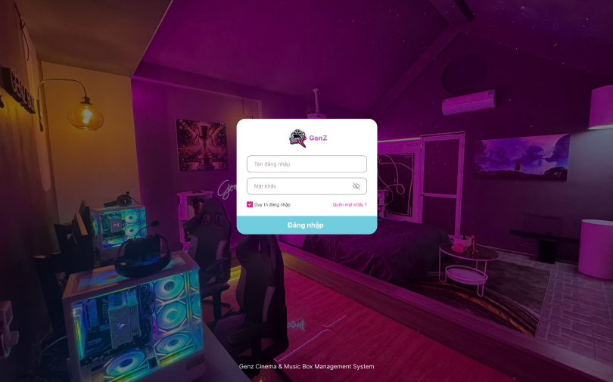
Figure 3.30. Login Screen
Field Name | Description
Username | A required text field for entering the username of an existing account. The field is initially blank and displays the placeholder “Tên đăng nhập”.
Password | A required password field for entering the account password. The field is initially blank and displays the placeholder “Mật khẩu”, with entered characters hidden by default.
Show/Hide Password | Toggles the visibility of the password.
Remember Me | A checkbox that allows the user to maintain their login session according to the system’s session policy. It is selected by default.

1.2 Forgot / Reset Password

1.2.1 Forgot Password Screen
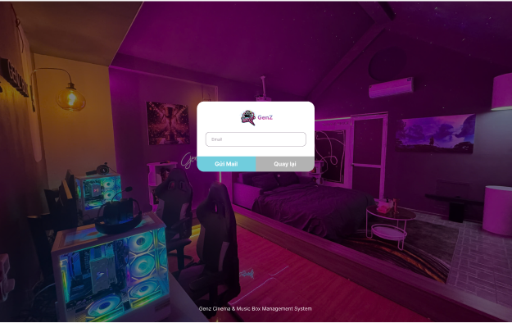
Figure 3.31. Forgot Password Screen
Field Name | Description
Email | A required text field for entering the email address registered with the account. The field is initially blank and displays the placeholder “Email”, and the entered value must follow a valid email format.
Actions
Send Email | Sends a verification code to the registered email address and opens the Reset Password screen when the request is accepted.
Back | Returns the user to the Login screen.

1.2.1 Reset Password Screen
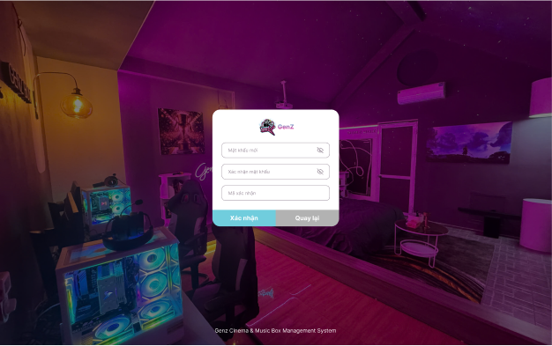
Figure 3.32. Reset Password Screen
Field Name | Description
New Password | A required password field that is initially blank and hides entered characters. The new password must meet the system’s password rules.
Show/Hide Password | Toggles the visibility of the password.
Confirm Password | A required password field that is initially blank. Its value must match the New Password field.
Verification Code | A required text field for entering the valid verification code sent to the registered email address. It is initially blank.
Actions
Confirm | Validates the verification code and password fields, then updates the password and displays a success message.
Back | Returns to the Forgot Password screen.

2. Booking and Room Operations

2.1 Receptionist Overview

2.1.1 Receptionist Overview Screen
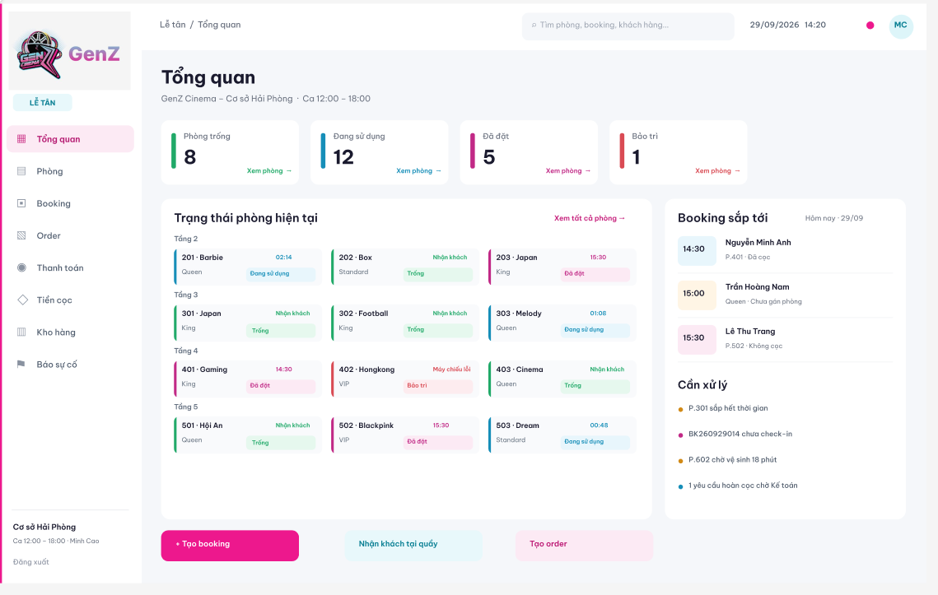

Field Name | Description
General Information
Branch and Shift | Read-only information showing the Receptionist’s assigned branch and current shift.
Current Date and Time | Read-only system date and time displayed in the page header.
Global Search | A text field for searching rooms, bookings, or customers. Initially blank, with the placeholder “Tìm phòng, booking, khách hàng...”.
Navigation Menu | Provides links to Overview, Rooms, Booking, Orders, Payment, Deposits, Inventory, and Incident Reporting. Overview is selected on this screen.
Room Summary
Available Rooms | A read-only non-negative integer showing the number of available rooms at the current branch. “Xem phòng” opens the corresponding room list.
Occupied Rooms | A read-only non-negative integer showing the number of rooms currently in use. “Xem phòng” opens the corresponding room list.
Reserved Rooms | A read-only non-negative integer showing the number of reserved rooms. “Xem phòng” opens the corresponding room list.
Rooms under Maintenance | A read-only non-negative integer showing the number of rooms under maintenance. “Xem phòng” opens the corresponding room list.
Current Room Status | Displays room cards grouped by floor. Each card shows the room code, name, room type, and status: Available, Occupied, Reserved, or Maintenance.
Room Status Details | Displays status-dependent information, such as elapsed usage time, scheduled arrival time, readiness to receive guests, or a reported equipment issue.
Upcoming Bookings and Alerts
Upcoming Bookings | A read-only list of upcoming bookings for the displayed date, including arrival time, customer name, assigned room or room type, and deposit or room-assignment information.
Items Requiring Attention | Displays operational reminders, including stays approaching their end time, bookings awaiting check-in, rooms awaiting cleaning, and deposit refund requests awaiting Accountant action.
Actions
View All Rooms | Opens the Rooms screen to view the branch room map and room details.
Create Booking | Opens the Create Booking screen to record an advance reservation.
Receive Walk-in Guest | Opens the walk-in reception screen to create a booking and check in a guest at the counter.
Create Order | Opens the F&B order creation flow.
Log Out | Ends the current user session and returns to the Login screen.

2.2 Room Management

2.2.1 Room Management Screen
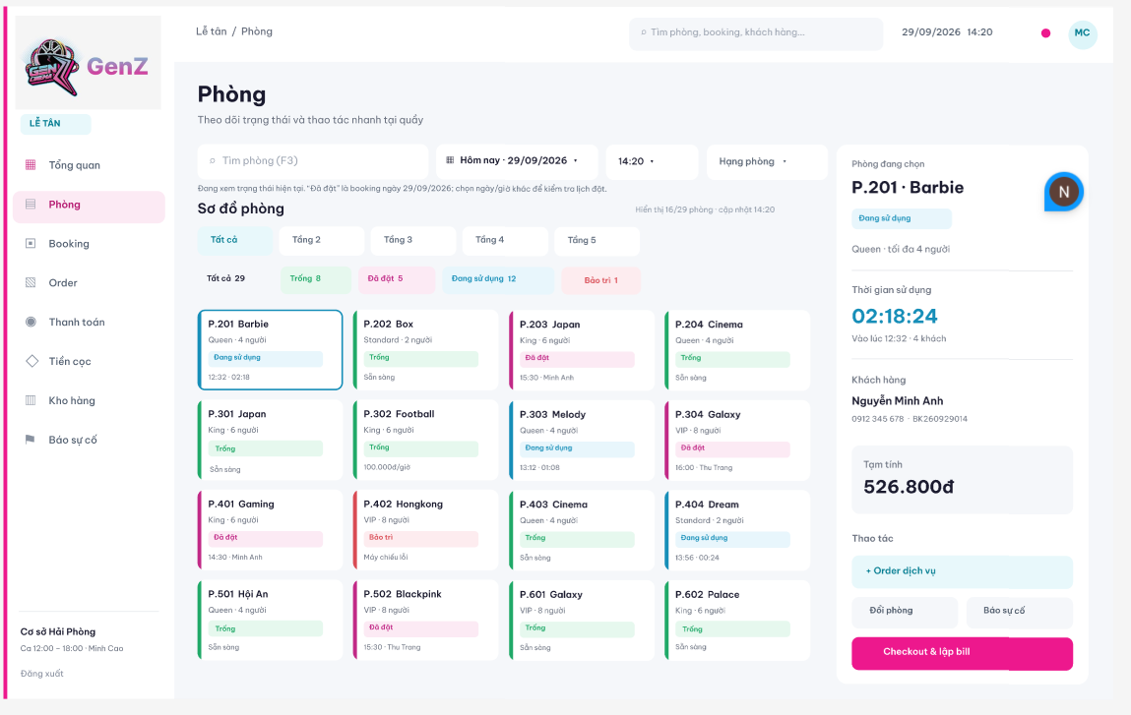

Field Name | Description
Search and Filters
Room Search | A text field for finding a room. Initially blank, with the placeholder “Tìm phòng (F3)”.
Date | A date selector displayed in dd/MM/yyyy format. The initial selection is today; another date can be selected to inspect room reservations.
Time | A time selector displayed in HH:mm format for checking room availability at the selected time.
Room Type | A selection control for filtering rooms by room type.
Floor | Tabs for displaying all floors or a specific floor. “Tất cả” is initially selected.
Room Status | Filters for All, Available, Reserved, Occupied, and Maintenance. Each filter displays the corresponding room count.
Room Map
Result Count and Update Time | Read-only text showing the number of displayed rooms, total rooms, and the last update time.
Room Card | Displays the room code, name, room type, capacity, and status. Additional information depends on the status, such as check-in time, elapsed usage time, scheduled customer arrival, hourly price, or equipment issue.
Selected Room | Selecting a room card highlights it and loads its details in the panel on the right.
Selected Room Details
Room Information | Read-only room code, name, status, room type, and maximum guest capacity.
Usage Duration | A read-only duration in HH:mm:ss for the active stay, with its actual check-in time and guest count.
Customer Information | Read-only customer name, phone number, and booking code associated with the active stay.
Estimated Amount | A read-only provisional charge displayed in VND. The amount is an estimate before checkout.
Actions
Order Service | Opens the F&B order flow for the selected occupied room.
Change Room | Opens the room-change flow for the active stay in the selected room.
Report Incident | Opens incident reporting for the selected room.
Checkout and Create Bill | Opens checkout and billing for the active stay in the selected occupied room.

2.3 Walk-in Guest Reception

2.3.1 Walk-in Guest Reception Screen
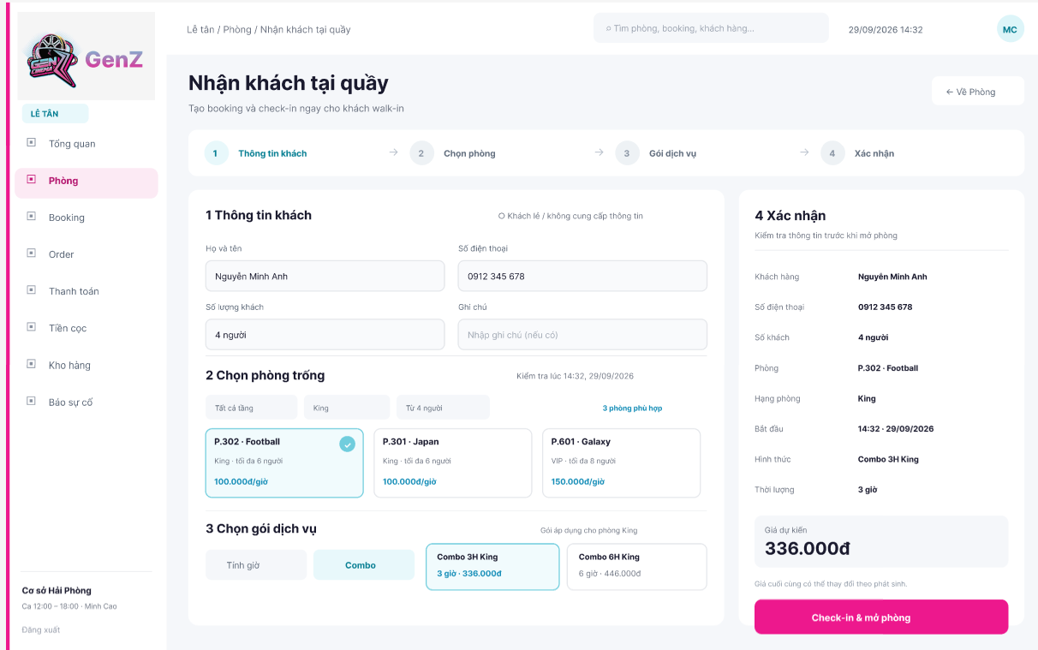
Field Name | Description
Customer Information
Walk-in / No Customer Information | A selection option for receiving a walk-in guest who does not provide personal information.
Customer Name | A text field for entering the guest’s name when customer information is provided.
Phone Number | A text field for entering the guest’s phone number. It preserves leading zeroes.
Number of Guests | A positive integer representing the party size. The selected room must accommodate this number of guests.
Notes | An optional text field for additional reception requirements, with the placeholder “Nhập ghi chú (nếu có)”.
Available Room Selection
Floor Filter | A selection control for filtering available rooms by floor; the displayed initial option is all floors.
Room Type Filter | A selection control for filtering available rooms by room type.
Capacity Filter | A selection control for filtering rooms by guest capacity.
Availability Check | Read-only information showing the availability-check time and date and the number of matching rooms.
Available Room | A selectable room card showing the room code, name, room type, maximum capacity, and hourly rate in VND. The selected card is highlighted.
Service Package
Pricing Mode | A choice between hourly pricing and a combo package. Combo is selected in the illustrated state.
Combo Package | A selectable package showing its name, duration, and price in VND. Available packages apply to the selected room type.
Confirmation Summary
Customer and Guest Count | Read-only summary of the entered customer name, phone number, and number of guests.
Room and Room Type | Read-only summary of the selected room and its type.
Start Time | Read-only proposed start date and time, displayed in HH:mm - dd/MM/yyyy format.
Pricing and Duration | Read-only summary of the selected pricing mode or package and its duration.
Estimated Price | A read-only estimated room charge in VND. The final total may change when additional charges are incurred.
Actions
Check In and Open Room | Validates the entered information and room availability, creates the walk-in booking, and starts the stay. On success, the booking is checked in and the room becomes occupied.
Back to Rooms | Returns to the Rooms screen without submitting the walk-in reception form.

2.4 Booking Management

2.4.1 Booking Management Screen
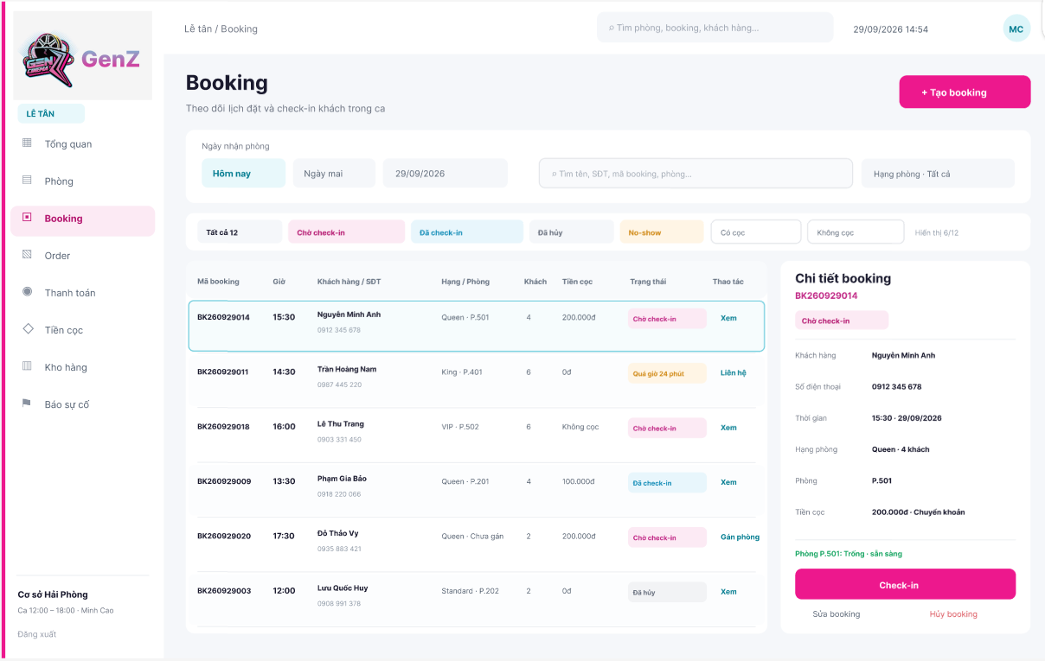
Field Name | Description
Search and Filters
Arrival Date | A date filter with Today and Tomorrow shortcuts and a date selector in dd/MM/yyyy format. Today is selected in the illustrated state.
Booking Search | A text field for searching by customer name, phone number, booking code, or room. Initially blank.
Room Type | A selection control for filtering bookings by room type; the displayed initial option is all room types.
Booking Status | Filters for All, Awaiting Check-in, Checked-in, Cancelled, and No-show.
Deposit Filter | Options for filtering bookings with a deposit or without a deposit.
Result Count | Read-only text showing the displayed booking count and total matching bookings.
Booking List
Booking Code | The read-only unique identifier of each booking.
Arrival Time | The scheduled check-in time displayed in HH:mm format.
Customer / Phone Number | The customer’s recorded name and phone number.
Room Type / Room | The requested room type and assigned room code, or an indication that no room has been assigned.
Guest Count | The recorded number of guests, displayed as a positive integer.
Deposit | The recorded deposit amount in VND or an indication that no deposit has been recorded.
Status | The booking’s current status. An overdue arrival can display the elapsed delay in minutes.
Row Actions | “Xem” displays booking details; “Liên hệ” supports follow-up for an overdue arrival; “Gán phòng” opens room assignment for an unassigned booking.
Booking Details
Selected Booking | Read-only booking code and status for the selected row.
Customer Details | Read-only customer name and phone number.
Scheduled Arrival | Read-only arrival date and time in HH:mm - dd/MM/yyyy format.
Room and Guests | Read-only room type, guest count, and assigned room.
Deposit Details | Read-only deposit amount and recorded payment method.
Room Readiness | Read-only availability and readiness information for the assigned room, used before check-in.
Actions
Create Booking | Open the Create Booking screen.
Check In | Opens the check-in panel for the selected booking. Check-in requires an eligible booking and a room that is ready to receive guests.
Edit Booking | Opens the editing flow for the selected booking.
Cancel Booking | Opens the cancellation flow for the selected booking, including applicable deposit handling.

2.5 Create Booking

2.5.1 Create Booking Screen
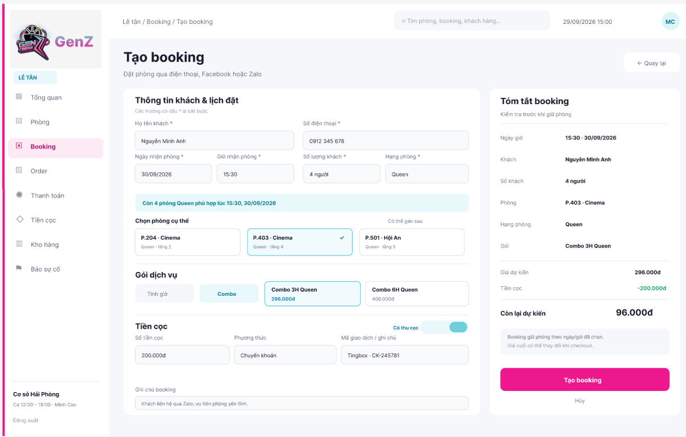
Field Name | Description
Customer and Reservation Information
Customer Name | A required text field for entering the customer’s full name. Marked with an asterisk.
Phone Number | A required text field for entering the customer’s contact number. Leading zeroes are preserved. Marked with an asterisk.
Arrival Date | A required date field in dd/MM/yyyy format for the planned arrival date. Marked with an asterisk.
Arrival Time | A required time field in HH:mm format for the planned arrival time. Marked with an asterisk.
Number of Guests | A required positive integer representing the party size. Marked with an asterisk.
Room Type | A required selection field for the requested room type. Marked with an asterisk.
Availability Message | Read-only information showing the number of suitable rooms for the selected room type and arrival date and time.
Specific Room | An optional room selection. Cards show the room code, name, type, and floor. The selected card is highlighted; a room may be assigned later.
Service Package
Pricing Mode | A choice between hourly pricing and a combo package. Combo is selected in the illustrated state.
Combo Package | A selectable service package showing its name and price in VND, applicable to the selected room type.
Deposit Information
Collect Deposit | A toggle indicating whether a deposit is being recorded. It is enabled in the illustrated state.
Deposit Amount | A monetary input in VND used when collecting a deposit. The amount must be greater than zero when a deposit is recorded.
Payment Method | A selection field specifying how the deposit is received. Bank transfer is displayed in the illustrated state.
Transaction Reference / Notes | A text field for the payment transaction reference or deposit-related notes. A typed reference alone does not confirm receipt of a bank transfer.
Booking Notes | An optional text field for reservation details or customer preferences.
Booking Summary
Arrival Date and Time | Read-only summary of the scheduled arrival, displayed in HH:mm - dd/MM/yyyy format.
Customer and Guests | Read-only summary of the customer name and number of guests.
Room and Package | Read-only summary of the selected room, room type, and service package; the room may remain unassigned.
Estimated Price | The estimated booking charge displayed in VND.
Deposit Deduction | The deposit amount shown as a deduction in the estimated payment summary. Payment confirmation is required before the deposit is treated as received.
Estimated Remaining Amount | The estimated charge less the deposit shown in the summary, displayed in VND. The final amount is determined at checkout.
Actions
Create Booking | Validates required information and room availability for the booking period, then saves the reservation. Any deposit is recorded with its actual payment-confirmation status.
Back / Cancel | Returns to the booking list without submitting the form.

2.6 Booking Check-in

2.6.1 Booking Check-in Screen
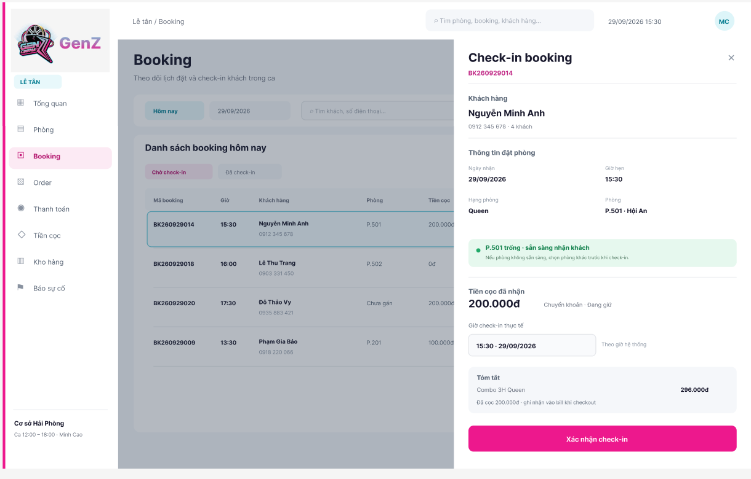
Field Name | Description
Booking and Customer Information
Booking Code | A read-only identifier of the booking selected from the booking list.
Customer Name | The customer’s recorded name, displayed as read-only text.
Phone Number and Guest Count | Read-only customer phone number and number of guests associated with the booking.
Reservation Information
Arrival Date | The scheduled arrival date displayed as read-only text in dd/MM/yyyy format.
Scheduled Arrival Time | The scheduled arrival time displayed as read-only text in HH:mm format.
Room Type | The booked room type, displayed as read-only text.
Assigned Room | The assigned room code and name, displayed as read-only text.
Room Readiness | A read-only status message confirming whether the assigned room is available and ready to receive guests. If it is not ready, another suitable room must be assigned before check-in.
Deposit and Stay Information
Deposit Received | The confirmed deposit amount displayed as read-only currency in VND.
Deposit Method and Status | Read-only information showing the recorded payment method and the deposit’s current holding status.
Actual Check-in Time | A system-generated date and time in HH:mm - dd/MM/yyyy format. The value is supplied by the system when the stay begins.
Package Summary | Read-only information showing the booked service package and its price in VND.
Deposit Application Note | Read-only text indicating that the received deposit will be applied to the bill at checkout.
Actions
Confirm Check-in | Rechecks the booking’s eligibility and room readiness, records the actual check-in time, marks the booking as checked in, and changes the room status to occupied. The existing deposit is retained for application at checkout.
Close | Closes the check-in panel and returns to the booking list without confirming check-in.

2.7 Room Stay Details

2.7.1 Room Stay Details Screen
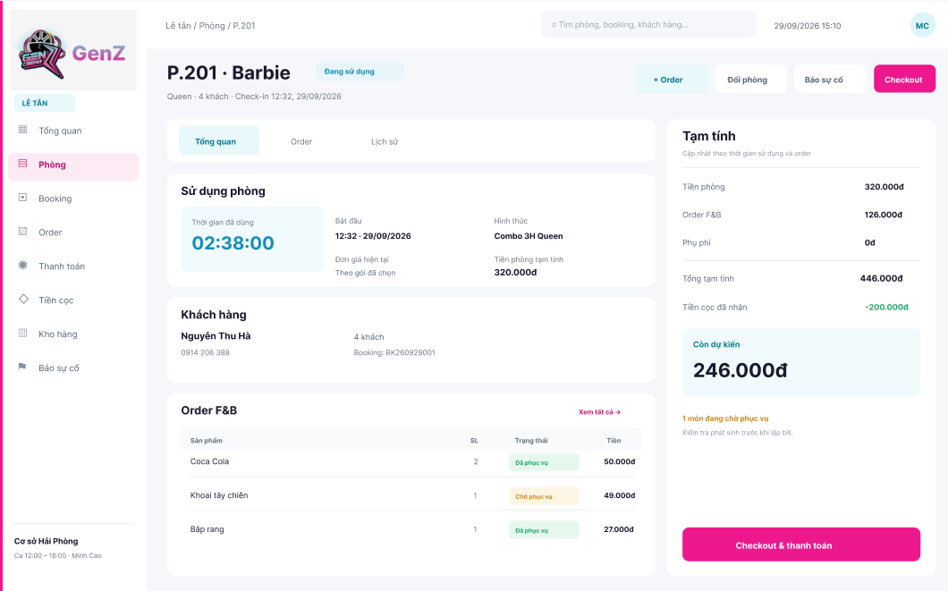

Field Name | Description
General Information
Breadcrumb | Read-only navigation path of the current screen, for example "Lễ tân / Phòng / P.201".
Room Header | Read-only room code and name, the room status badge ("Đang sử dụng"), room type, number of guests, and the actual check-in time of the active stay.
Detail Tabs | Tabs for switching between "Tổng quan", "Order", and "Lịch sử". "Tổng quan" is selected in the illustrated state.
Room Usage
Elapsed Usage Time | A read-only duration in HH:mm:ss counted from the actual check-in time.
Start Time | Read-only actual start date and time of the stay, displayed in HH:mm · dd/MM/yyyy format.
Pricing Mode | Read-only pricing form selected for the stay, such as the combo package name.
Current Unit Price | Read-only note on the price basis applied to the stay, for example "Theo gói đã chọn".
Estimated Room Charge | A read-only provisional room charge displayed in VND.
Customer
Customer Name | Read-only name of the customer associated with the active stay.
Phone Number and Guest Count | Read-only customer phone number and number of guests.
Booking Code | Read-only code of the booking associated with the active stay.
F&B Orders
Order List | A read-only list of F&B items ordered for the stay. Each row shows the product name, quantity, service status ("Đã phục vụ" or "Chờ phục vụ"), and amount in VND.
View All | Opens the full F&B order list of the stay ("Order" tab).
Pending Order Warning | A read-only message showing the number of items still awaiting service, with a reminder to check them before the bill is created.
Provisional Bill
Room Charge | Read-only provisional room charge in VND.
F&B Charge | Read-only total of F&B orders recorded for the stay, in VND.
Surcharge | Read-only total of additional charges recorded for the stay, in VND.
Provisional Total | Read-only sum of the room charge, F&B charge, and surcharge. The amount is updated according to usage time and orders and is an estimate before checkout.
Deposit Received | Read-only confirmed deposit of the booking, displayed as a deduction in VND.
Estimated Remaining Amount | Read-only provisional total less the deposit, displayed in VND. The final amount is determined at checkout.
Actions
+ Order | Opens the F&B order screen for this room.
Change Room | Opens the Change Room dialog for the active stay.
Report Incident | Opens incident reporting for this room.
Checkout | Opens the Checkout screen for the active stay. The "Checkout & thanh toán" button in the bill panel performs the same action.

2.8 F&B Order

2.8.1 F&B Order Screen
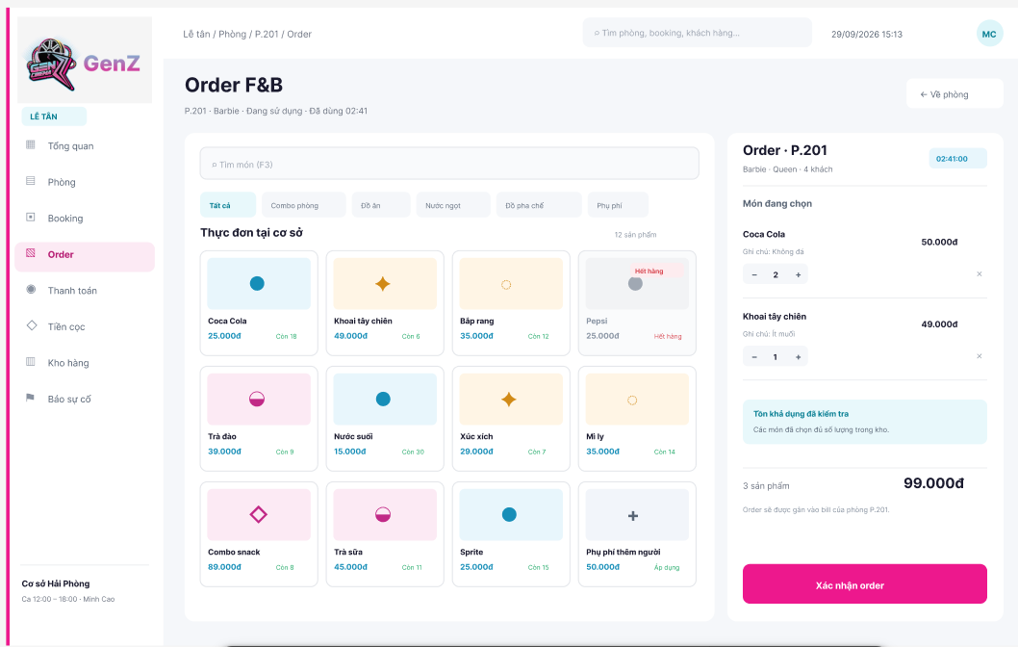
Field Name | Description
General Information
Page Header | Read-only title "Order F&B" with the room code, room name, room status, and elapsed usage time of the active stay.
Back to Room | Returns to the Room Stay Details screen without confirming the order.
Menu Search and Categories
Item Search | A text field for finding a menu item. Initially blank, with the placeholder "Tìm món (F3)".
Category Tabs | Tabs for filtering the menu by category: Tất cả, Combo phòng, Đồ ăn, Nước ngọt, Đồ pha chế, and Phụ phí. "Tất cả" is initially selected.
Menu Title and Count | Read-only title "Thực đơn tại cơ sở" with the number of products displayed.
Menu Items
Field Name | Description
Menu Item Card | A selectable card showing the product name, unit price in VND, and remaining stock quantity. Selecting a card adds the item to the current order.
Out-of-stock Item | A card displayed in a disabled style with the label "Hết hàng". It cannot be added to the order.
Surcharge Item | A chargeable item that is not tracked by stock, such as "Phụ phí thêm người". The card shows the indicator "Áp dụng" instead of a stock quantity.
Current Order
Order Header | Read-only order title with the room code, room name, room type, number of guests, and elapsed usage time.
Selected Item | A line for each selected item showing the product name and line amount in VND.
Quantity | A control for increasing or decreasing the quantity of a selected item. The quantity must be a positive integer and must not exceed the available stock.
Item Note | An optional text note for the selected item, for example a customer preference.
Remove Item | Removes the selected item from the current order.
Stock Check Message | A read-only message confirming that the selected quantities are available in stock, or indicating which items are not.
Order Summary | Read-only number of selected items and the order total in VND, with a note that the order is attached to the bill of the room.
Actions
Confirm Order | Validates the selected items and their stock availability, records the order against the active stay of the room, and adds the charges to the room's bill.

2.9 Change Room

2.9.1 Change Room Dialog
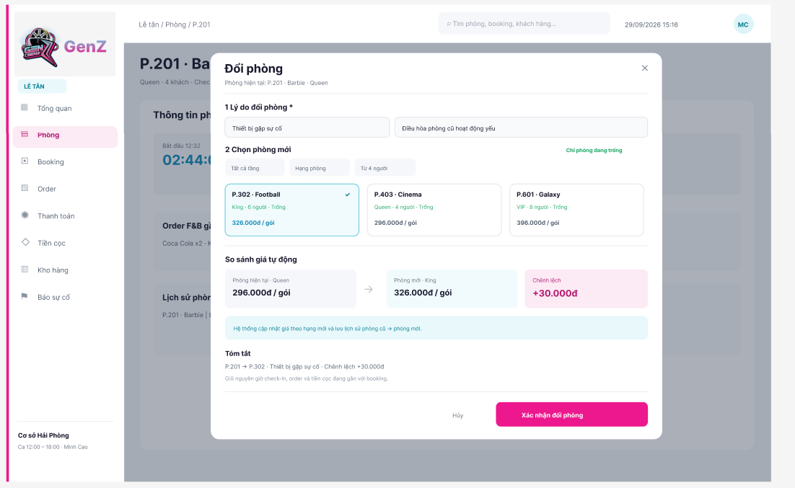
Field Name | Description
General Information
Dialog Header | Read-only title "Đổi phòng" with the current room code, name, and room type. The close button (×) closes the dialog without changing the room.
Change Reason
Reason Type | A required selection field for the reason for changing rooms, for example "Thiết bị gặp sự cố". Marked with an asterisk.
Reason Details | A text field for describing the reason in more detail, for example the equipment problem found in the current room.
New Room Selection
Floor Filter | A selection control for filtering replacement rooms by floor; the displayed initial option is all floors.
Room Type Filter | A selection control for filtering replacement rooms by room type.
Field Name | Description
Capacity Filter | A selection control for filtering replacement rooms by minimum guest capacity. The initial value corresponds to the number of guests of the active stay.
Availability Notice | A read-only label indicating that only available rooms are listed.
Available Room Card | A selectable card showing the room code, name, room type, maximum capacity, availability status, and package price in VND. The selected card is highlighted with a check mark.
Automatic Price Comparison
Current Room Price | Read-only package price of the current room type, in VND.
New Room Price | Read-only package price of the selected room type, in VND.
Price Difference | Read-only difference between the new and current package prices, in VND.
Price Update Note | Read-only note that the system updates the price according to the new room type and keeps the history of the change from the old room to the new room.
Summary
Change Summary | Read-only summary of the old room, the new room, the reason, and the price difference.
Retained Information | Read-only note that the original check-in time, existing orders, and the deposit attached to the booking are kept.
Actions
Cancel | Closes the dialog without changing the room.
Confirm Room Change | Validates the reason and the availability of the selected room, moves the active stay to the new room, and records the room change and any applicable price difference.

2.10 Checkout

2.10.1 Checkout Screen
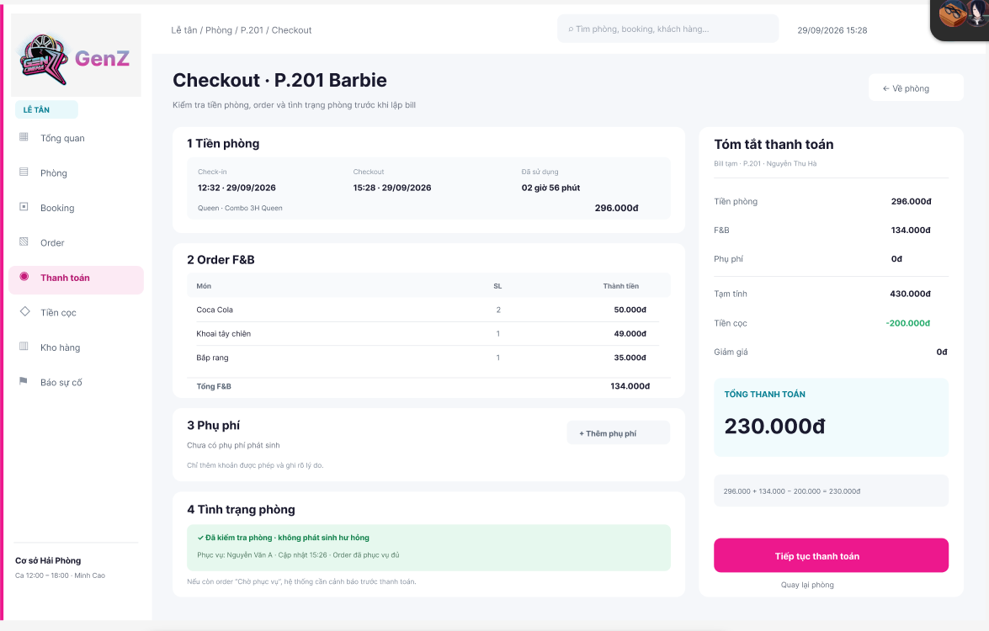
Field Name | Description
General Information
Page Header | Read-only title "Checkout" with the room code and name, and the instruction to check the room charge, orders, and room condition before the bill is created.
Back to Room | Returns to the Room Stay Details screen without creating the bill.
Room Charge
Check-in Time | Read-only actual check-in date and time of the stay, displayed in HH:mm · dd/MM/yyyy format.
Checkout Time | Read-only checkout date and time supplied by the system when the checkout is started.
Duration Used | Read-only total usage time of the stay.
Room Type and Package | Read-only room type and service package applied to the stay.
Room Charge | Read-only room charge in VND calculated from the package and the usage time.
F&B Orders
Field Name | Description
Order Item | Read-only rows listing each ordered item with its name, quantity, and amount in VND.
Total F&B | Read-only total of all F&B items of the stay, in VND.
Surcharges
Surcharge List | A list of additional charges added to the bill. When no surcharge exists, the message "Chưa có phụ phí phát sinh" is displayed.
Add Surcharge | Opens the flow for adding a surcharge. Only permitted charge types can be added, and the reason must be recorded.
Room Condition
Room Inspection Status | A read-only message showing whether the room has been checked after use and whether damage was found, with the name of the service staff member and the update time.
Pending Order Warning | If any F&B order is still "Chờ phục vụ", the system warns the Receptionist before payment can proceed.
Payment Summary
Bill Reference | Read-only temporary bill reference with the room code and customer name.
Room Charge | Read-only room charge in VND.
F&B | Read-only total F&B charge in VND.
Surcharge | Read-only total surcharge in VND.
Subtotal | Read-only sum of the room charge, F&B charge, and surcharge, in VND.
Deposit | Read-only confirmed deposit applied to the bill, displayed as a deduction in VND.
Discount | Read-only discount applied to the bill, in VND.
Total Payable | Read-only final amount the customer must pay, in VND.
Calculation Formula | Read-only line showing how the total payable was calculated from the charges and the deposit.
Actions
Continue to Payment | Validates the bill and opens the Payment screen for the amount due.
Back to Room | Returns to the Room Stay Details screen without creating the bill.

2.11 Payment

2.11.1 Payment Screen - Bank Transfer
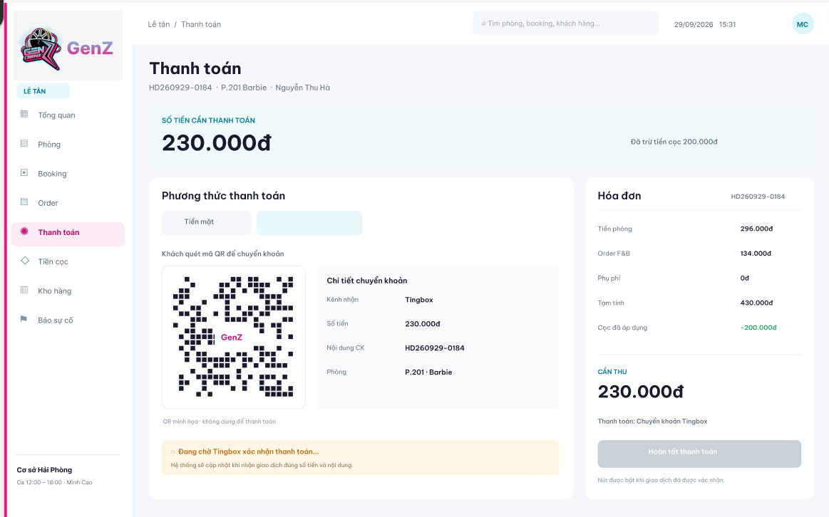
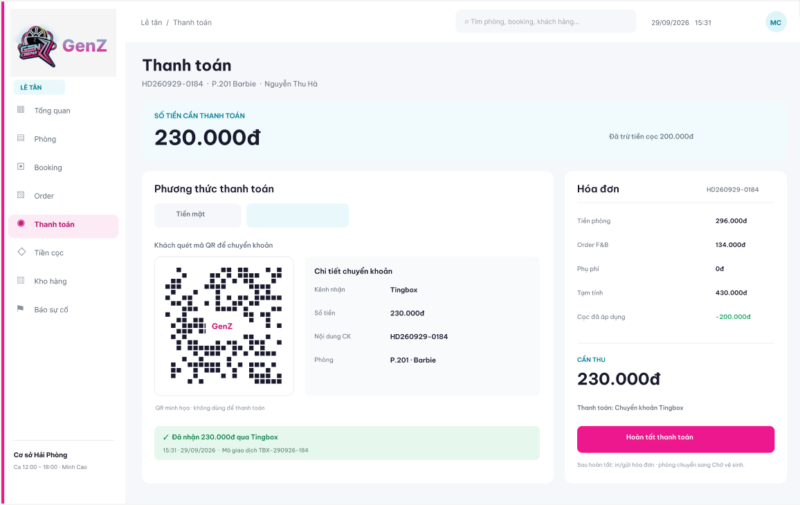

Field Name | Description
Bill Information
Page Header | Read-only title "Thanh toán" with the bill code, room code and name, and customer name.
Amount Due | A read-only amount in VND that the customer must still pay, after the deposit is deducted.
Deposit Deducted Note | Read-only note showing the deposit amount that has already been deducted from the bill.
Payment Method
Payment Method Selector | Tabs for choosing the payment method: "Tiền mặt", bank transfer, and "Kết hợp". Bank transfer is selected in the illustrated state.
Bank Transfer
Transfer QR Code | A QR code generated for the bill that the customer scans to make the transfer. The QR code in the mock-up is for illustration only.
Receiving Channel | Read-only name of the payment channel that receives the transfer.
Transfer Amount | Read-only amount in VND that the customer must transfer.
Transfer Content | Read-only payment reference that the customer must enter in the transfer, which is the bill code.
Room | Read-only room code and name associated with the bill.
Payment Confirmation Status | A read-only status message. While the payment is not confirmed, it shows "Đang chờ ... xác nhận thanh toán" and states that the system updates it when a transaction with the correct amount and content is received. After confirmation, it shows the received amount, the confirmation time, and the transaction code.
Invoice Summary
Invoice Code | Read-only code of the invoice.
Room Charge, F&B, Surcharge | Read-only room charge, F&B total, and surcharge total of the invoice, in VND.
Subtotal | Read-only sum of the room charge, F&B, and surcharge, in VND.
Deposit Applied | Read-only deposit amount applied to the invoice, displayed as a deduction in VND.
Field Name | Description
Amount to Collect | Read-only amount in VND that must be collected.
Payment Method Summary | Read-only text showing the selected payment method.
Actions
Complete Payment | Disabled until the bank transfer is confirmed. When enabled, it completes the bill, records the payment, prints or sends the invoice, and changes the room status to awaiting cleaning ("Chờ vệ sinh").

2.11.2 Payment Screen - Cash
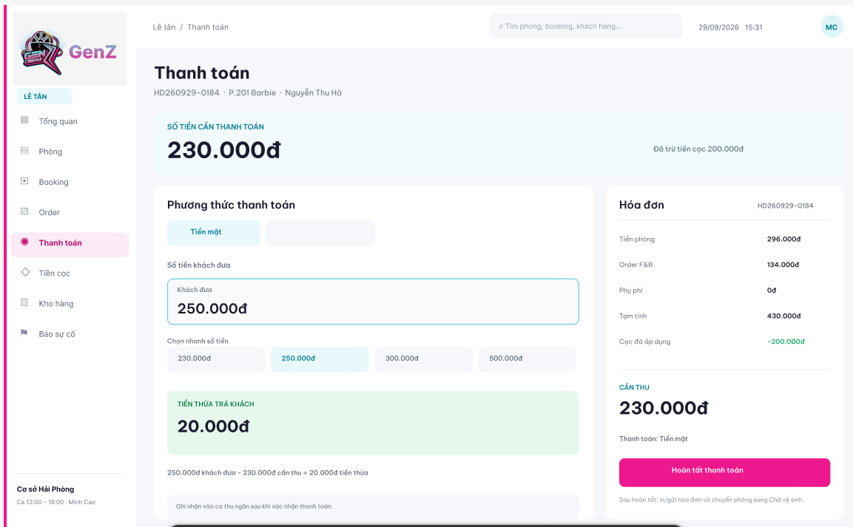
Field Name | Description
Common Information
Bill Information and Invoice Summary | Same as in the Payment Screen - Bank Transfer (2.11.1).
Cash Payment
Field Name | Description
Cash Received | A required monetary input in VND for the amount handed over by the customer. The amount must be greater than or equal to the amount due.
Quick Amount Selection | Shortcut buttons for common cash amounts. The first shortcut equals the exact amount due. Selecting a shortcut fills the Cash Received field.
Change Due | A read-only amount in VND to be returned to the customer, calculated as the cash received less the amount due.
Change Calculation | Read-only line showing the cash received, the amount due, and the resulting change.
Cashier Shift Note | Read-only note that the payment is recorded in the cashier's shift after the payment is confirmed.
Actions
Complete Payment | Enabled when the cash received covers the amount due. Completes the bill, records the cash payment, prints or sends the invoice, and changes the room status to awaiting cleaning ("Chờ vệ sinh").

2.11.3 Payment Screen - Combined Cash and Bank Transfer
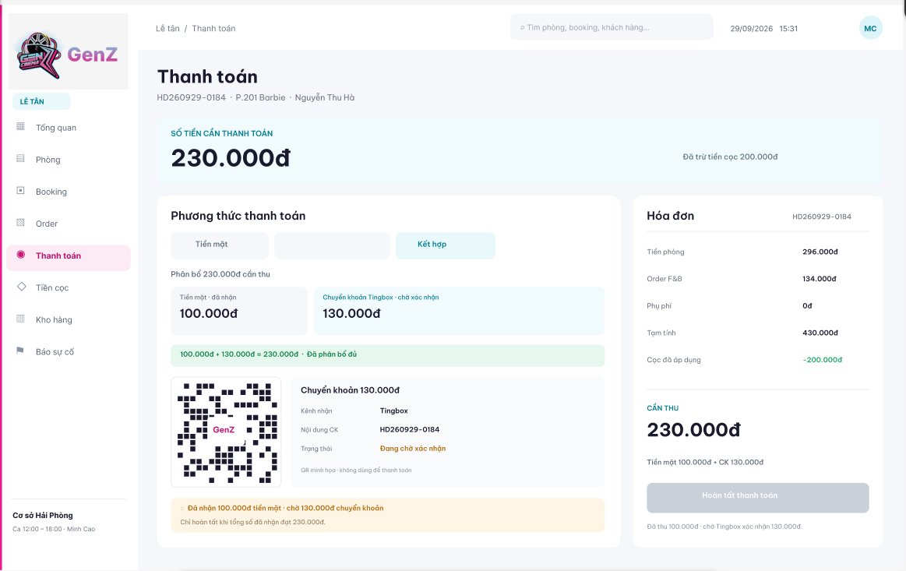
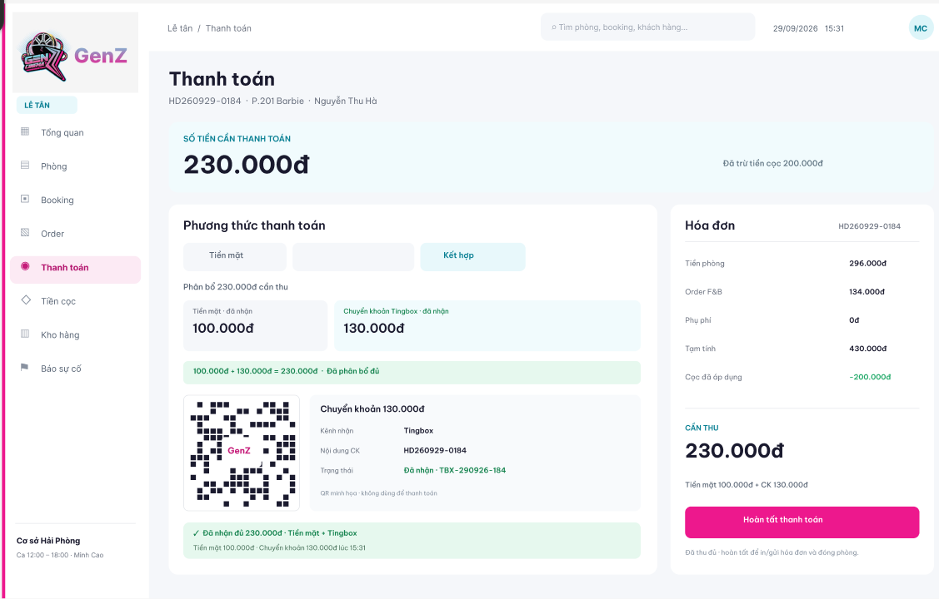
Field Name | Description
Common Information
Bill Information and Invoice Summary | Same as in the Payment Screen - Bank Transfer (2.11.1). "Kết hợp" is selected in the Payment Method Selector.
Payment Allocation
Allocation Header | Read-only text showing the total amount to be collected and allocated between the two payment methods.
Cash Portion | The amount in VND received in cash. It is displayed as received once the cash has been taken.
Bank Transfer Portion | The amount in VND to be paid by bank transfer, with its status "chờ xác nhận" or "đã nhận".
Allocation Check | A read-only message showing that the cash portion plus the bank transfer portion equals the amount due. The two portions must add up to the full amount due.
Bank Transfer for the Transfer Portion
Field Name | Description
Transfer QR Code | A QR code generated for the bank transfer portion only. The QR code in the mock-up is for illustration only.
Receiving Channel, Transfer Content | Read-only receiving channel and payment reference (the bill code) for the transfer.
Transfer Status | Read-only status of the transfer portion. It shows "Đang chờ xác nhận" before confirmation and "Đã nhận" with the transaction code after confirmation.
Payment Status Message
Partial Payment Message | A warning shown while part of the amount is still awaiting confirmation. It states how much has been received in cash and how much is still awaited by transfer, and that the bill can be completed only when the total received equals the amount due.
Full Payment Message | A confirmation shown when the full amount has been received, with the cash amount, the transfer amount, and the time of the transfer.
Actions
Complete Payment | Disabled until the total received (cash and confirmed transfer) equals the amount due. When enabled, it completes the bill, records both payments, prints or sends the invoice, and changes the room status to awaiting cleaning ("Chờ vệ sinh").

2.12 Cancel Booking

2.12.1 Cancel Booking Dialog - Refundable Deposit
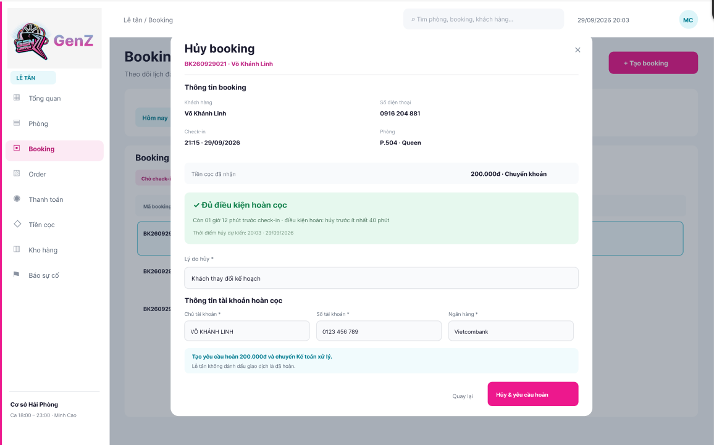

Field Name | Description
Booking Information
Dialog Header | Read-only title "Hủy booking" with the booking code and customer name. The close button (×) closes the dialog without cancelling the booking.
Customer Name and Phone Number | Read-only name and phone number of the customer.
Check-in Time | Read-only scheduled check-in time and date, displayed in HH:mm · dd/MM/yyyy format.
Room | Read-only assigned room code and room type.
Deposit Received | Read-only confirmed deposit amount in VND with its payment method.
Refund Eligibility
Refund Eligibility Notice | A read-only message "Đủ điều kiện hoàn cọc" showing the time remaining before check-in and the refund condition: the booking must be cancelled at least 40 minutes before the scheduled check-in time.
Field Name | Description
Expected Cancellation Time | Read-only date and time at which the cancellation is recorded.
Cancellation Information
Cancellation Reason | A required text field for the reason for cancelling the booking. Marked with an asterisk.
Refund Account Information
Account Holder | A required text field for the name of the account holder who receives the refund. Marked with an asterisk.
Account Number | A required text field for the bank account number that receives the refund. Marked with an asterisk.
Bank | A required text field for the bank of the receiving account. Marked with an asterisk.
Refund Request Note | Read-only note that a refund request for the deposit amount is created and sent to the Accountant for processing, and that the Receptionist does not mark the transaction as refunded.
Actions
Back | Closes the dialog and returns to the booking list without cancelling the booking.
Cancel and Request Refund | Validates the required information, cancels the booking, releases the room, and creates a deposit refund request for the Accountant.

2.12.2 Cancel Booking Dialog - Forfeited Deposit
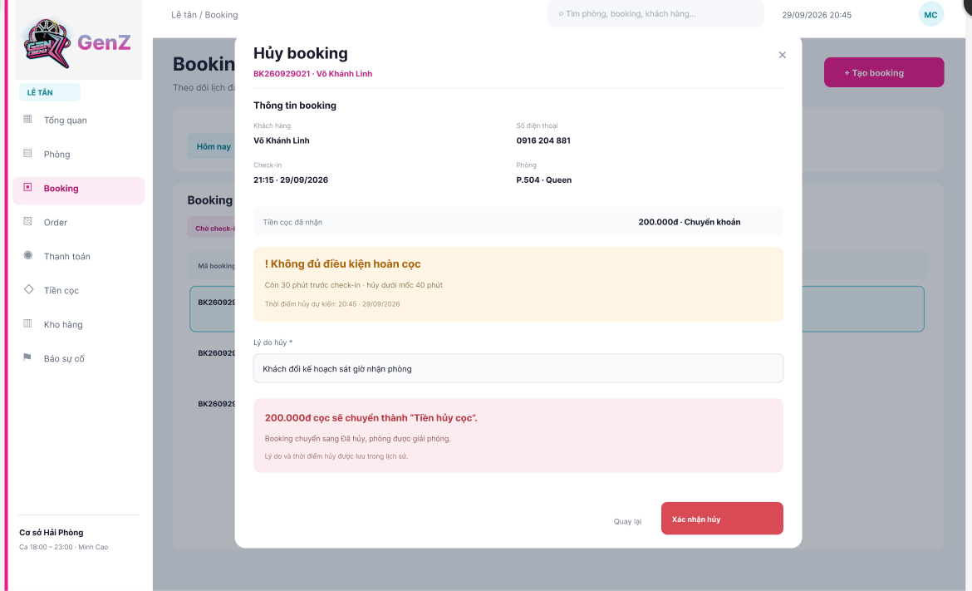
Field Name | Description
Booking Information
Dialog Header, Customer, Check-in Time, Room, Deposit Received | Same as in the Cancel Booking Dialog - Refundable Deposit (2.12.1).
Refund Eligibility
Refund Eligibility Notice | A read-only warning "Không đủ điều kiện hoàn cọc" showing the time remaining before check-in, which is below the 40-minute threshold.
Expected Cancellation Time | Read-only date and time at which the cancellation is recorded.
Cancellation Information
Cancellation Reason | A required text field for the reason for cancelling the booking. Marked with an asterisk.
Field Name | Description
Forfeiture Notice | A read-only message stating that the deposit amount is recorded as a forfeited deposit ("Tiền hủy cọc"), the booking is changed to cancelled ("Đã hủy"), the room is released, and the reason and time of cancellation are saved in the history.
Actions
Back | Closes the dialog and returns to the booking list without cancelling the booking.
Confirm Cancellation | Validates the required information, cancels the booking, releases the room, and records the deposit as forfeited. No refund request is created.

2.13 Deposit Management

2.13.1 Deposit Management Screen
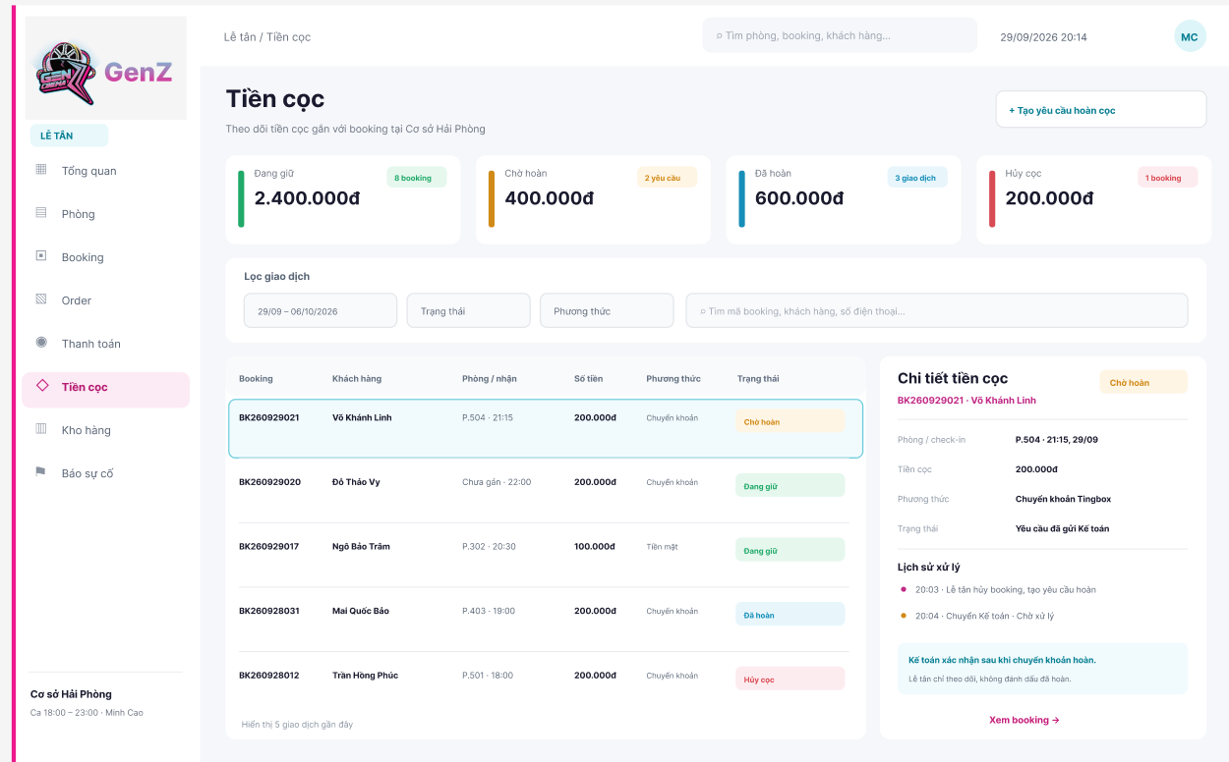

Field Name | Description
General Information
Page Header | Read-only title "Tiền cọc" with a description that deposits linked to bookings at the current branch are tracked on this screen.
Deposit Summary
Holding | Read-only total amount in VND of deposits currently held, with the number of bookings.
Pending Refund | Read-only total amount in VND of refund requests awaiting Accountant processing, with the number of requests.
Refunded | Read-only total amount in VND of deposits already refunded, with the number of transactions.
Forfeited | Read-only total amount in VND of deposits recorded as forfeited, with the number of bookings.
Search and Filters
Date Range | A date range selector displayed in dd/MM - dd/MM/yyyy format, used to filter deposit transactions.
Status | A selection control for filtering deposits by status: held, refund pending, refunded, or forfeited.
Payment Method | A selection control for filtering deposits by the method used to receive the deposit.
Deposit Search | A text field for searching by booking code, customer name, or phone number. Initially blank, with the placeholder "Tìm mã booking, khách hàng, số điện thoại...".
Deposit List
Booking | The read-only code of the booking that holds the deposit.
Customer | The recorded customer name.
Room / Arrival | The assigned room code and scheduled arrival time, or an indication that no room has been assigned.
Amount | The deposit amount in VND.
Method | The payment method used to receive the deposit.
Status | The current deposit status: "Đang giữ", "Chờ hoàn", "Đã hoàn", or "Hủy cọc".
Field Name | Description
Selected Row | Selecting a row highlights it and loads its details in the panel on the right.
List Footer | Read-only text showing the number of recent transactions displayed.
Deposit Details
Selected Deposit | Read-only booking code, customer name, and status badge of the selected deposit.
Room / Check-in | Read-only room code and scheduled check-in time and date.
Deposit Amount | Read-only deposit amount in VND.
Payment Method | Read-only method and channel through which the deposit was received.
Processing Status | Read-only current processing status of the deposit, for example that the refund request has been sent to the Accountant.
Processing History | A read-only chronological list of events for the deposit, each with its time and description.
Accountant Note | Read-only note that the Accountant confirms the refund after the transfer is made, and that the Receptionist only tracks the deposit and does not mark it as refunded.
Actions
Create Refund Request | Opens the flow for submitting a deposit refund request for an eligible cancelled booking.
View Booking | Opens the details of the booking associated with the selected deposit.

2.14 Paid Bill Lookup and Adjustment

2.14.1 Paid Bill List Scree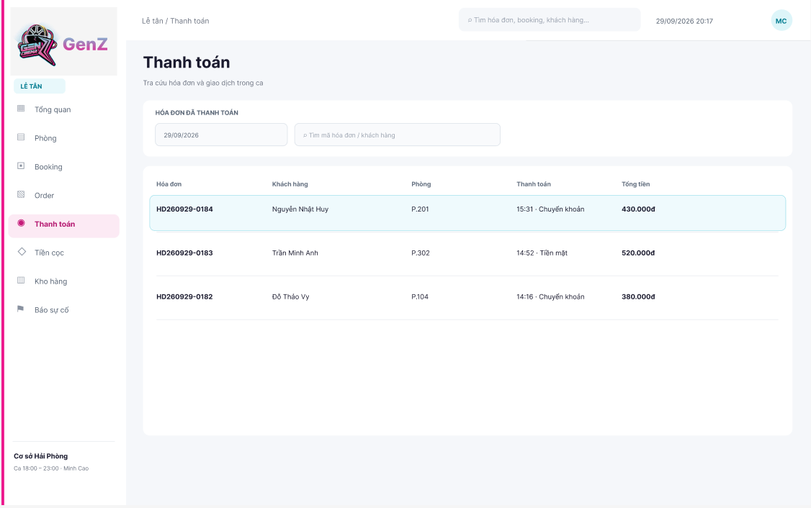
Field Name | Description
Search and Filters
Page Header | Read-only title "Thanh toán" with a description that paid invoices and transactions of the shift can be looked up on this screen.
Payment Date | A date selector displayed in dd/MM/yyyy format. The initial selection is today.
Bill Search | A text field for searching by invoice code or customer name. Initially blank, with the placeholder "Tìm mã hóa đơn / khách hàng".
Paid Bill List
Invoice | The read-only unique code of each paid invoice.
Customer | The recorded customer name.
Room | The room code associated with the invoice.
Payment | The payment time in HH:mm format with the payment method.
Total | The total paid amount of the invoice in VND.
Selected Row | Selecting a row highlights it and opens the Paid Bill Detail panel.

2.14.2 Paid Bill Detail Panel
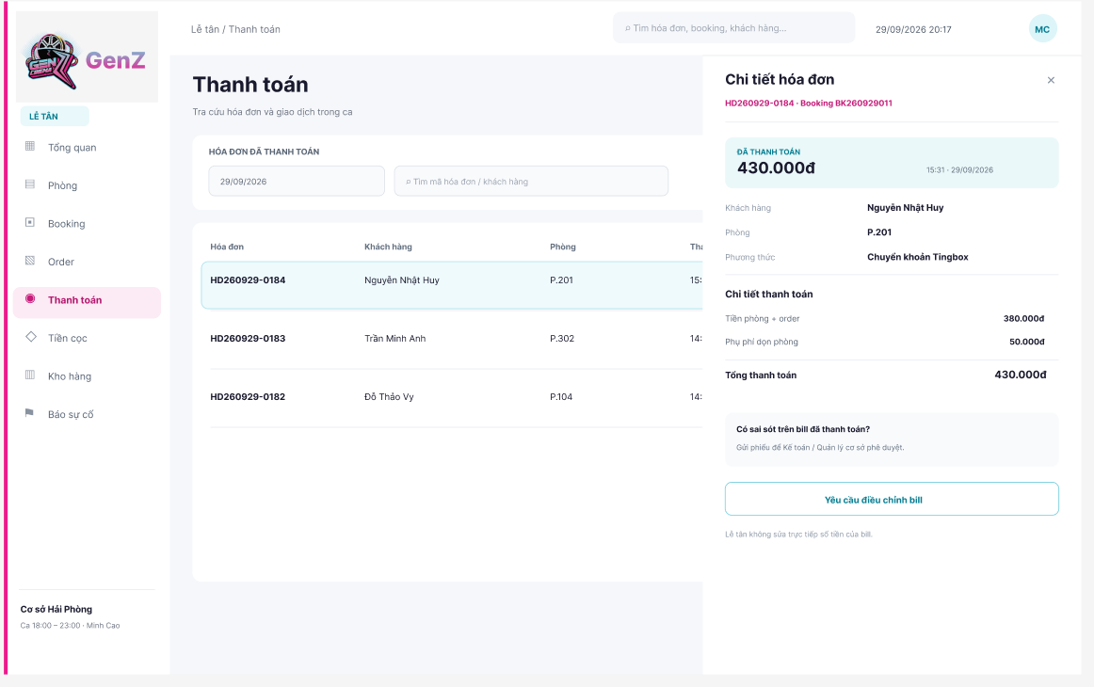
Field Name | Description
Bill Information
Panel Header | Read-only title "Chi tiết hóa đơn" with the invoice code and booking code. The close button (×) closes the panel.
Paid Amount | Read-only total amount paid, in VND, with the payment time and date.
Customer | Read-only customer name.
Room | Read-only room code.
Payment Method | Read-only method and channel used to pay the invoice.
Payment Breakdown
Room Charge and Orders | Read-only combined room and F&B charge of the invoice, in VND.
Surcharge | Read-only surcharge recorded on the invoice, in VND.
Total Paid | Read-only total amount paid, in VND.
Bill Correction
Adjustment Guidance | Read-only text explaining that a request can be sent to the Accountant or Branch Manager for approval if the paid bill contains an error.
Request Bill Adjustment | Opens the Bill Adjustment Request dialog for the selected invoice. The Receptionist cannot edit the amounts of a paid bill directly.

2.14.3 Bill Adjustment Request Dialog
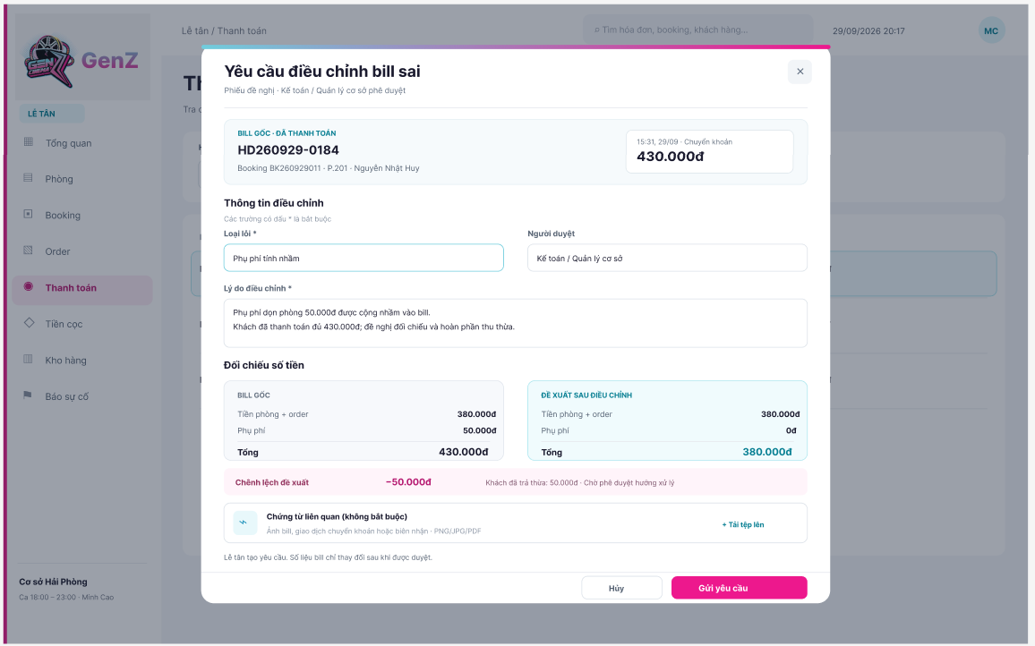
Field Name | Description
Original Bill
Dialog Header | Read-only title "Yêu cầu điều chỉnh bill sai" with a note that the request is approved by the Accountant or Branch Manager. The close button (×) closes the dialog.
Original Bill Information | Read-only invoice code, booking code, room, customer name, payment time, payment method, and paid amount in VND.
Adjustment Information
Error Type | A required selection field for the type of error found on the bill, for example an incorrectly charged surcharge. Marked with an asterisk.
Approver | A selection field for the role that reviews the request: Accountant or Branch Manager.
Field Name | Description
Adjustment Reason | A required multi-line text field explaining the error and the proposed handling. Marked with an asterisk.
Amount Comparison
Original Bill Amounts | Read-only room and order charge, surcharge, and total of the original bill, in VND.
Proposed Amounts After Adjustment | Read-only room and order charge, surcharge, and total proposed after the adjustment, in VND.
Proposed Difference | Read-only difference between the proposed total and the original total, in VND, with a note on how the difference affects the customer and that the handling awaits approval.
Supporting Documents
Upload File | An optional upload control for supporting documents such as a bill image, a bank transfer transaction, or a receipt record. Accepted formats are PNG, JPG, and PDF.
Request Note | Read-only note that the Receptionist creates the request and that the bill amounts change only after the request is approved.
Actions
Cancel | Closes the dialog without submitting the request.
Submit Request | Validates the required information and sends the adjustment request to the selected approver. The original bill remains unchanged until the request is approved.

2.15 Incident Reporting

2.15.1 Incident Progress List Screen
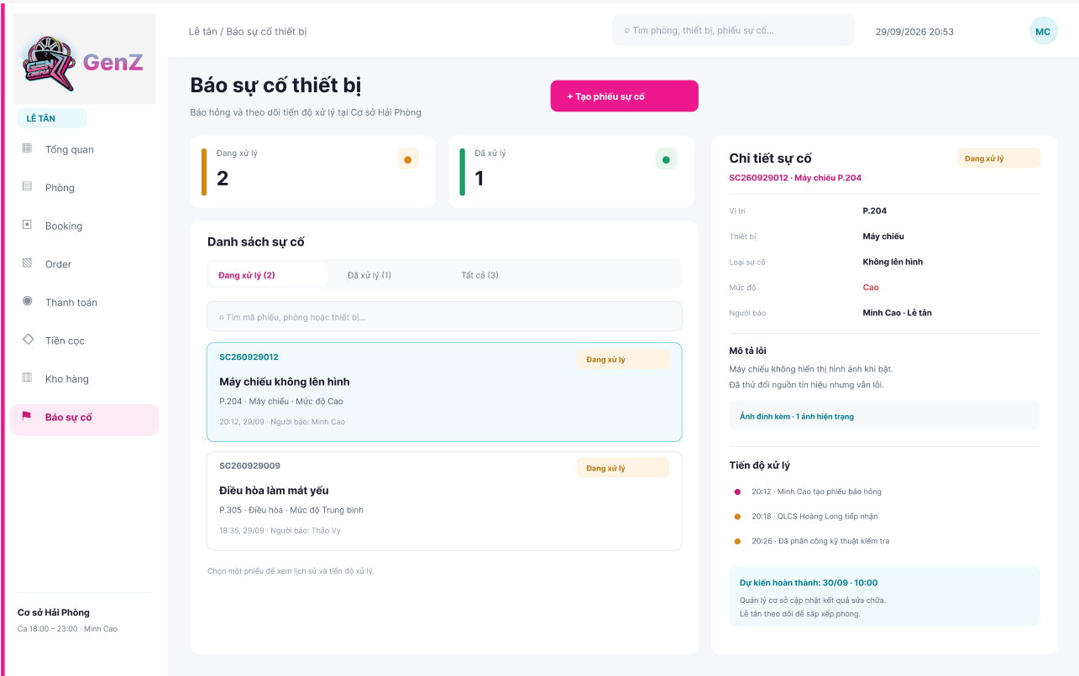

2.15.2 Create Incident Report Screen
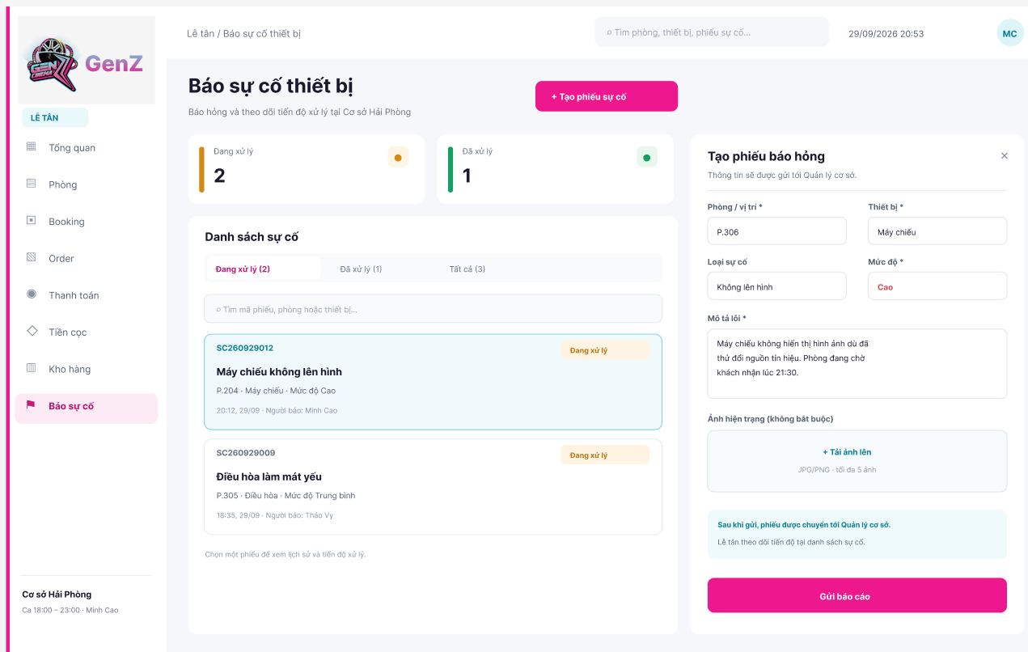

Field Name | Description
Panel Header | Displays the title “Create Incident Report” and a close button for dismissing the form.
Room / Location * | A required field for selecting the room or location where the incident occurred. The illustrated value is P.306.
Equipment * | A required field for selecting the affected equipment. The illustrated value is Projector.
Incident Type | Specifies the type of problem reported. The illustrated value is No Display.
Severity * | A required field for selecting the incident severity. Available values may include Low, Medium, and High. The illustrated value is High.
Problem Description * | A required multi-line text field describing the incident and relevant circumstances. The illustrated description states that the projector does not display an image despite trying another signal source, and that the room is scheduled to receive a customer at 21:30.
Current Condition Images | An optional upload control for attaching photos of the affected equipment or location. JPG and PNG files are accepted, with a maximum of five images.
Submission Notice | Displays a notice informing the Receptionist that the submitted incident will be forwarded to the Branch Manager for handling.
Submit Report | Validates the required information and submits the incident report. After submission, the incident is assigned the initial status In Progress or Reported according to the system workflow.
Close | Closes the incident report panel without submitting the form.

5. Background Job Inventory

5.1 Monitor Booking Arrival and Stay Time (JOB-01)
Trigger: Scheduled - every minute
Purpose: Identifies bookings with overdue customer arrival and active room sessions approaching or exceeding their scheduled end time, and notifies the Receptionist at the responsible branch.
Processing steps:
- Find bookings that have reached their planned start time but have not been checked in, cancelled, or marked as no-show.
- If the configured arrival grace period has elapsed, notify the responsible branch’s Receptionist to check the booking.
- Find active room sessions approaching or exceeding their scheduled end time, taking approved stay extensions into account.
- Notify the Receptionist when the configured reminder threshold is reached.
- Record the notification time and type to prevent duplicate reminders for the same booking and threshold.
Failure behavior:
Scenario | System behavior
Database unreachable | Job logs an error and retries at the next scheduled run. Booking and room statuses remain unchanged
Notification delivery fails | Jb records the failed delivery and retries later without duplicating successfully delivered notifications.
Booking is changed during processing | ob rechecks the booking status and scheduled times before sending the notification.

5.2 Monitor Daily Revenue Closing and Reconciliation (JOB-02)
Trigger: Scheduled - every 15 minutes. Checks apply after each branch’s configured daily revenue-closing or reconciliation deadline.
Purpose: Identifies overdue daily revenue closings and unresolved discrepancies between completed bills and their associated settlements, including recorded cash payments, confirmed bank transfers, and deposits applied to bills. The job reminds the responsible Branch Manager
Processing steps:
- Determine the business date and configured revenue-closing and reconciliation deadlines for each operating branch.
- Find branches that have passed their closing deadline without submitting a daily revenue closing.
- Notify the responsible Branch Manager of the overdue closing.
- For submitted closings awaiting reconciliation, check the amounts due on completed bills after valid discounts and adjustments.
- Compare each bill’s amount due with recorded cash payments, confirmed bank transfers, and deposits applied to that bill. Deposits collected earlier must not be recorded again as new receipts for the current business date.
- Identify missing, insufficient, excessive, unconfirmed, or unmatched payments. Exclude unapplied deposits and operating expenses from daily service revenue.
- Notify the Branch Manager when a discrepancy requires investigation or explanation, or the Accountant when reconciliation review is overdue. The job does not automatically approve closings or mark unresolved discrepancies as reconciled.
- Recheck the closing status and related payment records before sending each notification.
- Record the reminder time, recipient, and closing reference to prevent duplicate notifications within the configured reminder interval.
Failure behavior:
Scenario | System behavior
Database unreachable | Job logs an error and retries at the next scheduled run. Revenue-closing and reconciliation records remain unchanged.
Closing or reconciliation deadline is not configured | Job skips the affected deadline check and logs a configuration warning.
Bill or payment records change during processing | Job rechecks the current data before identifying discrepancies and sending notifications.
Notification delivery fails | Job records the failed delivery and retries later without duplicating successfully delivered notifications.
No overdue closings or unresolved discrepancies are found | Job completes with no action - this is normal and expected.

6. External API Inventory

6.1 SePay Payment Integration (API-01)
URL | To be configured according to the selected SePay integration interface.
Purpose | Obtains transaction information to verify booking deposits and checkout bank-transfer payments. Matches the receiving account, payment reference, and amount before recording a confirmed payment against the corresponding branch, booking, or bill. Prevents duplicate transaction processing.
Caller | GCMB backend
Auth | Credentials required by the selected SePay integration interface.

6.2 Password Reset Confirmation API (API-02)
URL | Email delivery endpoint or SMTP server provided by the configured Email Service.
Purpose | Sends a password-reset link to the user's registered email address. GCMB generates and validates the one-time, time-limited reset token and processes the password change internally.
Caller | GCMB backend
Auth | Email service API credentials or SMTP authentication, depending on the selected provider.

IV. Non-Functional Requirements

1. External Interfaces
Interface Type | Interface | Requirement
User Interface | Internal Web Interface | GCMB shall provide a web-based interface for Head Office Manager, Branch Manager, Receptionist, and Accountant. Functions and data shall be displayed according to the user's role and permitted branch scope
User Interface | Customer F&B Interface | Customers shall be able to access the F&B ordering interface through the QR code associated with an active room session. Customers shall not access internal booking, payment, staff, or financial functions
Software Interface | SePay | GCMB shall exchange the required payment amount and reference with SePay for booking deposits and checkout bank transfers, and shall record a payment as successful only after receiving a matching payment confirmation
Software Interface | Cloud Storage Service | GCMB shall use the configured Cloud Storage Service to store and retrieve supporting evidence such as bills, receipts, repair evidence, reimbursement evidence, and payment documents while maintaining their association with the corresponding business records
Software Interface | Email Service | GCMB shall use the configured Email Service for forgot-password and password-reset activities. General workflow email notification is not required in the current scope
Hardware Interface | Client Devices | GCMB shall be accessible through standard desktop or laptop devices with a supported web browser. The customer F&B interface shall also support common smartphones. No dedicated POS, barcode scanner, biometric device, or other specialized hardware interface is required
Communication Interface | Web Communication | GCMB shall support secure network communication between supported web browsers and the system for internal and customer-facing functions
Communication Interface | External Service Communication | Communication with SePay, Cloud Storage, and Email Service shall protect transmitted information and shall not mark an external operation as successful unless the required confirmation is received

2. Quality Attributes
This section defines the main non-functional requirements of GCMB. The selected quality attributes reflect the system’s actual operating context as a multi-branch business system used for booking, payment, F&B, workforce, and financial activities.
- Usability: Chosen because Receptionists and customers need to complete frequent tasks quickly and with minimal guidance
- Performance: Important because booking, check-in, checkout, F&B ordering, and reporting must respond fast enough for daily operations
- Security: Required to protect user accounts, financial data, payroll information, and role-based access across branches
- Availability: Necessary because core services must remain accessible during branch operating hours
- Scalability: Included to ensure GCMB can support additional branches, users, and growing operational data as the business expands

2.1 Usability

Requirement | Description
Self-Service F&B Ordering | A first-time customer shall be able to view the F&B menu, select items, and submit an order through the room QR interface using the instructions provided by GCMB without assistance from staff.
Operational Ease of Use | After normal onboarding, a Receptionist shall be able to perform core operations, including booking, check-in, checkout, and F&B order handling, without referring to external operating instructions.
Input Error Feedback | When invalid data is entered, GCMB shall identify the relevant field, explain the reason for rejection, and provide sufficient information for the user to correct the input.

2.2 Performance
Requirement | Description
Operational Response Time | GCMB shall maintain acceptable response times for frequently used operations, including booking creation, check-in, checkout, F&B order submission, and payment-status updates, under the representative peak workload defined for acceptance testing.
Batch Processing Performance | GCMB shall complete payroll generation and business-data export within the performance threshold established using a representative monthly branch dataset.
Concurrent Usage Performance | GCMB shall remain operational with at least 30 concurrent internal users and 100 concurrent customer F&B users during peak usage.

2.3 Security
Requirement | Description
Authentication | Access to GCMB internal management functions shall require successful authentication. The public customer F&B interface accessed through a valid room QR code is exempt from internal-user authentication.
Role-Based Access Control | GCMB shall restrict access to functions and protected business data according to the user's assigned role and authorized branch scope.
Sensitive Data Protection | User credentials, financial information, payroll data, and supporting documents shall be protected against unauthorized disclosure, including during transmission between GCMB and external services.
Audit Trail | GCMB shall record security-sensitive and financially significant operations with the responsible user, performed action, and time of the action.

2.4 Availability
Requirement | Description
Operational Availability | GCMB shall maintain a minimum system availability of 99.5% during primary branch operating hours (from 06:00 AM to 12:00 AM daily), ensuring that critical operations including booking, check-in, checkout, and FB services remain operational
Scheduled Maintenance | Maintenance or backup activities that may interrupt GCMB services shall be performed outside normal branch operating hours and shall be communicated to affected users before the interruption.

2.5 Scalability
Requirement | Description
Branch Scalability | GCMB shall support the addition of new branches and their associated rooms, equipment, staff, and operational records without requiring changes to existing core business workflows.
Data Growth Scalability | GCMB shall support growth in booking, billing, F&B, inventory, attendance, payroll, and financial records while continuing to satisfy the approved performance requirements for normal system operations.

V. Requirement Appendix

1. Business Rules
BR-ID | Rule Statement | Applies To | Rationale | Enforced By | Rule Type | Source Of Rule
BR-01 | Receptionists must create, modify, check in, and check out bookings only within their assigned branch scope | UC-35, UC-36, UC-38, UC-41 | Preserves branch-level operational control | GCMB Authorization | Constraint | GenZ organizational policy / confirmed GCMB process
BR-02 | A booking's reserved end time must be later than its reserved start time | UC-35, UC-36 | Prevents invalid booking intervals | GCMB Booking Management | Constraint | GenZ booking policy
BR-03 | Two effective bookings for the same room must not overlap in time | UC-35, UC-36 | Prevents double booking | GCMB Booking Management | Constraint | GenZ booking policy
BR-04 | Room availability checks must consider all effective future bookings that still occupy the requested time slot | UC-35, UC-36 | Ensures availability reflects existing commitments | GCMB Booking Management | Constraint | GenZ booking policy
BR-05 | A room under maintenance must not be assigned to a new or updated booking, checked in, or used as a replacement room until it is operational | UC-35, UC-36, UC-38, UC-39 | Prevents use of unavailable rooms | GCMB Room Management | Constraint | GenZ room operation policy
BR-06 | If a customer is a walk-in, then a booking/session record must be created before check-in starts | UC-35, UC-38 | Keeps every room-use session traceable | Receptionist / GCMB | Action Enabler | GenZ booking process
BR-07 | If the room or reserved time of an existing booking is changed, then GCMB must perform a new room-availability check before the change is accepted | UC-36 | Prevents conflicts caused by booking modification | GCMB Booking Management | Action Enabler | GenZ booking policy
BR-08 | A room change during an active stay is allowed only when the destination room is available for the required remaining period | UC-39 | Prevents moving a stay into a conflicting room | GCMB Booking Management | Constraint | GenZ room-change policy
BR-09 | If a room change is required because of a facility or equipment fault attributable to the branch, then the customer must not be charged an additional room-price difference solely because the replacement room is more expensive | UC-39 | Implements service-recovery policy | Receptionist / GCMB | Action Enabler | GenZ organizational policy
BR-10 | If a customer voluntarily requests a change to a more expensive room, then the applicable room-price difference must be added to the customer's bill | UC-39, UC-41 | Applies customer-requested upgrade charge | GCMB Billing | Action Enabler | GenZ organizational policy
BR-11 | A stay extension is allowed only when the extended period does not overlap the next effective booking for the room | UC-40 | Prevents extension conflicts | GCMB Booking Management | Constraint | GenZ booking policy
BR-12 | If a booking is cancelled or becomes a no-show before room use begins, then its future reserved room slot must be released | UC-37 | Returns unused capacity to availability | GCMB Booking Management | Action Enabler | GenZ cancellation process
BR-13 | A confirmed booking must preserve the applicable price snapshot so later pricing changes do not alter the commercial terms already confirmed for that booking | UC-35, UC-36, UC-37, UC-41 | Prevents retrospective price changes | GCMB Pricing / Booking | Constraint | GenZ pricing policy
BR-14 | If a cancellation is recorded at least 40 minutes before the booked start time, then the held deposit becomes eligible for refund | UC-37, UC-43, UC-44 | Implements confirmed refund policy | GCMB Deposit Management | Action Enabler | GenZ cancellation/deposit policy
BR-15 | If a cancellation is recorded less than 40 minutes before the booked start time, then the held deposit is not refundable | UC-37 | Implements late-cancellation policy | GCMB Deposit Management | Action Enabler | GenZ cancellation/deposit policy
BR-16 | If a booking becomes a no-show, then the held deposit is not refundable | UC-37 | Implements confirmed no-show policy | GCMB Deposit Management | Action Enabler | GenZ cancellation/deposit policy
BR-17 | Only the Accountant may execute the actual deposit refund transaction | UC-44 | Separates refund-processing responsibility | Accountant / GCMB Authorization | Constraint | GenZ refund policy
BR-18 | The amount refunded for a booking must not exceed its remaining refundable deposit balance | UC-44 | Prevents over-refund | GCMB Deposit Management | Constraint | GenZ refund policy
BR-19 | The same deposit amount must not be consumed more than once across deposit application, refund, and forfeiture | UC-41, UC-42, UC-44 | Prevents duplicate use of customer deposit | GCMB Deposit Management | Constraint | GenZ deposit policy
BR-20 | If a valid held deposit remains at checkout, then GCMB must apply that deposit to the bill before collecting the remaining amount | UC-41 | Applies prepaid funds correctly | GCMB Billing | Action Enabler | GenZ checkout policy
BR-21 | Gross Bill = Room Charge + F&B/Service Charges + Surcharges | UC-41 | Standardizes bill aggregation | GCMB Billing | Computation | GenZ checkout policy
BR-22 | Net Bill = Gross Bill − Authorized Voucher/Discount Amount | UC-41 | Standardizes authorized discounts | GCMB Billing | Computation | GenZ checkout policy
BR-23 | Remaining Amount Due = Net Bill − Deposit Applied − Previous Valid Payments | UC-41 | Determines final amount still payable | GCMB Billing | Computation | GenZ checkout policy
BR-24 | Applying a deposit to a bill must reduce the amount still payable but must not reduce recognized service revenue | UC-41, UC-123 | Separates settlement method from service revenue | GCMB Billing / Reporting | Constraint | GenZ financial policy
BR-25 | A bank-transfer payment must be treated as settled only after SePay confirms a transaction that matches the GCMB payment reference and expected amount | UC-41, UC-42 | Prevents unconfirmed or mismatched payments | GCMB / SePay | Constraint | GenZ payment policy
BR-26 | The amount encoded in a GCMB-generated payment QR must equal the current amount due for that payment request | UC-41, UC-42 | Prevents normal-flow underpayment or overpayment | GCMB Payment Service | Constraint | GenZ payment policy
BR-27 | Items charged to an occupied room must be linked to that room's active booking | UC-50, UC-51, UC-53 | Assigns F&B charges to the correct stay | GCMB F&B Management | Constraint | GenZ F&B process
BR-28 | Booking Item Amount = Accepted Quantity × Applicable Unit Price | UC-41, UC-51, UC-53 | Standardizes item-level F&B charges | GCMB F&B Management | Computation | GenZ F&B pricing policy
BR-29 | Additional Item Total = Σ Booking Item Amount | UC-41, UC-50, UC-51, UC-53 | Standardizes F&B order totals | GCMB F&B Management | Computation | GenZ F&B pricing policy
BR-30 | If an additional item is not included in the selected combo, its charge must be added separately to the booking bill | UC-41, UC-51, UC-53 | Implements treatment of additional F&B | GCMB Billing | Action Enabler | GenZ F&B/combo policy
BR-31 | A confirmed stock receipt quantity must be greater than zero | UC-58 | Prevents invalid stock increases | GCMB Inventory | Constraint | GenZ inventory policy
BR-32 | If a stock receipt is confirmed, then the received quantity must be added to the branch inventory balance | UC-54, UC-58 | Ensures confirmed receipts affect stock | GCMB Inventory | Action Enabler | GenZ inventory process
BR-33 | Stock Receipt Item Cost = Quantity Received × Unit Cost | UC-58 | Standardizes receipt valuation | GCMB Inventory | Computation | GenZ purchasing records / current operating report
BR-34 | A manual stock adjustment must record the before quantity, after quantity, reason, responsible user, and time of adjustment | UC-59 | Makes stock corrections traceable | Branch Manager / GCMB | Constraint | GenZ inventory policy
BR-35 | Adjustment Difference = Quantity After − Quantity Before | UC-59 | Quantifies stock adjustment | GCMB Inventory | Computation | GenZ inventory process
BR-36 | When an AUTO_ON_SALE item is added as a confirmed sale to a booking, its sold quantity must be deducted from branch stock exactly once | UC-50, UC-53, UC-55 | Implements automatic stock deduction | GCMB Inventory | Action Enabler | GenZ inventory policy
BR-37 | Stock After Sale = Stock Before Sale − Confirmed Sold Quantity | UC-50, UC-53, UC-55 | Defines automatic inventory movement | GCMB Inventory | Computation | GenZ inventory policy
BR-38 | An AUTO_ON_SALE item must not be added as a confirmed sale when the requested quantity exceeds available branch stock | UC-51, UC-53 | Prevents negative stock | GCMB Inventory | Constraint | GenZ inventory policy
BR-39 | Prepared-item ingredient consumption must be handled through manual stock adjustment because GCMB does not use recipe/BOM-based automatic ingredient deduction in the current scope | UC-59 | Aligns inventory with simplified current process | Branch Manager / GCMB | Constraint | GenZ inventory operating policy
BR-40 | Current Stock = Opening Stock + Confirmed Receipts − AUTO_ON_SALE Deductions + Net Manual Adjustments | UC-54 | Provides consistent inventory balance | GCMB Inventory | Computation | GenZ inventory movement policy
BR-41 | Only the Receptionist or Branch Manager may submit an equipment/facility incident for their branch | UC-70 | Restricts reporting to operational roles | GCMB Authorization | Constraint | GenZ equipment policy
BR-42 | The Branch Manager must assess a reported equipment or facility incident and determine the repair or replacement action for the branch | UC-73, UC-39 | Defines incident-management responsibility | Branch Manager | Constraint | GenZ equipment process
BR-43 | If an incident makes a room unusable, then the Branch Manager must place the room in UNDER_MAINTENANCE and affected active stays must follow room-change handling when required | UC-73, UC-39 | Prevents continued use of unavailable room | Branch Manager / GCMB | Action Enabler | GenZ maintenance policy
BR-44 | If the affected equipment is assessed as repairable, then the incident follows the repair path; otherwise it follows the replacement path | UC-73, UC-39 | Defines repair/replacement decision | Branch Manager / GCMB | Action Enabler | GenZ maintenance process
BR-45 | Repaired equipment must be verified by the Branch Manager before it is returned to normal operation or the incident is treated as completed | UC-71 | Requires post-repair verification | Branch Manager | Constraint | GenZ maintenance policy
BR-46 | A completed repair must record the actual repair cost and supporting evidence required by the organization's expense policy | UC-71 | Supports repair-cost traceability | Branch Manager / GCMB | Constraint | GenZ maintenance/expense policy
BR-47 | Normal repair invoices must be paid through the Accountant finance process; reimbursement is used only when personal funds were actually used for the business expense | UC-73, UC-112, UC-113, UC-114 | Separates company payment from reimbursement | Accountant / GCMB | Constraint | GenZ expense policy
BR-48 | Only the Head Office Manager may initiate a transfer of equipment between branches | UC-74 | Centralizes cross-branch asset movement | GCMB Authorization | Constraint | GenZ equipment-transfer policy
BR-49 | The source Branch Manager must confirm equipment handover before a cross-branch transfer can proceed to receipt confirmation | UC-75, UC-76 | Establishes source-branch accountability | Source Branch Manager / GCMB | Constraint | GenZ equipment-transfer policy
BR-50 | The destination Branch Manager must confirm receipt before GCMB changes the equipment's assigned branch and location | UC-76 | Prevents premature reassignment | Destination Branch Manager / GCMB | Constraint | GenZ equipment-transfer policy
BR-51 | If both source handover and destination receipt are confirmed, then GCMB must update the equipment's assigned branch/location and retain the transfer history | UC-76 | Completes controlled asset transfer | GCMB Equipment Management | Action Enabler | GenZ equipment-transfer policy
BR-52 | A Branch Manager may create and manage ordinary staff records only for the manager's own branch | UC-77, UC-78, UC-79, UC-80 | Aligns staff administration with branch responsibility | GCMB Authorization | Constraint | GenZ workforce policy
BR-53 | The current operation must use the four fixed shifts 00:00–07:00, 07:00–12:00, 12:00–18:00, and 18:00–00:00 | UC-85 | Standardizes branch scheduling | Branch Manager / GCMB | Constraint | GenZ shift policy
BR-54 | A Receptionist may register only for an available shift at the employee's home branch | UC-83 | Restricts registration to valid shifts | GCMB Shift Management | Constraint | GenZ shift policy
BR-55 | If a displayed shift still has remaining capacity when a Receptionist registers, then the registration is automatically confirmed | UC-83 | Implements automatic shift confirmation | GCMB Shift Management | Action Enabler | GenZ shift policy
BR-56 | If a shift has reached its configured staffing capacity, then additional self-registration for that shift must not be accepted | UC-83 | Prevents over-capacity registration | GCMB Shift Management | Action Enabler | GenZ shift policy
BR-57 | Cross-branch self-registration for work shifts must not be allowed in the current release | UC-83 | Maintains home-branch workforce model | GCMB Shift Management | Constraint | GenZ workforce policy
BR-58 | Only the Branch Manager may change another employee's assigned shift | UC-86 | Restricts schedule overrides | GCMB Authorization | Constraint | GenZ workforce policy
BR-59 | The Branch Manager must record the employee's actual worked hours and relevant attendance exceptions for the branch | UC-88 | Defines attendance-recording responsibility | Branch Manager | Constraint | GenZ attendance policy
BR-60 | A Receptionist may view only their own shift schedule and attendance information | UC-90 | Protects personal attendance information | GCMB Authorization | Constraint | GenZ workforce policy
BR-61 | A Receptionist must not directly edit their own Actual Worked Hours; attendance discrepancies must be resolved by the Branch Manager | UC-88, UC-90 | Separates employee review from manager correction | GCMB Authorization / Branch Manager | Constraint | GenZ attendance policy
BR-62 | The Branch Manager may close a monthly attendance sheet only after reported attendance discrepancies for that period have been resolved | UC-89 | Prevents unresolved attendance reaching payroll | Branch Manager / GCMB | Constraint | GenZ attendance policy
BR-63 | A closed attendance sheet must be locked from normal editing | UC-88, UC-89 | Protects finalized attendance | GCMB Attendance | Constraint | GenZ attendance policy
BR-64 | Only closed attendance data may be used to generate monthly payroll | UC-91, UC-94, UC-95 | Ensures payroll uses approved attendance | GCMB Payroll | Constraint | GenZ attendance/payroll policy
BR-65 | Payroll processing in the current scope must be performed by monthly payroll period | UC-91, UC-94, UC-95 | Aligns payroll with monthly cycle | Accountant / GCMB | Constraint | GenZ payroll policy
BR-66 | Only the Accountant may generate, review, adjust, and confirm monthly payroll | UC-91, UC-94, UC-95 | Defines payroll authority | GCMB Authorization | Constraint | GenZ payroll policy
BR-67 | Payroll must use the hourly pay rate that is effective for the employee's applicable work period | UC-91, UC-94, UC-95 | Prevents use of incorrect pay rate | GCMB Payroll | Constraint | GenZ payroll policy
BR-68 | Base Salary = Regular Paid Hours × Applicable Hourly Rate | UC-91, UC-94, UC-95 | Standardizes base salary calculation | GCMB Payroll | Computation | GenZ payroll policy
BR-69 | Overtime Pay (normal working day) = Overtime Hours × Hourly Rate × 150% | UC-91, UC-94, UC-95 | Applies statutory overtime minimum | GCMB Payroll / Accountant | Computation | Vietnam Labor Code 2019, Article 98; Decree 145/2020/NĐ-CP
BR-70 | Overtime Pay (weekly rest day) = Overtime Hours × Hourly Rate × 200% | UC-91, UC-94, UC-95 | Applies statutory overtime minimum | GCMB Payroll / Accountant | Computation | Vietnam Labor Code 2019, Article 98; Decree 145/2020/NĐ-CP
BR-71 | Overtime Pay (public holiday) = Overtime Hours × Hourly Rate × 300%, excluding any separate holiday wage entitlement required by law | UC-91, UC-94, UC-95 | Applies statutory holiday overtime minimum | GCMB Payroll / Accountant | Computation | Vietnam Labor Code 2019, Article 98; https://xaydungchinhsach.chinhphu.vn/lich-nghi-le-gio-to-hung-vuong-30-4-1-5-quoc-khanh-2-9-nam-2026-119260222115822151.htm
BR-72 | If approved worked time falls between 22:00 and 06:00, then the statutory night-work premium must be applied | UC-91, UC-94, UC-95 | Applies statutory night-work requirement | GCMB Payroll / Accountant | Action Enabler | Vietnam Labor Code 2019, Articles 98 and 106
BR-73 | Night Work Premium = Night Hours × Hourly Rate × Premium Rate | UC-91, UC-94, UC-95 | Applies statutory minimum night premium | GCMB Payroll / Accountant | Computation | Vietnam Labor Code 2019, Article 98; Decree 145/2020/NĐ-CP
BR-74 | A salary advance must be recorded as a separate transaction made before the employee's final salary payment for the period | UC-91, UC-94, UC-95 | Separates advance from final salary | Accountant / GCMB | Constraint | GenZ payroll policy
BR-75 | Only salary advances that were actually paid may be deducted from payroll, and each paid advance must be deducted no more than once | UC-91, UC-94, UC-95 | Prevents unsupported or duplicate deductions | GCMB Payroll | Constraint | GenZ payroll policy
BR-76 | Net Salary = Base Salary + Bonus − Approved Deductions − Paid Salary Advances | UC-91, UC-94, UC-95 | Standardizes final salary calculation | GCMB Payroll | Computation | GenZ payroll policy
BR-77 | Each employee must have no more than one final salary payment for the same payroll period | UC-91, UC-94, UC-95 | Prevents duplicate salary payment | Accountant / GCMB | Constraint | GenZ payroll policy
BR-78 | A salary advance must not be treated as the employee's final salary payment for the payroll period | UC-91, UC-94, UC-95 | Separates advance and settlement status | GCMB Payroll | Constraint | GenZ payroll policy
BR-79 | Payroll data may be exported for salary payment processing only after the payroll has been confirmed by the Accountant | UC-91, UC-94, UC-95 | Prevents use of unapproved payroll | Accountant / GCMB | Constraint | GenZ payroll policy
BR-80 | If a final salary payment fails or remains unconfirmed, then the employee's payroll payment must not be marked as paid | UC-91, UC-94, UC-95 | Prevents false payment completion | Accountant / GCMB | Action Enabler | GenZ payroll policy
BR-81 | Payroll Total = Σ Net Salary of employees included in the payroll period | UC-91, UC-94, UC-95 | Provides period payroll total | GCMB Payroll | Computation | GenZ payroll policy
BR-82 | Funds received from Head Office must be recorded by the Accountant as an internal funding movement and must not be classified as operating revenue | UC-102, UC-123 | Separates financing from operating revenue | Accountant / GCMB | Constraint | GenZ fund-management policy
BR-83 | Accountant Available Fund = Opening Balance + Incoming Fund + Returned Fund − Branch Fund Allocations − Direct Approved Expenses − Deposit Refunds − Reimbursements − Payroll Payments | UC-44, UC-96, UC-97, UC-102, UC-103, UC-104, UC-110, UC-114 | Defines available central operating fund | GCMB Finance | Computation | GenZ fund-management policy
BR-84 | Only the Accountant may allocate Branch Operating Fund in GCMB | UC-103 | Defines allocation authority | GCMB Authorization | Constraint | GenZ fund-management policy
BR-85 | A transfer of Branch Operating Fund from Accountant to a branch must be treated as an internal fund transfer, not as an expense at the time of transfer | UC-104, UC-123 | Prevents internal funding from inflating expenses | GCMB Finance | Constraint | GenZ fund-management policy
BR-86 | Closing Branch Fund = Opening Branch Fund + Fund Received + Other Approved Fund In − Approved Expenses Paid from Branch Fund − Fund Returned | UC-107, UC-108 | Defines branch operating-fund balance | GCMB Finance | Computation | GenZ fund-management policy
BR-87 | When Branch Fund is selected as the expense payment source, the approved expense amount must not exceed the branch's available operating fund | UC-108, UC-110 | Prevents branch-fund overspending | GCMB Finance | Constraint | GenZ expense policy
BR-88 | Expense Line Amount = Quantity × Unit Price | UC-107, UC-108 | Standardizes expense-line values | GCMB Expense Management | Computation | GenZ expense records / September operating report
BR-89 | Expense Total = Σ Expense Line Amount | UC-107, UC-108 | Standardizes expense total | GCMB Expense Management | Computation | GenZ expense records / September operating report
BR-90 | A payment request must identify the business reason, amount, recipient, payment source, and supporting evidence when required by the organization's expense policy | UC-107, UC-108 | Makes requested spending reviewable and traceable | Branch Manager / GCMB | Constraint | GenZ expense policy
BR-91 | If a payment request amount is greater than VND 3,000,000, then Head Office Manager approval is required before the Accountant may process the payment | UC-109, UC-110 | Implements large-expense approval threshold | HOM / Accountant / GCMB | Action Enabler | GenZ expense-approval policy
BR-92 | A reimbursement request for a personal-money business expense must identify the person who paid and must remain linked to the underlying business expense and its supporting evidence | UC-112, UC-113, UC-114 | Preserves expense/reimbursement traceability | GCMB Expense Management | Constraint | GenZ reimbursement policy
BR-93 | Only the Accountant may review and process reimbursement payment in the current workflow | UC-113, UC-114 | Defines reimbursement authority | GCMB Authorization | Constraint | GenZ reimbursement policy
BR-94 | A reimbursement amount must not exceed the approved reimbursable amount, and the same approved personal expense must not be reimbursed more than once | UC-113, UC-114 | Prevents duplicate or excessive reimbursement | GCMB Expense Management | Constraint | GenZ reimbursement policy
BR-95 | Expected Closing Cash = Opening Cash + Cash Sales + Cash Deposits + Approved Cash Inflows − Cash Expenses − Cash Refunds − Cash Remitted | UC-98 | Determines expected end-of-day cash | GCMB Cash Closing | Computation | GenZ daily-closing policy
BR-96 | Cash Variance = Actual Closing Cash − Expected Closing Cash | UC-98, UC-100 | Quantifies closing discrepancy | GCMB Cash Closing | Computation | GenZ daily-closing policy
BR-97 | If the closing variance is non-zero or meets the configured materiality condition, then the Branch Manager must provide an explanation before the closing can be fully reconciled | UC-98, UC-100 | Requires investigation of relevant variance | Branch Manager / GCMB | Action Enabler | GenZ reconciliation policy
BR-98 | The Accountant must review the branch's daily closing; required explanations must be reviewed and the relevant discrepancies resolved before the closing is treated as fully reconciled | UC-101 | Establishes independent reconciliation | Accountant / GCMB | Constraint | GenZ financial-control policy
BR-99 | Only the Accountant may close a financial period, and the period must not be closed until the required reconciliations are completed | UC-105 | Protects period-close authority and completeness | Accountant / GCMB | Constraint | GenZ period-closing policy
BR-100 | Financial transactions in a closed period must not be directly overwritten through normal editing; corrections must use a traceable financial adjustment | UC-105, UC-106 | Preserves finalized financial history | GCMB Finance | Constraint | GenZ financial-control policy
BR-101 | A financial adjustment must preserve the original transaction and record the correction separately with its reason, responsible user, and time | UC-106 | Maintains correction auditability | Accountant / GCMB | Constraint | GenZ financial-control policy
BR-102 | Service Revenue = Σ Net Amount of completed service/sales bills within the reporting period | UC-121, UC-123 | Defines recognized service revenue | GCMB Reporting | Computation | GenZ reporting policy
BR-103 | Operating Expenses = Σ Approved OPEX transactions in the reporting period, excluding internal fund transfers and CAPEX | UC-121, UC-123 | Defines operating expense consistently | GCMB Reporting | Computation | GenZ reporting policy / September profit report
BR-104 | Operating Profit = Operating Income − Operating Expenses | UC-121, UC-123 | Standardizes management profit | GCMB Reporting | Computation | GenZ September profit report
BR-105 | Operating Margin = (Operating Profit / Operating Income) × 100%, when Operating Income > 0 | UC-121, UC-123 | Enables normalized profitability comparison | GCMB Reporting | Computation | GenZ management reporting policy
BR-106 | Net Cash Flow = Total Cash Inflows − Total Cash Outflows | UC-121, UC-123 | Separates cash movement from accounting profit | GCMB Reporting | Computation | GenZ cashflow reporting policy
BR-107 | CAPEX/Investment must be reported separately from operating expenses when presenting operating profit | UC-121, UC-123 | Prevents investment from distorting operating result | GCMB Reporting | Constraint | GenZ reporting policy
BR-108 | Held customer deposits must not be recognized as completed service revenue; forfeited deposits must be reported separately from normal room/F&B service revenue | UC-37, UC-42, UC-123 | Separates deposit movements from normal service revenue | GCMB Finance / Reporting | Constraint | GenZ financial-reporting policy
BR-109 | Chain Operating Profit = Σ Branch Operating Profit for all branches in the selected reporting period | UC-121 | Provides consistent chain-wide profit total | GCMB Reporting | Computation | GenZ chain reporting policy
BR-110 | If replacement equipment is placed into service, then the asset must be registered or updated in GCMB with its responsible branch/location before it is treated as available for operation | UC-66, UC-67, UC-72 | Maintains asset accountability | Branch Manager / GCMB | Action Enabler | GenZ equipment policy
BR-111 | Required information must be provided; required text must not be blank or contain only spaces | UC-05, UC-10, UC-15, UC-20, UC-24, UC-29, UC-35, UC-46, UC-55, UC-61, UC-66, UC-71, UC-74, UC-78, UC-108, UC-112, UC-116 | Prevents incomplete records | GCMB | Constraint | Validation Requirement
BR-112 | A username must be unique across existing accounts, including deactivated accounts | UC-04 | Prevents duplicate account identity | GCMB | Constraint | Validation Requirement
BR-113 | An email address supplied for account contact or recovery must contain exactly one @, a non-empty local part before @, and a domain containing at least one dot with non-empty parts between dots No whitespace is allowed | UC-02, UC-03, UC-05 | Rejects malformed email input | GCMB | Constraint | Validation Requirement
BR-114 | A new password must contain 8–64 characters, including at least one uppercase letter, one lowercase letter, one digit, and one special character such as !, @, #, or $ Spaces are not allowed GCMB must reject passwords that do not meet these requirements without shortening them | UC-01, UC-02, UC-05 | Defines password-length validation | GCMB | Constraint | Validation Requirement
BR-115 | An evidence image must be a readable JPEG, PNG, or WebP image; its actual content must match its declared format | UC-71, UC-73, UC-108, UC-112 | Rejects unsupported or corrupt images | GCMB | Constraint | Validation Requirement
BR-116 | An evidence image must have a size greater than 0 bytes and no more than (20 MB) | UC-71, UC-73, UC-108, UC-112 | Defines image-size validation | GCMB | Constraint | Validation Requirement
BR-117 | The quantity of a menu item added to a booking must be a positive whole number | UC-51, UC-52, UC-53 | Prevents invalid ordered quantities | GCMB | Constraint | Validation Requirement
BR-118 | A master-data record may be deleted only when it has never been used and no other record depends on it; deletion must not remove historical business records | UC-18, UC-27, UC-31, UC-49, UC-57, UC-64, UC-69, UC-119 | Protects history while allowing correction of unused records | GCMB | Constraint | Latest user-supplied deletion policy

2. System Messages
# | Message Code | Message Type | Context | Content
1 | MSG01 | Inline | No search results found | Không tìm thấy kết quả phù hợp.
2 | MSG02 | In red, under text box | Required field is left blank | Vui lòng nhập thông tin này.
3 | MSG03 | In red, under text box | Input exceeds the maximum allowed length | Chỉ được nhập tối đa {max_length} ký tự.
4 | MSG04 | In red, under text box | Invalid phone number format | Số điện thoại phải gồm 10 chữ số.
5 | MSG05 | In red, under text box | Invalid email format | Vui lòng nhập đúng định dạng email.
6 | MSG06 | In red, under text box | Password confirmation does not match | Mật khẩu xác nhận chưa khớp.
7 | MSG07 | In red, under text box | End time is not later than start time | Giờ kết thúc phải sau giờ bắt đầu.
8 | MSG08 | Inline | Authentication failed | Tên đăng nhập hoặc mật khẩu không đúng.
9 | MSG09 | Toast (Info) | Password reset link sent successfully | Đã gửi liên kết đặt lại mật khẩu đến {email_address}.
10 | MSG10 | Toast (Success) | Record created successfully | Đã tạo {entity_name}.
11 | MSG11 | Toast (Success) | Record updated successfully | Đã cập nhật {entity_name}.
12 | MSG12 | Toast (Success) | Record deactivated successfully | Đã vô hiệu hóa {entity_name}.
13 | MSG13 | Toast (Success) | Excel file exported successfully | Đã xuất file {file_name}.
14 | MSG14 | Modal (Confirmation) | Confirmation before a critical or irreversible action | Bạn có chắc muốn {action_name}? Hành động này không thể hoàn tác.
15 | MSG15 | Toast (Warning) | Selected room is unavailable for the requested time period | Phòng đã có lịch trong khung giờ này. Vui lòng chọn phòng hoặc thời gian khác.
16 | MSG16 | Toast (Warning) | Booking is cancelled within 40 minutes before check-in | Đơn được hủy trong vòng 40 phút trước giờ nhận phòng nên tiền cọc không được hoàn lại.
17 | MSG17 | Toast (Warning) | Extension conflicts with the next booking | Không thể gia hạn vì phòng đã có lịch đặt tiếp theo.
18 | MSG18 | Toast (Warning) | Ordered quantity exceeds available inventory | {item_name} chỉ còn {available_quantity}. Vui lòng giảm số lượng đặt.
19 | MSG19 | Toast (Warning) | Shift has reached its staffing capacity | Ca này đã đủ nhân sự đăng ký. Vui lòng chọn ca khác.
20 | MSG20 | Toast (Warning) | Attendance sheet contains unresolved discrepancies | Chưa thể chốt bảng công. Vui lòng xử lý các sai lệch chấm công còn lại trước.
21 | MSG21 | Banner / Modal | Cash discrepancy detected during end-of-day closing | Số tiền kiểm đếm không khớp với số liệu hệ thống. Vui lòng kiểm tra và nhập lý do chênh lệch.
22 | MSG22 | Toast (Info) | Payment confirmation is pending | Đang chờ xác nhận thanh toán từ SePay...
23 | MSG23 | Toast (Success) | Payment or deposit confirmed by SePay | Đã nhận {amount} VND qua SePay.
24 | MSG24 | Toast (Error) | User does not have permission to perform the action | Bạn không có quyền thực hiện thao tác này.
25 | MSG25 | Modal / Toast (Error) | External service did not respond within the allowed time | Dịch vụ hiện chưa phản hồi. Vui lòng thử lại sau.
26 | MSG26 | Modal / Toast (Error) | Network connection is unavailable or server cannot be reached | Không thể kết nối đến hệ thống. Vui lòng kiểm tra kết nối mạng và thử lại.
27 | MSG27 | Modal / Toast (Error) | Internal server or database error prevents the operation from completing | Không thể lưu thay đổi. Vui lòng thử lại.

3. Other Requirements
- OR-01 - Global Error Handling & Logging: GCMB shall globally handle database, network, and system-level errors; automatically roll back failing transactions where applicable to prevent data corruption and display user-friendly error messages without exposing technical stack traces
- OR-02 - Localization & Standards: GCMB interface shall support Vietnamese (UTF-8). All monetary values shall be displayed in VND (e.g 500.000 VND), and all timestamps shall follow Indochina Time (ICT, UTC+07:00).

Definition and Acronyms
Acronym | Definition
SRS | Software Requirement Specification
MBF | Main Business Flow
ERD | Entity Relationship Diagram
UC | Use Case
API | Application Programming Interface
JOB | Background Job
GCMB | GenZ Cinema & Music Box Management System
F&B | Food and Beverage
QR | Quick Response Code
ID | Identifier
VND | Vietnamese Dong
BR | Business Rule
SMTP | Simple Mail Transfer Protocol
UI | User Interface
POS | Point of Sale
BOM | Bill of Materials (a structured list of materials/components required to create a product)
HOM | Head Office Manager
OPEX | Operating Expenses (day-to-day costs required to operate the business, such as utilities, supplies, salaries, and routine maintenance)
CAPEX | Capital Expenditure (spending on long-term assets or major improvements, such as equipment, facilities, or infrastructure)
MSG | System Message
OR | Other Requirement
UTF-8 | 8-bit Unicode Transformation Format (a character encoding standard used to represent multilingual text, including Vietnamese characters)
ICT | Indochina Time (the standard time zone used in Vietnam, UTC+07:00)
UTC | Coordinated Universal Time (the global reference time standard used to define time-zone offsets)

